| Item | Information |
| --- | --- |
| Report title | Breeding Bird Monitoring Protocol for the Heartland Inventory and Monitoring Network |
| Report subtitle | Narrative, Version 3.0 |
| Author 1 name,  organization name,  city, state | Heartland Inventory and Monitoring Network, National Park Service, Republic, MO |
| Author 2 name,  organization name,  city, state |  |
| Author 3 name,  organization name,  city, state |  |
| Author 4 name,  organization name,  city, state |  |
| Author 5 name,  organization name,  city, state |  |

Add more author rows as needed



protecting the habitat of our heritage

| Item | Information |
| --- | --- |
| Cover photo caption | Herbert Hoover birthplace cottage at Herbert Hoover NHS, prescribed fire at Tallgrass Prairie NPres, aquatic invertebrate monitoring at George Washington Carver NM, the Mississippi River at Effigy Mounds NM. |
| Cover photo credit | Heartland I&M Network, NPS |

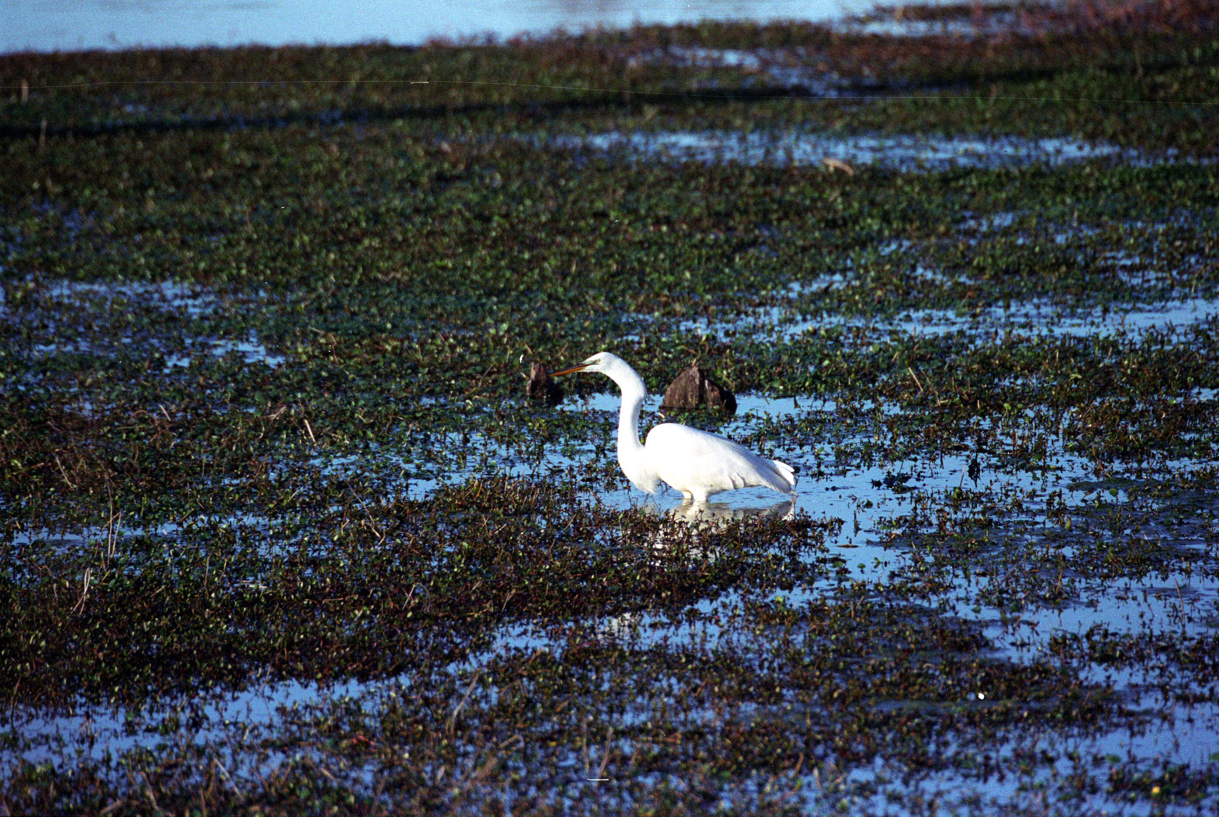

| Item | Information |
| --- | --- |
| Inside Cover photo caption | Great Egret at Arkansas Post National Memorial |
| Inside Cover photo credit | Heartland I&M Network, NPS |

| Peer Review Statement: |
| --- |
| This protocol narrative received formal, high-level peer review based on the importance of its content, or its potentially controversial or precedent-setting nature. Peer review was conducted by highly qualified individuals with subject area technical expertise and was overseen by a peer review manager. |

Executive Summary

Birds are an important component of park ecosystems and have a tremendous following among the public, with many parks providing information on the status and long-term trends of bird populations through their interpretive programs. With habitat vanishing, ecosystems being altered, and bird populations declining, we propose monitoring bird communities on National Park Service lands within the Heartland Inventory and Monitoring Network. Monitoring breeding bird populations better positions park management to take action to mitigate concerns involving declining bird numbers.

This monitoring protocol consists of a protocol narrative (this document) and 10 standard operating procedures for monitoring breeding birds in Heartland Inventory and Monitoring Network parks. The overall goals of Heartland Inventory and Monitoring Network breeding bird monitor­ing are to 1) identify significant temporal changes in the species composition and abundance of bird communities that occur on parks during the breeding season, and 2) improve our understanding of relationships between breeding birds and their habitat and the effects of management actions (such as prairie restoration or prescribed fire) on bird populations by examining potential correlations between changes in specific habitat variables (e.g., vegetation structure, ground cover) and changes in bird community composition and abundance.

This protocol narrative describes the sampling design for breeding birds, including the response design (data collection methods), spatial design (the park and survey plots within a park), and revisit design (timing and frequency of park visits). It also outlines field methods for establishing survey plots, counting birds, and measuring habitat variables. Details can be found in the Standard Operating Procedures, which are listed below and available at irma.nps.gov. Other aspects of the protocol summarized in the narrative include procedures for data management and report­ing, personnel and operating requirements, and instructions for how to revise the protocol.

**Acknowledgements**

The National Park Service’s Inventory and Monitoring Program provided funding for the development of this bird monitoring protocol and continues to fund monitoring of the resource in network parks. Numerous NPS personnel and volunteers have contributed in-kind support to the development of this protocol and continue to assist with annual surveys. This protocol in an earlier version (Version 1.00) benefited from comments by Drs. John Sauer (USGS Patuxent Wildlife Research Center), Rich Camp (USGS Pacific Island Ecosystems Research Center) and Rodney Siegel (Institute for Bird Populations). In 2008, the protocol was revised (Version 2.00) to reflect the network’s expansion of its bird monitoring efforts into additional parks and the turning over of Agate Fossil Beds National Monument, Nebraska to the Northern Great Plains Inventory and Monitoring Network.

**Revision History Log**

Revision history log

|  |  |  |  |  |  |
| --- | --- | --- | --- | --- | --- |
| Prev Version # | Revision Date | Author(s) | Changes Made | Reason for Changes | New Version # |
| 2.0 | May 2019 | D.G. Peitz | Updated throughout to NRR format per NRSS guidelines. Moved SOPs from Narrative to stand alone documents. Added a Quality Assurance Plan (QAP) to the protocol. Minor edits throughout the documents. | Edited to meet I&M Division Guidance. Made Narrative NRSS compliant. | 3.0 |

Version numbers increase incrementally by hundredths (e.g., version 1.01, version 1.02, etc.) for minor changes. Major revisions will be designated with the next whole number (e.g., version 2.0, 3.0, 4.0…). The previous version number, date of revision, author of the revision, and the reason for making the changes are recorded along with the new version number. The first version of this protocol was published in 2003.

**List of Standard Operating Procedures (SOPs)**

The following standard operating procedures (SOPs) are associated with this narrative. Each SOP is a stand-alone document and can be found at irma.nps.gov.

**SOP 1.** Preparations and Equipment Setup Prior to the Field Season

**SOP 2.** Training Observers

**SOP 3.** Establishing and Marking Sampling Plots

**SOP 4.** Conducting the Variable Circular Plot Count

**SOP 5.** Documenting Habitat Variables

**SOP 6.** Data Management

**SOP 7.** Data Summary and Analysis

**SOP 8.** Reporting

**SOP 9.** Procedures and Equipment Storage after the Field Season

**SOP 10.** Revising the Protocol

## Background and Objectives

Issue Being Addressed and Rationale for Monitoring Bird Populations

Birds are an important component of park ecosystems. Their high body temperature, rapid metabolism, and high ecological position in most food webs make them a good indicator of the effects of local and regional changes in ecosystems. It has been suggested that management activities aimed at preserving habitat for bird populations, such as for neotropical migrants, can have the added benefit of preserving entire ecosystems and their attendant ecosystem services (Karr 1991, Maurer 1993). Moreover, birds have a tremendous following among the public, and many parks provide information on the status and trends of bird populations through their interpretive programs.

Native Great Plains grasslands and their constituent avian fauna once covered vast areas of the North American continent in which the Heartland Inventory and Monitoring Network now resides. In fact, 10 of the 11 parks with bird populations monitored by the Heartland Inventory and Monitoring Network have significant grassland components in their landscape. However, during the last century, large portions of grassland landscapes were plowed for cropland or converted to livestock pasture (29% of shortgrass, 41% of mixed-grass, and 99% of tallgrass prairie; Knopf and Samson 1997). Remaining grasslands have been altered further through continued fragmentation and isolation, changing agricultural practices, forest encroachment, interruption of driving ecological processes such as periodic wildfire, and loss of significant faunal species, including bison (*Bison bison*), elk (*Cervus elaphus*), and wolves (*Canis lupus*). Therefore, most bird communities are being monitored on a landscape far different from which they evolved in.

Parts of seven bird conservation regions identified by the North American Bird Conservation Initiative are found within the Heartland Inventory and Monitoring Network (Figure 1). Started in 1999, the North American Bird Conservation Initiative is a coalition of government agencies and private organizations in the United States working to ensure the long-term health of North America's native bird populations (North American Bird Conservation Initiative 2019). Each bird conservation region has a unique habitat and suite of birds in need of conservation.

Hopewell Culture National Historical Park, Ohio is located on the boarder of two bird conservation regions, the Eastern Tallgrass Prairie and Appalachian Mountains (Figure 1). The Eastern Tallgrass Prairie Bird Conservation Region historically consisted of the tallest and lushest grasslands of the Great Plains (North American Bird Conservation Initiative 2019). However, forests dominate the region in the east creating an oak-savanna ecotone between the eastern woodlands and the western prairie. The Appalachian Mountains Bird Conservation Region has a rugged terrain dominated by oak-hickory and other deciduous forest types at lower elevations and by various combinations of pine, hemlock, spruce, and fir in higher areas. Flatter portions are used for agriculture; however, the majority of this region is forested. High priority birds common to both regions include Peregrine Falcon (*Falco peregrinus*), Upland Sandpiper (*Bartramia longicauda*), Eastern Whip-poor-will (*Antrostomus vociferus*), Red-headed Woodpecker (*Melanerpes erythrocephalus*), Loggerhead Shrike (*Lanius ludovicianus*), Bewick’s Wren (*Thryomanes bewickii*), Wood Thrush (*Hylocichla mustelina*), Blue-winged Warbler (*Vermivora cyanoptera*), Cerulean Warbler (*Setophaga cerulea*), Kentucky Warbler (*Geothlypis formosa*), and Henslow’s Sparrow (*Ammodramus henslowii*; U.S. Fish and Wildlife Service 2008). Approximately 126 species of breeding birds can be found in the habitats of the Eastern Tallgrass Prairie and Appalachian Mountains Bird Conservation Regions around Hopewell Culture National Historical Park (Peterjohn 2001).

Herbert Hoover National Historic Site, Iowa is located in the north-central section of the Eastern Tallgrass Prairie Bird Conservation Region (Figure 1). Threats to the habitat of this region include urbanization, recreational development, and agriculture. Approximately 124 species of breeding birds can be found in the tallgrass prairie habitat of the area around Herbert Hoover National Historic Site (Jackson et al. 1996). Species in the region such as American Coot (*Fulica* *americana*), Savannah Sparrow (*Passerculus sandwichensis*), Western Meadowlark (*Sturnella* *neglecta*), and Eastern Whip-poor-will (*Antrostomus vociferus*) are declining at alarming rates.

Tallgrass Prairie National Preserve, Kansas is located in the west-central section of the Eastern Tallgrass Prairie Bird Conservation Region, which consists of the Flint Hills and its remnant native tallgrass prairie (Figure 1; Fitzgerald et al. 2000). The rocky, rolling terrain of the Flint Hills has been largely untouched by the plow. Threats to the upland and wetland habitats of this region include urbanization, recreational development, and agricultural expansion. High priority grassland birds that persist in some areas include the Greater Prairie-Chicken (*Tympanuchus cupido*) and Henslow’s Sparrow (*Ammodramus henslowii*). Cerulean Warblers (*Setophaga cerulea*) are found in some wooded areas, and the Red-headed Woodpecker (*Melanerpes erythrocephalus*) leads the list of savanna specialists (North American Bird Conservation Initiative 2019). Approximately 120 species of breeding birds can be found in the habitat of the Flint Hills around Tallgrass Prairie National Preserve (Thompson et al. 2011).

Lincoln Boyhood National Memorial, Indiana is located in the Interior Low Plateaus section of the Central Hardwoods Bird Conservation Region (Figure 1; North American Bird Conservation Initiative 2019). The area is dominated by an oak-hickory deciduous forest inhabited by interior forest species, such as the Cerulean Warbler (*Setophaga cerulea*), Worm-eating Warbler (*Helmitheros vermivorum*), and Louisiana Waterthrush (*Parkesia motacilla*). The region includes some of the most extensive forests in the middle of the continent and is likely a source for many bird populations continent-wide. Threats to the region include deforestation for agriculture and urbanization. Like other parks in the region (Pea Ridge National Military Park, Arkansas and Wilson’s Creek National Battlefield and George Washington Carver National Monument, Missouri) high priority birds found there include Bell’s Vireo (*Vireo bellii*), Bewick’s Wren (*Thryomanes bewickii*), Blue-winged Warbler (*Vermivora cyanoptera*), Cerulean Warbler (*Setophaga cerulea*), Henslow’s Sparrow (*Ammodramus henslowii*), Kentucky Warbler (*Geothlypis formosa*), Prairie Warbler (*Setophaga discolor*), Red-headed Woodpecker (*Melanerpes erythrocephalus*), Sedge Wren (*Cistothorus platensis*), Eastern Whip-poor-will (*Antrostomus vociferus*), Wood Thrush (*Hylocichla mustelina*), and Worm-eating Warbler (*Helmitheros vermivorum*; U.S. Fish and Wildlife Service 2008). Approximately 119 species of breeding birds can be found in the habitat of the Central Hardwoods around Lincoln Boyhood National Memorial (Mumford and Keller 1984).

Pea Ridge National Military Park, Arkansas is located in the western edge of the Ozark Highland section of the Central Hardwoods Bird Conservation Region (Figure 1). Topography of the area in and around Pea Ridge National Military Park is dissected, with local relief over 100 meters common (Fitzgerald et al. 2000). However, broad flat ridges can be found throughout. The landscape historically contained a habitat of oak-hickory forest with a prairie grass understory in ravines and grass savanna habitat on ridges. Widespread habitat loss to agriculture, as well as urban and industrial development, threaten the integrity of the area for birds. Approximately 113 species of breeding birds can be found in the habitat of the area (James and Neal 1986).

Wilson’s Creek National Battlefield and George Washington Carver National Monument, Missouri are also located in the western edge of the Ozark Highland section of the Central Hardwoods Bird Conservation Region (Figure 1). However, they occupy a section of the Central Hardwoods Bird Conservation Region further north that is commonly referred to as oak savanna. Historically, it consisted of the transition zone between the northern and western tallgrass prairie and southern and eastern pine-hardwood forest. Topography of the area in and around Wilson’s Creek National Battlefield and George Washington Carver National Monument is less dissected than other portions of the Ozark Highlands but more dissected than areas of the Osage Plains further north and west (Fitzgerald et al. 2000). This landscape contains a rich mix of forested plant communities and grasslands. Widespread habitat loss to agriculture, as well as urban and industrial development, threaten the integrity of the area for birds. Approximately 116 species of breeding birds can be found in the habitat of the area (Robbins and Easterla 1992).

Arkansas Post National Memorial, Arkansas is located in the Lower Mississippi Alluvial Valley Bird Conservation Region (Figure 1). The Lower Mississippi Alluvial Valley Bird Conservation Region consists of millions of acres of alluvial floodplain south of the Mississippi River’s confluence with the Ohio River (North American Bird Conservation Initiative 2019). Historically, it was the greatest bottomland hardwood forest on earth and was subject to massive annual flood events of the Mississippi River and its tributaries. Threats to the region include flood control and deforestation for agriculture. Today, less than 25% of the region remains forested, and flooding has been reduced by about 90 percent. Some of the high priority birds of the region recorded in the park include Bald Eagle (*Haliaeetus leucocephalus*), Orchard Oriole (*Icterus spurius*), Prothonotary Warbler (*Protonotaria citrea*), Red-headed Woodpecker (*Melanerpes erythrocephalus*), and Wood Thrush (*Hylocichla mustelina*; U.S. Fish and Wildlife Service 2008). Approximately 113 species of breeding birds can be found in the habitat of the Lower Mississippi Alluvial Valley around Arkansas Post National Memorial (James and Neal 1986).

Effigy Mounds National Monument, Iowa is located in the south-central section of the Prairie Hardwood Transition Bird Conservation Region (Figure 1). Prairies once dominated this region in the west and south and beech-maple forests in the north and east, separated by an oak savanna (North American Bird Conservation Initiative 2019). Glaciation has resulted in numerous pothole-type wetlands, shallow lakes, and the Great Lakes’ coastal estuaries. Many rivers can be found in this region, with the Mississippi River being the largest. This region is second only to the Prairie Potholes region in terms of high densities of breeding waterfowl. Both early successional and mature woodlands provide habitat to numerous bird species as well. Habitat on the park lacks the extensive prairie component found in parts of the region, but the mix of deciduous trees, shrubs, permanent and seasonally flooded areas, and brushy openings (Hop et al. 2005) is similar to other parts of the region. The diverse mix of habitat (structural composition) on the park is important for the species of regional concern, as their microhabitat requirements vary (Pashley and Barrow 1993). Some of the high priority birds of the region recorded in the park include Bald Eagle (*Haliaeetus leucocephalus*) Black-billed Cuckoo (*Coccyzus erythropthalmus*), Blue-winged Warbler (*Vermivora cyanoptera*), Brown Thrasher (*Toxostoma rufum*), Cerulean Warbler (*Setophaga cerulea*), Red-headed Woodpecker (*Melanerpes erythrocephalus*), and Willow Flycatcher (*Empidonax traillii*; U.S. Fish and Wildlife Service 2008). Approximately 133 species of breeding birds can be found in the Prairie-Hardwood Transition habitat around Effigy Mounds National Monument (Jackson et al. 1996).

Pipestone National Monument, Minnesota is located on the southeastern edge of the Prairie Potholes Bird Conservation Region (Figure 1). The Prairie Potholes Bird Conservation Region is a glaciated area of mixed-grass prairie in the west and tallgrass prairie in the east (North American Bird Conservation Initiative 2019). This is the most important waterfowl production area on the North American continent, despite extensive wetland drainage and tillage of native grasslands. The region comprises the core of the breeding range of most dabbling duck and several diving duck species and provides critical breeding and migration habitat for over 200 other bird species, including many species of continental concern. Some of the high priority birds of the region recorded in the park include Black Tern (*Chlidonias niger*), Dickcissel (*Spiza americana*), Grasshopper Sparrow (*Ammodramus savannarum*), Least Bittern (*Ixobrychus exilis*), and Upland Sandpiper (*Bartramia longicauda*; U.S. Fish and Wildlife Service 2008). Approximately 105 species of breeding birds can be found in the habitat in and around Pipestone National Monument (Janssen et al. 2003). Continued wetland degradation, widespread habitat loss to agriculture and urban and industrial development, and fragmentation of remaining grasslands threaten many species in the region.

Homestead National Monument of America, Nebraska is located in the north-east section of the Central Mixed Grass Prairie Bird Conservation Region (Figure 1). The Central Mixed Grass Prairie extends from the edge of the shortgrass prairie to the west to the beginning of the tallgrass prairie and savanna-like habitat to the east (North American Bird Conservation Initiative 2019). Large areas in the center of this region have been converted to agriculture. However, extensive areas of high-quality grassland in the Nebraska Sandhills and shrublands in Texas remain. Some of the high priority birds of the region recorded in the park include Bell’s Vireo (*Vireo bellii*) and Lark Sparrow (*Chondestes grammacus*; U.S. Fish and Wildlife Service 2008). Approximately 125 species of breeding birds can be found in the Central Mixed Grass Prairie habitat around Homestead National Monument of America (Sharpe et al. 2001).

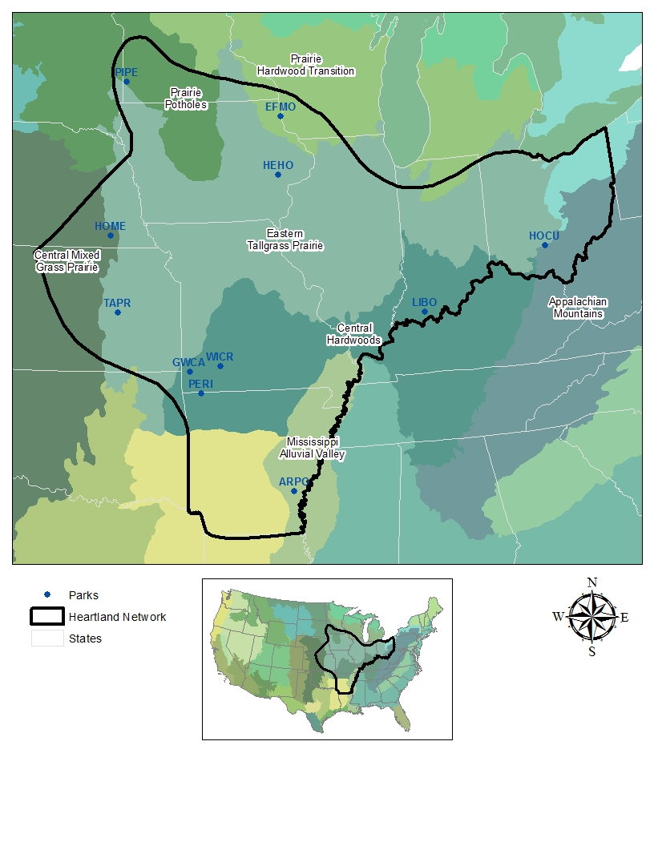

**Figure 1.** Bird Conservation Regions identified by the North American Bird Conservation Initiative found within the Heartland Inventory and Monitoring Network.

While not to the extent of large native ungulates and mammalian predators, many avian species have demonstrated declining abundance as habitat loss continues. Data collected during the U.S. Geological Survey’s annual North American Breeding Bird Surveys between 1966 and 1999 indicate that 70% of 29 grassland bird species show evidence of population declines (Sauer et al. 2000). Many prairie species such as the Grasshopper Sparrow (*Ammodramus savannarum*), Eastern Meadowlark (*Sturnella magna*), Horned Lark (*Eremophila alpestris*), Bobolink (*Dolichonyx oryzivorus*), Lark Bunting (*Calamospiza* *melanocorys*), and Dickcissel (*Spiza americana*) have declined at alarming rates (Sauer et al. 2003). The destruction and fragmentation of prairie landscapes, as well as the structural degradation resulting from fire suppression and changes in grazing regimes of remaining prairie habitats, contribute to these declines. Woodland bird species, especially neotropical warblers, have undergone even more precipitous declines related to habitat loss. Similar to grassland bird species, many woodland species that breed in one or more bird conservation regions within the Heartland Inventory and Monitoring Network are in need of conservation. Species are identified as in need of conservation because of low population numbers and/or threats to the unique habitat they require. National Park Service lands are well suited for avian species conservation as they are often managed to preserve unique habitats that are under-represented at the landscape scale but are vital to species survival.

It is against a backdrop of vanishing and altered ecosystems, declining bird populations, and the unique role that National Park Service lands can play in conserving threatened bird species that we propose monitoring avian communities on National Park Service lands within the Heartland Inventory and Monitoring Network. Long-term trends in the community composition and abundance of breeding bird populations provide one measure for assessing the ecological integrity and sustainability of ecosystems. Long-term patterns in community composition and species abundance in relation to changes in the structural diversity of vegetation will improve our understanding of the effects of various management actions.

Historical Development of Bird Monitoring in Network Parks

In prairies, trends in the composition and abundance of grassland bird populations have been proposed as long-term indicators of ecosystem integrity, which is defined as the capability to support and maintain a balanced, integrated, and adaptive community of organisms having a community composition, diversity, and functional organization comparable to that of natural habitat of the region (Karr and Dudley 1981). As part of the design phase (1998-1999) of the Prairie Cluster Prototype Long-term Ecological Monitoring Program led by the U.S. Geological Survey, bird inventories and pilot monitoring work were conducted in eight prairie parks by Dr. Abby Powell to identify the species present at each park and assess the feasibility of using grassland birds as indicators of ecosystem integrity (Powell 2000). Work was conducted at Agate Fossil Beds National Monument - Nebraska, Badlands National Park - South Dakota, Homestead National Monument of America - Nebraska, Pipestone National Monument - Minnesota, Scotts Bluff National Monument - Nebraska, Tallgrass Prairie National Preserve - Kansas, Theodore Roosevelt National Park - North Dakota, and Wilson’s Creek National Battlefield - Missouri.

As a follow-up to work done by Dr. Powell, the Prairie Cluster Prototype Long-term Ecological Monitoring Program initiated a pilot bird monitoring project in the spring of 2001 to monitor avian communities at Agate Fossil Beds National Monument and Tallgrass Prairie National Preserve. A culmination of this pilot project was a bird monitoring protocol completed in July 2003 (Peitz et al. 2003), and a bird monitoring program for the Prairie Cluster Prototype Long-term Ecological Monitoring Program. With the merger of the Prairie Cluster Prototype Long-term Ecological Monitoring Program and the Heartland Inventory and Monitoring Network, bird monitoring was expanded to include: Herbert Hoover National Historic Site - Iowa and Hopewell Culture National Historical Park - Ohio in 2005; Arkansas Post National Memorial - Arkansas and Lincoln Boyhood National Memorial - Indiana in 2007; George Washington Carver National Monument - Missouri, Pea Ridge National Military Park - Arkansas, and Wilson’s Creek National Battlefield in 2008; and Effigy Mounds National Monument - Iowa, Homestead National Monument of America, and Pipestone National Monument in 2009. With the transfer of Agate Fossil Beds National Monument to the Northern Great Plains Network, bird monitoring by the Heartland Inventory and Monitoring Network at Agate Fossil Beds National Monument ceased in 2006.

Initially, habitat data was collected on four subplots per variable circular plot surveyed. To facilitate the expansion of bird monitoring across network parks, we reduced the number of subplots sampled from four to one in 2008.

Measurable Objectives

There are two primary objectives for the monitoring described in this protocol:

* Identify significant temporal changes in the species composition and abundance of bird communities that occur on parks during the breeding season.
* Improve our understanding of relationships between breeding birds and their habitat and the effects of management actions (such as prairie restoration or prescribed fire) on bird populations by examining potential correlations between changes in specific habitat variables (e.g., vegetation structure, ground cover) and changes in bird community composition and abundance.

**Sampling Design**

Rationale for Selecting This Sampling Design over Others

Hundreds of different sampling approaches have been used to quantify the status of bird populations and dozens of different monitoring programs are currently in place throughout North America to determine local, regional, or national trends in bird numbers. Most common survey methods allow simultaneous collection of information about species that share a common life history or habitat, but no single method will adequately sample the diversity of either habitats that birds occupy or life history groups such as seabirds, songbirds, raptors, and shorebirds.

The sampling design described in this protocol involves a series of sampling stations laid out on a systematic grid that are sampled during 5-minute counts using the variable circular plot methodology (Reynolds et al. 1980, Scott et al. 1986, Buckland et al. 1993, 2001, Fancy 1997, Nelson and Fancy 1999). Variable circular plots and line transect sampling are two types of distance sampling. Distance sampling has been used for more than 30 years to estimate animal abundance and is the best omnibus method currently available for determining relative abundance or trends for birds in most sampling situations. In practice, the method documented in this protocol is basically the same as point counts, such as those used in the National Breeding Bird Survey, except that for each bird heard or seen during the count, its horizontal distance from the observer is estimated or measured. In the case of line transect sampling, the observer walks down a transect and records either the perpendicular distance to each bird heard or seen, or else records the sighting angle and sighting distance instead of the perpendicular distance. Line transects are usually more efficient than variable circular plot counts because the observer collects data continuously while walking along the transect, whereas during variable circular plot counts the observer only records birds detected during 3-10 minute sampling periods from stations located along a transect or on a systematic grid. However, variable circular plot counts are the preferred approach in patchy habitats where correlations between bird data and vegetation or other habitat information are sought, and in dense, rugged or hazardous terrain where you need to watch your footing as you traverse the landscape. Another advantage of variable circular plot counts is that data can be directly compared to historical point count data such as those obtained during National Breeding Bird Survey counts and can contribute to ongoing programs such as the National Point Count Database. A summary of the advantages and disadvantages of the variable circular plot method in relation to other techniques can be found in Bibby et al. (2000).

An important benefit of using the variable circular plot method is the ability to accommodate a wide range of bird species, each of which possesses a different singing style and each of which may occur in a variety of acoustically different habitats (British Columbia Resource Inventory Branch 1999). Variable circular plot counts operate by essentially allowing the habitat to determine the size of the area being surveyed. The maximum detectable distance to a bird may change between different habitats, but the radius of the survey will also change. For example, surveys of grassland birds usually cover a larger area per plot because of the absence of a screen of trees and because bird species may be flushed at greater distances in open habitats (British Columbia Resource Inventory Branch 1999).

In addition to the rationale for variable circular plot counts given above, this protocol uses variable circular plot counts arranged in a systematic grid to address the two objectives for bird monitoring parks for the following reasons:

* A primary objective is to associate changes in bird community composition and abundance with long-term changes in vegetation that occur as a result of natural succession or various management actions (e.g., prescribed fire, grazing). We cannot (prior to the first year of the long-term sampling scheme) stratify the park into areas that will be subjected to different management regimes (e.g., grazed versus ungrazed) because the location and timing of future management will be based on feedback from adaptive management and other factors and cannot be predicted. Thus, the approach is to sample birds on a systematic grid that will allow inferences to be made to the entire park, and to later post-stratify the data to investigate changes in bird community composition and numbers as a result of different management regimes.
* Unadjusted point counts, such as those used in the National Breeding Bird Survey, do not account for the number of birds missed during the counting interval. The number of birds that are counted at a sampling station is a combination of the number of birds that are actually there and the proportion of them detected. Use of unadjusted point counts to calculate trends in abundance assumes that the proportion of birds detected is the same among species, observers, and counting conditions, which is usually not the case. Without a measure of detectability, counts of birds are an unreliable measure of differences in the actual number of birds present (see Burnham 1981, Barker and Sauer 1995, Nelson and Fancy 1999). To obtain credible long-term trend data and to allow comparisons among bird species and habitat types where detectability is expected to differ, we will incorporate distance measures to improve the quality of the data.
* By recording distances and by keeping track of whether a bird was detected during the first 3 minutes of the count or between minutes 3-5, we will be able to make direct comparisons between our data and those collected by others using the National Breeding Bird Survey or Ralph et al. (1995) methods.
* Our approach allows data from repeated surveys of the same area or areas with similar habitat characteristics to be combined to increase sample sizes. By combining surveys, it is possible to develop detection functions for uncommon species for which few detections are recorded during any single survey.

Occasionally, there are detectability issues in bird sampling that variable circular plot and other estimation procedures cannot address. For example, there may be unobservable portions of the population (such as cryptic and silent females or nocturnal birds) that are not detected during counting, or it may be impossible to estimate detectability at the appropriate scale (e.g., when habitat-specific detectability exists in a rare species). In structurally complex habitats (e.g., forests in the northwest U.S. with very tall trees and multiple shrub and tree layers that make it impossible to see birds high up in the canopy directly above the observer) it may be difficult or impossible to detect birds at close horizontal distances to the observer. Thus, even with a measure of detectability factored into estimates derived from counts of birds, such estimates may still be an unreliable measure of differences in the actual number of birds present in some situations. However, it is important to note that although data may be less reliable for species encountered at low rates, it is still valuable to collect the data, and pooling of data over time may allow certain limited analyses. Interpretation of survey data requires sensitivity to these extra-statistical limitations of the estimation procedures.

Site Selection

Sampling locations or ‘plots’ are selected as described in SOP #3, “Establishing and Marking Sampling Plots.” Briefly, permanent sampling locations were selected by overlaying systematic grids (originating from a random starting point) on park maps (see Appendix A and B). Systematic sampling across the park will allow us to make park-wide inferences concerning the avian community. The orientation of the systematic grid was rotated 45 degrees from north at: Arkansas Post National Memorial, George Washington Carver National Monument, Homestead National Monument of America, Lincoln Boyhood National Memorial, Pea Ridge National Military Park, Pipestone National Monument, and Wilson’s Creek National Battlefield to prevent sampling sites from being influenced by man-made features (roads, fences, etc.) oriented along cardinal directions. The systematic grids at Effigy Mounds National Monument and Herbert Hoover National Historic Site were rotated from north 8 and 52 degrees, respectively, to match existing vegetation grids. The angle of the sampling grid at Tallgrass Prairie National Preserve was selected randomly and equals 34 degrees from north. The unique shapes of the different units at Hopewell Culture National Historical Park dictated that the systematic grid be oriented in cardinal directions. At Tallgrass Prairie National Preserve, the riparian corridor was identified as a separate stratum, with sampling extending 125 m on either side of the stream channel (Palmer and Fox Creeks). The riparian stratum makes up 5.3% of the total park area (4398 ha) at Tallgrass Prairie National Preserve. Within the riparian stratum, plots were located at 250 m intervals along the extent of the stream. Any plots from the overall park grid that fell within the riparian stratum were discarded. A total of 771 plots were established in parks across the Heartland Inventory and Monitoring Network with 749 plots available for sampling (Table 1). Sampling locations are not physically marked on the ground; rather, UTM coordinates are maintained and located in the field with a GNSS unit. Refer to SOP #3 “Establishing and Marking Sampling Plots” for navigation between sampling plots and plot establishment instructions.

This systematic approach to selecting sampling sites allows flexibility to choose the appropriate reference frame to answer different monitoring questions. For example, when making park-wide inferences at Tallgrass Prairie National Preserve, the results from each stratum on the park may be weighted by area, and then combined to give an overall park mean and variance. At the same time, more intensive sampling in the riparian corridor will ensure an adequate sample to describe habitat relationships specific to this less common, but important, stratum. The systematic grid will also allow us to limit the reference frame appropriately when asking more specific monitoring questions (e.g. only those sampling plots within particular management units would be used to compare the avian response to different fire or grazing regimes, etc.).

Population Being Monitored

Sampling will be limited to the bird-breeding season (early May through mid-June), and sampling will include those species that may potentially breed in the park (see Appendix C). Thus, the population being sampled includes breeding bird species within the park boundary that are present during the survey period.

Sampling Frequency and Replication

For all parks included in the bird monitoring program, Heartland Inventory and Monitoring Network staff will survey birds on a four-year rotating cycle (Table 1). Each individual bird plot will be visited once during a network staff visit. Additional monitoring by park staff and volunteer birders will occur in the interim years. To facilitate the assistance of park staff and volunteer birders, all individual bird plots may not be visited during a survey year. However, every attempt should be made to sample all plots or at least a subset of plots systematically distributed across all habitats on a park. If only a subset of plots is sampled, the same plots should be sampled in each reoccurring interim year to help identify trends in bird populations.

**Table 1.** Sampling schedule for breeding bird surveys in Heartland Inventory and Monitoring Network parks, 2020 through 2029. Parks are visited on a [1-3] sampling schedule.

|  |  |  |  |  |  |  |  |  |  |  |
| --- | --- | --- | --- | --- | --- | --- | --- | --- | --- | --- |
| Park / Plots | 2020* | 2021* | 2022 | 2023 | 2024 | 2025 | 2026 | 2027 | 2028 | 2029 |
| ARPO / 36 | -- | -- | -- | -- | 36 | -- | -- | -- | 36 | -- |
| EFMO / 36 | -- | -- | 36 | -- | -- | -- | 36 | -- | -- | -- |
| GWCA / 70 | 70 | -- | -- | -- | -- | 70 | -- | -- | -- | 70 |
| HEHO / 38 | -- | -- | 38 | -- | -- | -- | 38 | -- | -- | -- |
| HOCU / 27 | -- | -- | -- | -- | 27 | -- | -- | -- | 27 | -- |
| HOME / 44 | -- | -- | 44 | -- | -- | -- | 44 | -- | -- | -- |
| LIBO / 35 | -- | -- | -- | -- | 35 | -- | -- | -- | 35 | -- |
| PERI / 99 | -- | 99 | -- | -- | -- | 99 | -- | -- | -- | 99 |
| PIPE / 68 | -- | -- | 68 | -- | -- | -- | 68 | -- | -- | -- |
| TAPR / 259 | -- | -- | -- | 259 | -- | -- | -- | 259 | -- | -- |
| WICR / 37 | 37 | -- | -- | -- | -- | 37 | -- | -- | -- | 37 |
| **TOTAL** | **107 / 2** | **99 / 1** | **186 / 4** | **259 / 1** | **98 / 3** | **206 / 3** | **186 / 4** | **259 / 1** | **98 / 3** | **206 / 3** |

*Travel restrictions related to a global pandemic required that plots sample at GWCA, PERI, and WICR (generally sampled in the same year) be sampled over a two-year period. Thus, the sampling schedule was delayed by one year.

## Field Methods

Field Season Preparations, Field Schedule, and Equipment Setup

Prior to the field season each year, usually beginning in March or April, the observer(s) should review this entire protocol, including all the SOPs. The observer(s) should pay special attention to the tasks described in SOP #1 “Before the Field Season” and SOP #2 “Training Observers.” Review of bird identification by sight and sound (see SOP #2 “Training Observers”) is particularly important each year, as the misidentification of a species is perhaps the most serious error one can make during a bird count, with greater consequences than errors in estimating distances or double-counting a bird. All the equipment and supplies listed in SOP #1 “Before the Field Season” should be organized and made ready for the field season. Copies of the field data forms in SOP #4 “Conducting the Variable Circular Plot Count” and SOP #5 “Documenting Habitat Variables” should be made, 25% of which should be on write-in-the-rain paper.

Staff workloads and unpredictable weather (e.g. delays in the onset of spring, periods of rain, spring storms) necessitate maintaining some flexibility in scheduling the sequence and duration of sampling trips. Sampling dates should be scheduled, and logistics organized prior to the start of each field season. Twelve to 30 variable circular plot counts should be scheduled for completion each field day, depending on grid size. Larger grids (400 x 400 m) take longer to navigate between plots so fewer plots can by sampled in a day than on smaller grids (100 x 100 m or 200 x 200 m). Field trips up to 12 days in length will be necessary to complete bird surveys within the breeding season. To accommodate differences in vegetation phenology, parks should be visited in a south to north progression if possible.

Sampling Methods

The protocol generates two data sets collected concurrently, bird abundance (variable circular plot) and habitat measures. The bird crew should arrive at the park the afternoon prior to the first day of sampling to familiarize themselves with the area and the birds present. Each night, the group discusses the next day's plans and establishes the route for visiting bird plots. The birding crew arrives at the first plot each day before sunrise and begins sampling as soon as it is light enough to do so. In years when both bird and habitat data are collected, the habitat crew follows the route of the bird observer, being careful to avoid walking to the next plot until bird observations are completed and the observer has moved on. Habitat sampling on a plot commences after bird observations are complete. Loud voices, motion, or walking through a plot may disrupt the birds and bias survey results. The bird observer completes counts approximately four hours after local sunrise and then joins the habitat crew. Each day, the habitat crew attempts to complete habitat work on all plots sampled for birds that morning. However, this is not always possible, and some plots may need to be sampled later. No habitat sampling should be scheduled after June 30. Refer to SOP #4 “Conducting the Variable Circular Plot Count” for conducting bird counts and SOP #5 “Documenting Habitat Variables” for measuring habitat work.

Before leaving the field each day, data sheets are checked for completeness and readability. All information pertinent to the plots sampled that day is recorded to avoid repeating or skipping sampling plots. The project manager is responsible for the safekeeping and organization of the data sheets and ensuring that data are entered into the database.

Conducting the Variable Circular Plot Count

Variable circular plot counts are a point count methodology that incorporate a measure of detectability into population estimates (Buckland et al. 2001). Details on how to conduct variable circular plot counts during the breeding season and for filling in data forms are given in SOP #4 “Conducting the Variable Circular Plot Count” and are summarized here. All birds seen or heard at each plot are recorded during a 5-minute sampling period. Bird observations are separated into two-time segments: those detected during the first 3 minutes of the count (to allow comparisons with Breeding Bird Survey data) and any new birds detected during the final 2 minutes of the count. All birds, regardless of distance detected from the observer, are counted and recorded. For most species, each individual bird will be recorded as a separate observation. For species that usually occur in clusters or flocks, the appropriate unit to record is the cluster or flock size, not the individual bird.

When we conduct a variable circular plot count, we are attempting to get an “instantaneous count” of birds present. Birds flushed from the plot when approached by the observer should be recorded and the count started as soon as the observer is at plot center. The method takes into account the fact that birds close to the observer have a higher probability of being detected (if they are not flushed) than birds far from the observer, and that different species have different detection functions (i.e., the probability of detecting a bird at different distances from the observer). An important assumption of the method is that a bird exactly at the center of the plot has a 100% probability of being detected, and that there is a high probability of detecting birds within the first 5-10 m of the plot center. The most important birds to detect are those very close to the observer (within the first 5-10 m), and it is highly desirable that estimated or measured (using a laser rangefinder) distances be within 1-2 m of actual distances for any bird within 20 m of the observer. However, all birds seen or heard should be recorded with an estimate or measure of distance from the observer. Distances should be estimated or measured to the nearest meter in the field (during subsequent data analysis, distances will be grouped into intervals to lessen the effect of errors in estimating distances), and distances should not be rounded to the nearest 5 or 10 m. Birds far from the center of the plot usually have little effect on the resulting distance function. During data analysis, 5-10% of the farthest detection distances for each species will be truncated before a detection function is calculated.

Once a count is completed at a plot and the data sheet filled out, the observer uses a GNSS unit to navigate to the next plot. Depending on grid size, 12 to 30 plots can be sampled each morning during a period between when it is light enough to observe birds to four hours post sunrise. Larger grids (400 x 400 m) take longer to navigate between plots so fewer plots can by sampled in a day than on smaller grids (100 x 100 m or 200 x 200 m).

Collecting Habitat Data

Habitat data are collected in a 50-m radius plot centered on each bird sampling plot and in one 5-m radius and 1.78-m radius nested subplots. SOP #5 “Documenting Habitat Variables” gives a detailed description of how habitat data are collected; a brief summary is presented here.

Habitat data are collected to meet several objectives. Large-scale plot attributes such as vegetation type, slope, and water cover are relevant to bird community composition and place the plot in a landscape context. Canopy structure and horizontal vegetation profile data (collected at 5-m radius scale) characterize habitat structure available to birds and link bird data to park vegetation types. Similarly, ground cover and foliar cover of vegetation guilds (collected at the 1.78-m radius scale) allow us to integrate bird monitoring with more in-depth vegetation data collected as part of plant community monitoring. Integrating these monitoring projects will allow us to provide feedback on how management actions influence vegetation, which in turn may affect bird community composition and abundance.

In years when both bird and habitat data are collected, and the sampling occurs simultaneously, the collection of habitat data starts each morning after the first variable circular plot count is complete. The habitat crew samples variable circular plots in the same order as the bird observer to avoid disturbing birds on plots where the bird count has not been conducted. The habitat crew navigates to the plots using one or more of the following: a GNSS unit, a compass and field map that includes compass bearings for the grid if the plots have been flagged by the birder, or directions from the bird observer. Once the habitat crew arrives at a plot, they set up the subplots at plot center and complete all habitat measures for the subplots and for the 50-m radius plot.

**Data Management**

General Procedures

Data management procedures are an important part of any long-term monitoring program in that they provide data consistency, data security, and availabil­ity over time. Therefore, care must be taken to ensure that adequate time and personnel are available for accurate data recording, data entry and verification, and analysis.

Data processing typically involves the following steps: data entry, data verification, data validation, and backups/storage (see SOP #6 “Data Management” for details on each step). Data entry consists of transferring field data from field sheets into a monitoring database using data-entry forms. Data verification immediately follows data entry and involves checking the accu­racy of computerized records against the original source, usually paper field records. Validation proce­dures seek to identify generic errors, such as missing, mismatched, or duplicate records, as well as logical errors specific to a particular project.

The HTLN_Landbirds Database

The breeding bird monitoring database is implemented in the Microsoft SQL Server. The database is called HTLN_Landbirds. The database backend is located on the WASO IRMA production instance. Database users will need to become familiar with the web-based data entry/edit tools, while database administrators will need to use web-based tools for look-up tables and the SQL Server Management Studio backend. Changes in data-values can *only* be made through the web-based user interface and data access through SQL Server Management Studio is read-only. A local copy of SQL Server Express is necessary to view the database backend. General familiarity with SQL queries is required to download data from HTLN_Landbirds.

Quality Assurance and Quality Control

Quality Assurance (QA) includes all activities designed to ensure that data, products, or services meet specified requirements. Quality Assurance focuses on built-in quality to prevent defects. Quality Control (QC) includes procedures for check­ing whether data meet standards and annotating or qualifying data that do not (DeVivo 2016). QA and QC procedures and design elements occur through­out data collection, processing, and reporting. The Quality Assurance Plan for Monitoring Breeding Birds in the Heartland Inventory and Monitoring Network fully describes all QA and QC elements for this protocol. The database design includes fields to document the completion and results of QA/QC procedures and assessments.

The Inventory and Monitoring Division Data­base Standards (Frakes et al. 2015) requires every datum to be unambiguously traceable to a spe­cific version of a monitoring protocol, a quality assurance plan where available, and a suite of standard operating procedures. The certification guidelines for I&M data prod­ucts (National Park Service 2016) and Minimum Implementation Standards for Network Projects v. 3.0 (Frakes and Kingston 2017) call for every datum to have an associated QA/QC processing level (e.g., raw, provisional, certified). An annual operational review is required for all active monitoring protocols (Mitchell et al. 2018). Completion of an operational review, a sum­mary of any flagged data, and a link to the review report are stored in the monitoring database.

Metadata Procedures

The Federal Geographic Data Committee now provides a range of options as guidance for metadata of spatial and non-spatial federal agency data. Most recommendations are variations of the ISO191xx standard which is typically used for natu­ral resource datasets. Creation of ISO metadata has been greatly facilitated by ESRI ArcGIS utilities that automatically generate spatial metadata. Once metadata are created, they should be saved in XML format following ISO metadata standards. Metadata are archived in the geodatabase and by WASO Inventory and Monitoring (IRMA). Metadata are archived by WASO with the submission of the monitoring protocol and should be updated with each protocol revision.

Data Archival Procedures

HTLN_LandBirds is a transaction database that resides on the IRMA production data instance, which is backed up daily. Redundant backups are stored at the NPS Denver Service Center and are accessible through virtual servers in Fort Collins. Backup copies are available on request to the WASO I&M IT support staff. In addition, HTLN provides an annual copy of HTLN_Landbirds in machine readable format (currently .csv) in IRMA Data Store as part of WASO IT AIR requirements. Please direct specific questions about HTLN_LandBirds to:

Data Manager

Heartland Inventory and Monitoring Network

Wilson’s Creek National Battlefield

Farm Road 182, Republic MO 65738

## Data Summary, Analysis, and Reporting

A critical component of any long-term monitoring protocol is a consistent and systematic way of analyzing and reporting on information (data) collected. This protocol has the stated goals to: 1) identify significant temporal changes in the species composition and abundance of bird communities that occur on parks during the breeding season; and 2) improve our understanding of relationships between breeding birds and their habitat and the effects of management actions on bird populations. Therefore, analyses must be able to identify changes in breeding bird communities through time and relate these changes to those seen in the measured habitat parameters (see SOP#7 “Data Summary and Analysis”).

As a first step, annual reporting on breeding bird data collected will be done as a method to QA/QC the data. Reports generated annually need to be sent to their appropriate park and birder(s) for review to ensure that the species reported are in fact the ones observed and in the appropriate numbers. Annual reports include a list of all birds seen or heard, residency status (migrant, permanent resident, summer resident, winter resident) of each species based on local authorities, number of individuals encountered per plot visit, and proportion of plots occupied by a species (total number of plots occupied by a species/plots surveyed).

Bird Data Trend Analysis

Again, prior to trend analysis, the residency status of each bird species recorded needs to be determined. Identifying the residency of each species helps to exclude migrants from analysis of breeding bird trends within a park. Like annual reports, proportion of plots occupied by each bird species should be calculated and reported for each year. For species with greater than 60 observations recorded, the statistical package ‘rDistance’ (built under R version 3.6.3) should be used to determine the park-wide abundance of each (Buckland et al. 2001). RDistance is the R version of the widely used Distance software package for determining population abundances. For species with fewer than 60 observations, park-wide abundance is calculated by first deriving a species density from observations recorded within a radius around each plot center, a radius that equals half the distance between plots on a park, and then calculating abundance based on average plot densities.

For species with adequate abundance (those with greater than 60 observations) trends were calculated by regressing abundance against survey years in the statistical package ‘rtrim’ (built under R version 3.6.3). Rtrim is the R version of the statistical software package ‘TRIM’, a program developed for the analysis of count data obtained from the monitoring of wildlife populations (Pannekoek and Van Strien 2005). It analyzes time series of counts using Poisson regression and produces estimates of yearly indices and trends. We employ a linear trend model with changepoints selected by a stepwise procedure. Serial correlation in count data among years and over-dispersion are taken into account with this software. Although rtrim has the capacity to estimate missing data, we restrict our regression analysis to plots sampled in most years. By doing this we can analyze a consistent ratio of plots across years.

For reports, regional breeding bird trends are obtained for the Bird Conservation Region the park is located within during a period that most closely matches the years data is collected on a park. Regional breeding bird trends can be obtained from the Breeding Bird Survey website of the USGS Patuxent Wildlife Research Center. It is possible to determine trends for many bird species and many regions of interest for periods ranging from 1966 to 2015 by using the interactive calculator available at: <https://www.mbr-pwrc.usgs.gov/bbs/trend/tf15.html>. Regional trends may then be compared with those calculated using rtrim for the park.

Trends in the diversity, richness, and species distribution evenness of the breeding bird community on a park are assessed by regressing each metric against survey years. Because not all species occurring in an area may actually be observed in a survey (i.e., rare species may be missed), recorded species richness is often an underestimate. Statistical species richness estimators utilize the information in species distribution and abundance patterns to produce an estimate of true species richness. Reese et al. (2014) recently reviewed nonparametric species richness estimators and found that two coverage-based estimators, the Abundance Coverage-based Estimator and Incidence Coverage-based Estimator, provided less biased and more accurate estimates than many of the others. We evaluated the use of ACE, ICE, and two other species richness estimators (Jackknife 2 and Chao 2) for a range of sample sizes (see Supplemental Document 2 “Analysis of species accumulation curves, species richness estimators, and suggested changes in grid size for bird community sampling”, and Morrison and Peitz 2020). Based on these results, the standard procedure will be to report estimated species richness using ACE and ICE, along with observed species richness.

Habitat Data Analysis

Summaries of habitat attributes at the 50-m plot level are required for “permanent” and “semi-permanent” features. For permanent features, the values for slope, aspect and topographic position are measured, reported, and assigned to a permanent locations table within the database only once. Semi-permanent plot features (those not expected to change much, including percent cover of coarse habitat types, road, and water cover) are recorded each time a survey is conducted, and these changes are reported.

The bulk of habitat data is collected at the 5-m subplot level using a single subplot (see Supplemental Document 1 “Evaluation of Habitat Data as Correlates of Bird Community Metrics and Species Occurrence”). Like permanent attributes measured on plots, permanent features for subplots (i.e., slope and aspects) are measured only once, and stored in a table within the database. Subplot features reported each time a survey is conducted include the average (+ std dev) tree tallies (stems/ha), canopy height, canopy coverage, basal area, ground and foliar coverage, horizontal vegetation coverage, and structural diversity. Ground cover includes deciduous and grass litter, bare soil, rock, woody debris (>2.50 cm DBH), and unvegetated. Foliar cover, determined by guilds, includes warm- and cool-season grasses, forbs, mosses and lichens, shrubs and vines, tree seedlings, and total foliar cover (<1.50 m tall).

To further evaluate relationships between bird metrics and habitat variables, inferential statistical methods can be applied. These should be hypothesis-driven and focus on observed patterns in the bird metrics or questions posed by park managers. A wide variety of statistical approaches are available depending upon the time scale of interest and structure of the underlying data, and we do not attempt to anticipate the most appropriate methods. A qualified analyst should always be consulted in the context of any bird-habitat interaction analyses.

Reporting

Annual reporting updates should be completed by March 31st of the year following the year data are collected. Annual reporting requirements include an informal trip report, an operational review report, and an annual update. The annual updates are a species list that reports on all birds seen or heard, residency status (migrant, permanent resident, summer resident, winter resident) of each species based on local authorities, number of individuals encountered per plot visit, and proportion of plots occupied by a species (total number of plots occupied by a species/plots surveyed). Trend reports explore correlations between breeding bird populations and habitat measures. Trend reports are published as Natural Resource Reports in the NPS Natural Resource Reporting Series and uploaded to IRMA. See SOP #8 “Reporting” for details on reporting requirements.

## Personnel Requirements and Training

Roles and Responsibilities

The project manager is the lead ecologist for imple­menting this monitoring protocol and is super­vised by the Program Manager for the Heartland Inventory and Monitoring Network. The data management aspect of the monitoring effort is the shared responsibility of the project manager, data manager, and National Inventory and Monitoring Divisions data management staff. Typically, the data manager is responsible for database design and working with the National Inventory and Monitoring Divisions data management staff in implementing the database. The project manager is responsible for data entry, data verification, and data validation, as well as data summary, analysis, and reporting. The data manager is responsible for data archiving, data security, and data dissemination. The data manager, in collaboration with the project manager and the National Inventory and Monitoring Divisions data management staff, develops data entry forms and other database features as part of qual­ity assurance and automates report generation. The data manager is ultimately responsible for assuring that adequate QA/QC procedures are built into the database management system and appropriate data handling procedures are followed.

Qualifications and Training

The most essential component for the collection of credible, high-quality data is competent observers. This cannot be overemphasized. Various studies have shown that observer bias is one of the most noteworthy bias factors in trend analysis of songbird populations (Scott et al. 1986, Sauer et al. 1994, Kendall et al. 1996). The quality of the observer will determine the quality of the data. Therefore, all individuals will meet data quality standards as outlined in SOP #2 of this protocol “Training Observers” and the “Quality Assur­ance Plan for Breeding Bird Monitoring in the Heartland Inventory and Monitoring Network” document prior to surveying birds.

As well as being able to visually identify birds, field observers must be proficient at identifying species by their songs and calls. Therefore, recordings of birds in the study area, especially for the less common or unexpected species, should be provided for surveyors. Observers should be tested frequently on their ability to identify bird calls. Good hearing ability is essential because many birds, particularly in forested habitats, are detected by sound only. Differences in hearing ability between observers may strongly affect survey results (Ramsey and Scott 1981).

The quality of the observer will determine the quality of the data. Time should also be invested in training personnel to estimate the distance from themselves to singing birds within different habitats. This will require training in the field (see SOP #2 “Training Observers”) to become proficient with the use of a laser rangefinder and to gain experience with estimating distances to different species in different habitat types.

The project manager and a staff botanist will assist in training the bird crew to conduct habitat monitoring. Habitat observers should familiarize themselves with the Heartland Inventory and Monitoring Network standard cover classes and vegetation guilds described in SOP #5 “Documenting Habitat Variables.” Prior to the field season, observers should practice estimating cover of different vegetation guilds and ground cover categories within 1.78-m radius practice plots. If habitat monitoring cannot be practiced prior to the field season, a staff botanist will accompany the bird crew on the first field trip of the year.

## Operational Requirements

Field Schedule

Breeding bird surveys will begin no sooner than the first full week of May and extend no later than the second full week of June, a period that coincides with the peak-breeding activity of most birds. Inclement weather and personnel workloads will preclude the scheduling of sampling events to specific annual dates. Bird surveys may be scheduled for the third week of June if spring green-up is unusually late. Habitat monitoring should be completed no later than June 30, in order for habitat measures to accurately reflect conditions experienced by breeding birds. Monitoring efforts will require a three- to four-person crew. Approximately two to seven field days are required to complete bird sampling at most parks. However, 10-12 days should be planned for at Tallgrass Prairie National Preserve. Twelve to 30 variable circular plot counts should be scheduled for completion each field day, depending on grid size. Larger grids (400 x 400 m) take longer to navigate between plots, so fewer plots can be sampled in a day than on smaller grids (100 x 100 m or 200 x 200 m).

Facility and Equipment Needs

The nature of bird survey work does not require special facilities beyond normal office space and equipment storage needs. Table 1.0 in SOP #3 “Preparations and Equipment Setup Prior to the Field Season” is a list of field equipment needs for one crew. If two or more crews work simultaneously, equipment requirements will increase accordingly.

Budget Considerations

Personnel expenses for field work are based on a crew of three people: an ecologist (project leader) to conduct the bird counts, a biologist to lead habitat sampling, and a biological science technician to assist with habitat sampling. Field days should be planned by referencing field notes from previous sampling events in each park under consideration for sampling that year. Field costs will vary from year to year depending on the skill level and training required to adequately prepare the seasonal biological science technician for surveying habitat (usually four to six hours at Wilson’s Creek National Battlefield). Data management personnel expenses include staff time of the biological science technician, project leader, and data manager. The project leader also invests time in preparation for field trips and data evaluation and reporting. These steps can include a month or more of the project leader’s time per report, not including the peer reviewer’s time. Additional shared support staff includes the Quantitative Ecologist.

Procedure for Revising the Protocol and Archiving Previous Versions

Over time, revisions to both the protocol narrative and to specific SOPs are to be expected. Careful documentation of changes to the protocol and a library of previous protocol versions are essential for maintaining consistency in data collection and for appropriate treatment of the data during data summary and analysis. Mitchell et al. (2018) describe the necessary review and documentation for modify­ing the monitoring protocol (SOP #10 “Revising the Protocol”).

## Literature Cited

Barker, R. J., and J. R. Sauer. 1995. Statistical aspects of point count sampling. Pages 125‑130 *in* C. J. Ralph, J. R. Sauer, and S. Droege, eds. Monitoring Bird Populations by Point Counts, USDA Forest Service, Pacific Southwest Research Station, General Technical Report PSW‑GTR‑149.

Bibby, C. J., N. D. Burgess, D. A. Hill, and S. Mustoe. 2000. Bird Census Techniques. Second Edition. Academic Press, London. 302 pp.

British Columbia Resource Inventory Branch. 1999. Inventory methods for forest and grassland songbirds: standards for components of British Columbia’s biodiversity No. 15. Resource Inventory Branch, British Columbia Ministry of Environment, Lands and Parks. Available from http://www.for.gov.bc.ca/RIC/Pubs/teBioDiv/.

Buckland, S. T., D. R. Anderson, K. P. Burnham, and J. L. Laake. 1993. Distance sampling: Estimating abundance of biological populations. Chapman and Hall, New York. 446 pp.

Buckland, S. T., D. R. Anderson, K. P. Burnham, J. L. Laake, D. L. Borchers, and L. Thomas. 2001. Introduction to distance sampling: estimating abundance of biological populations. Oxford University Press. 432 pp.

Burnham, K. P. 1981. Summarizing remarks: environmental influences. Studies in Avian Biology 6:324-325.

DeVivo, J. 2016. Draft quality management plan for the National Park Service Inventory & Monitoring Program: Guidance for vital signs monitoring protocols (distributed by K. Gallo email 19 August 2016).

Fancy, S. G. 1997. A new approach for analyzing bird densities from variable circular‑plot counts. Pacific Science 51:107-114.

Fitzgerald, J., B. Busby, M. Howery, R. Klataske, D. Reinking, and D. Pashley. 2000. Partners in Flight Bird Conservation Plan for The Osage Plains(Physiographic Area 33). Cornell Lab of Ornithology, Ithaca, New York. 60 pp.

Frakes, B., S. Kingston, and M. Beer. 2015. Inventory and Monitoring Division database standards: September 11, 2015. Natural Resource Report NPS/NRSS/NRR—2015/1035. National Park Service, Fort Collins, Colorado.

Frakes, B., and S. Kingston. 2017. Minimum implementation standards for network projects v.3.0. National Park Service. Available at https:// irma.nps.gov/DataStore/DownloadFile/588637 (accessed 23 May 2018).

Hop, K., S. Lubinski, S. Menard. 2005. USGS-NPS Vegetation Mapping Program: Effigy Mounds National Monument, Iowa. U.S. Geolological Survey, Upper Midwest Environmental Sciences Center, La Crosse, Wisconsin. 62 pp.

Jackson, L. S., C. A. Thompson, and J. J. Dinsmore. 1996. The Iowa breeding bird atlas. University of Iowa Press, Iowa City. 484 pp.

James, D.A. and J.C. Neal. 1986. Arkansas Birds – Their Distribution and Abundance. The University of Arkansas Press, Fayetteville, Arkansas. 402 pp.

Janssen, R. B., D. D. Tessen, and G. Kennedy. 2003. Birds of Minnesota and Wisconsin. Lone Pine Publishing, Auburn, Washington. 376 pp.

Karr, J. R. 1991. Biological integrity: a long-neglected aspect of water resource management. Ecological Applications 1:66-84.

Karr, J. R. and D. R. Dudley. 1981. Ecological perspective on water quality goals. Environmental Management 5:55-68.

Kendall, W. L., B. G. Peterjohn, and J. R. Sauer. 1996. First-time observer effects in the North American Breeding Bird Survey. Auk 113:823-829.

Knopf, F.L. and F.B. Samson. 1997. Conservation of grassland vertebrates. Pages 273-289 *in* F.L. Knopf and F.B. Samson, eds. Ecology and Conservation of Great Plains Vertebrates. Springer-Verlag, New York, New York.

Maurer, B.A. 1993. Biological diversity, ecological integrity, and neotropical migrants: New perspectives for wildlife managers. Pages 24-31 *in* D.M. Finch and P.W. Stangel, editors. Status and management of neotropical migratory birds. U.S. Forest Service General Technical Report RM-229.

Mitchell, B., A. Chung-MacCoubrey, J. Comiskey, L. Garrett, M. MacCluskie, B. Moore, T. Philippi, G. Sanders, and J. P. Schmit. 2018. Inventory and Monitoring Division protocol review guidance. Natural Resource Report NPS/NRSS/IMD/ NRR—2018/1644. National Park Service, Fort Collins, Colorado.

Morrison, L. W. and D. G. Peitz. 2020. Spacing of point counts for grassland bird surveys in small geographical areas: Biases and tradeoffs. Wilson Journal of Ornithology. 132:810-819.

Mumford, R.E. and C.E. Keller. 1984. The Birds of Indiana. Indiana University Press, Bloomington. 376 pp.

National Park Service. 2016. Certification guidelines for inventory and monitoring data products. National Park Service, Inventory and Monitoring Division, Fort Collins, CO. Available at https://irma.nps.gov/DataStore/Reference/ Profile/2227397.

Nelson, J. T. and S. G. Fancy. 1999. A test of the variable circular-plot method when exact density of a bird population was known. Pacific Conservation Biology 5:139-143.

North American Bird Conservation Initiative. 2019. North American Bird Conservation Initiative web site. Available at <http://nabci-us.org/> (accessed 20 November 2019).

Pashley, D. N., and W. C. Barrow. 1993. Effects of land use practices on neotropical migratory birds in bottomland hardwood forests. Pages 315-320 *in* D.M. Finch and P.W. Stangel, eds. Status and management of neotropical migratory birds. U.S. Forest Service General Technical Report RM-229.

Pannekoek J. and A. J. Van Strien. 2005. TRIM 3 manual (TRends and Indices for Monitoring data). Statistics Netherlands, Voorburg, The Netherlands.

Peitz, D.G., S.G. Fancy, L.P. Thomas, G.A. Rowell, and M.D. DeBacker. 2003. Bird monitoring protocol for Agate Fossil Beds National Monument, Nebraska and Tallgrass Prairie National Preserve, Kansas. Prairie Cluster Prototype Long-term Ecological Monitoring Program, National Park Service, Department of the Interior.

Peterjohn, B.G. 2001. The Birds of Ohio: with the Ohio breeding bird atlas. The Wooster Book Company, Wooster, Ohio. 637pp.

Powell, A. N. 2000. Grassland bird inventory of seven prairie parks. Final report to the Great Plains Prairie Cluster Long-term Ecological Monitoring Program, Wilson’s Creek National Battlefield, National Park Service, U.S. Department of the Interior, Republic, Missouri. 47 p.

Ralph, C. J., S. Droege, and J. R. Sauer. 1995. Managing and monitoring birds using point counts: standards and applications. Pages 161‑168 *in* C. J. Ralph, J. R. Sauer, and S. Droege, eds. Monitoring Bird Populations by Point Counts, USDA Forest Service, Pacific Southwest Research Station, General Technical Report PSW‑GTR‑149.

Ramsey, F. L. and J. M. Scott. 1981. Tests of hearing ability. Studies in Avian Biology 6:341-345.

Reese, G. C., K. R. Wilson, and C. H. Flather. 2014. Performance of species richness estimators across assemblage types and survey parameters. Global Ecology and Biogeography, 23: 585-594.

Reynolds, R. T., J. M. Scott, and R. A. Nussbaum. 1980. A variable circular-plot method for estimating bird numbers. Condor 82:309-313.

Robbins, M. B. and D. A. Easterla. 1992. Birds of Missouri: their distribution and abundance. University of Missouri Press, Columbia. 399 pp.

Sauer, J. R., B. G. Peterjohn, and W. A. Link. 1994. Observer differences in the North American Breeding Bird Survey. Auk 111:50-62.

Sauer, J. R., J. E. Hines, I. Thomas, J. Fallon, and G. Gough. 2000. The North American breeding bird survey, results and analysis 1966 – 1999. Version 98.1, USGS Patuxent Wildlife Research Center, Laurel, Maryland. Available athttp://www.mbr-pwrc.usgs.gov/bbs/bbs.html http://www.mbr-pwrc.usgs.gov/bbs/bbs.html

Sauer, J. R., J. E. Hines, and J. Fallon. 2003. The North American breeding bird survey, results and analysis 1966 - 2002. Version 2003.1, [USGS Patuxent Wildlife Research Center](http://www.pwrc.usgs.gov), Laurel, Maryland. Available at http://www.mbr-pwrc.usgs.gov/bbs/bbs.html

Scott, J. M., S. Mountainspring, F. L. Ramsey, and C. B. Kepler. 1986. Forest bird communities of the Hawaiian Islands: Their dynamics, ecology and conservation. Studies in Avian Biology 9:1-431.

Sharpe, R. S., W. R. Silcock, and J. G. Jorgensen. 2001. Birds of Nebraska, Their Distribution and Temporal Occurrence. University of Nebraska Press, Lincoln. 520 pp.

Thompson, M. C., C. A. Ely, B. Gress, C. Otte, S. T. Patti, D. Seibel, and E. A. Young. 2011. Birds of Kansas. University Press of Kansas, Lawrence. KS. 528pp.

U.S. Fish and Wildlife Service. 2008. Birds of conservation concern 2008. United States Department of Interior, Fish and Wildlife Service, Division of Migratory Bird Management, Arlington, Virginia. 85 pp. [Online version available at <<http://www.fws.gov/migratorybirds/>>].

**Appendices**

**Appendix A. Park maps with bird plot locations for the Heartland Inventory and Monitoring Network, by Park**

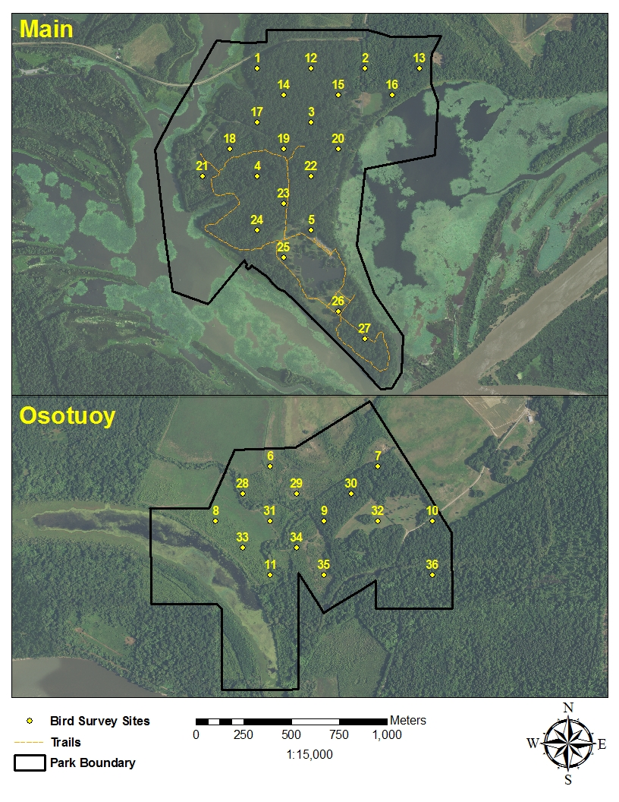

**Figure A1.** Heartland Inventory and Monitoring Network Bird Monitoring Sites at Arkansas Post National Memorial, Arkansas.

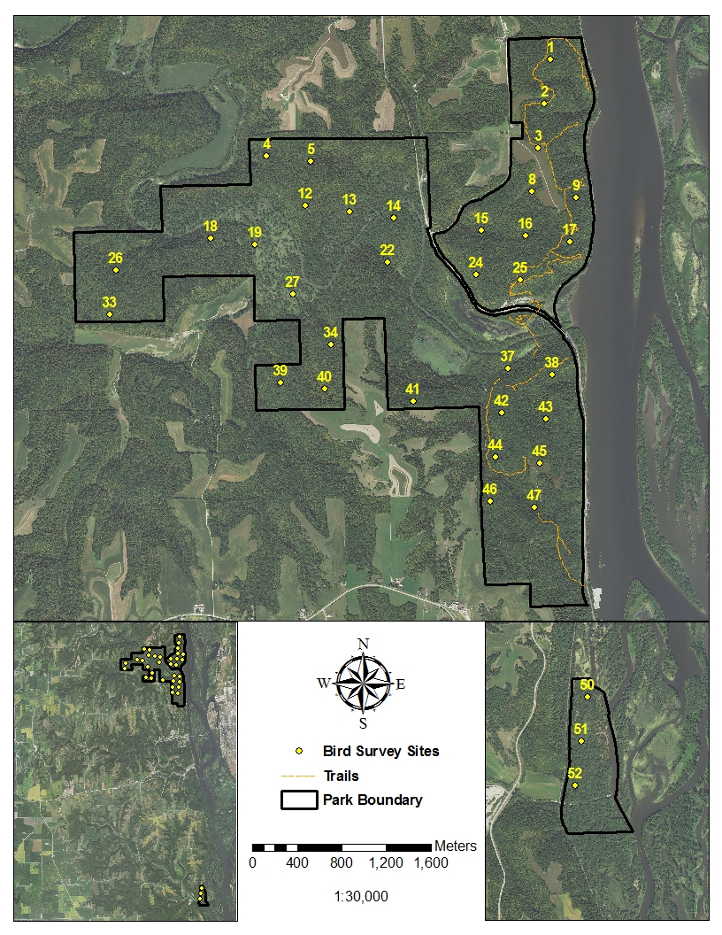

**Figure A2.** Heartland Inventory and Monitoring Network Bird Monitoring Sites at Effigy Mounds National Monument, Iowa.

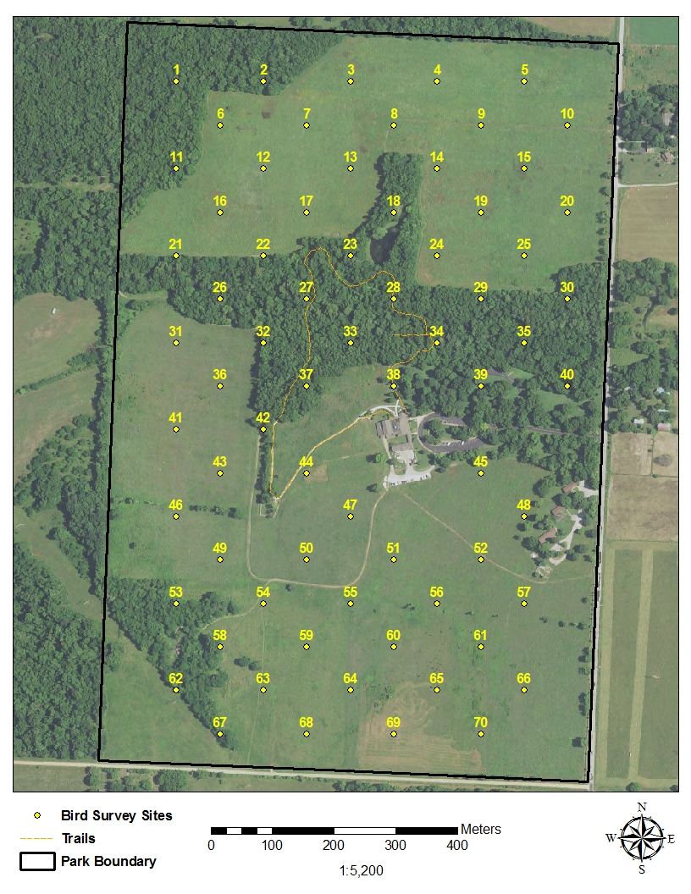

**Figure A3.** Heartland Inventory and Monitoring Network Bird Monitoring Sites at George Washington Carver National Monument, Missouri.

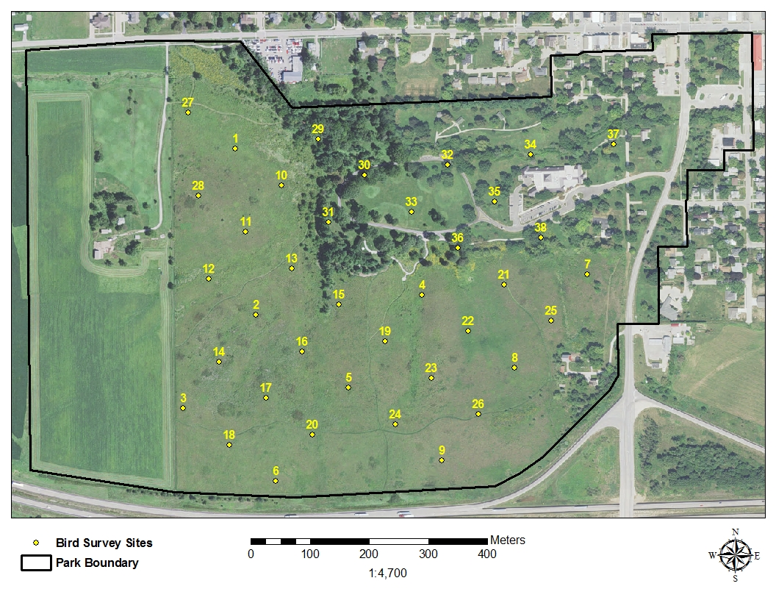

**Figure A4.** Heartland Inventory and Monitoring Network Bird Monitoring Sites at Herbert Hoover National Historic Site, Iowa.

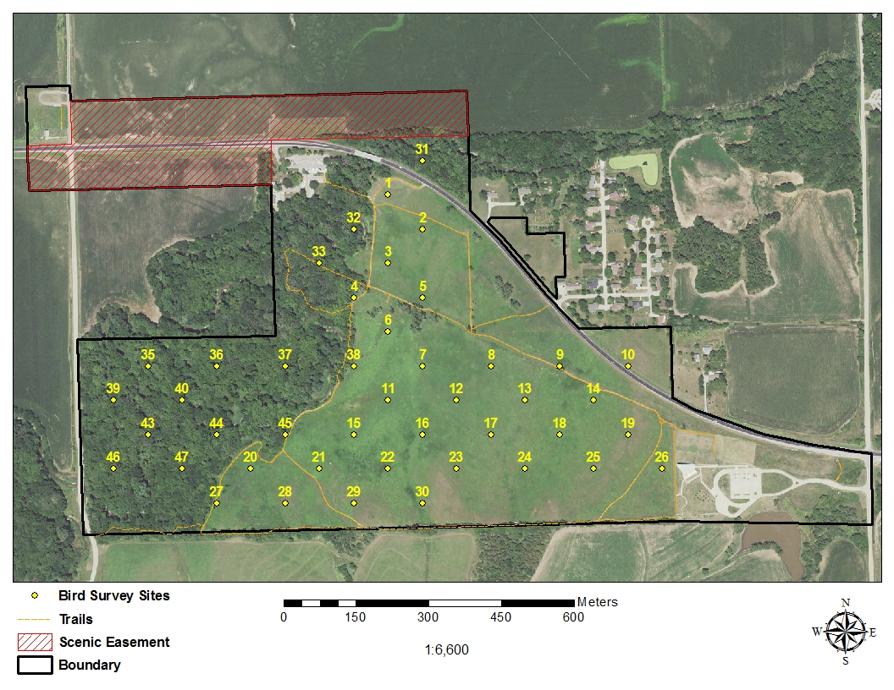

**Figure A5.** Heartland Inventory and Monitoring Network Bird Monitoring Sites at Homestead National Monument of America, Nebraska.

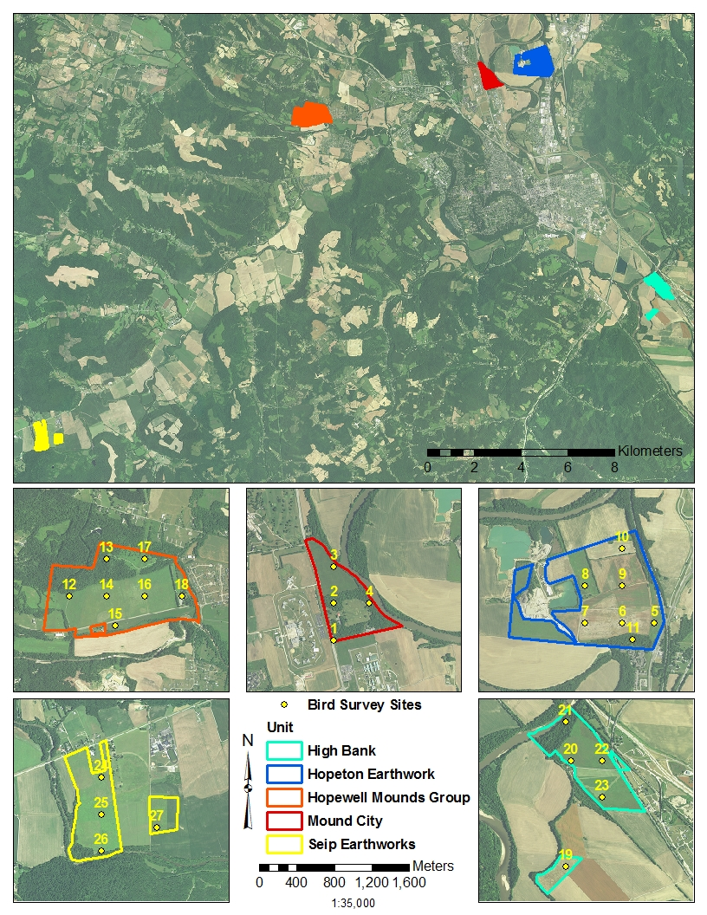

**Figure A6.** Heartland Inventory and Monitoring Network Bird Monitoring Sites at Hopewell Culture National Historical Park, Ohio.

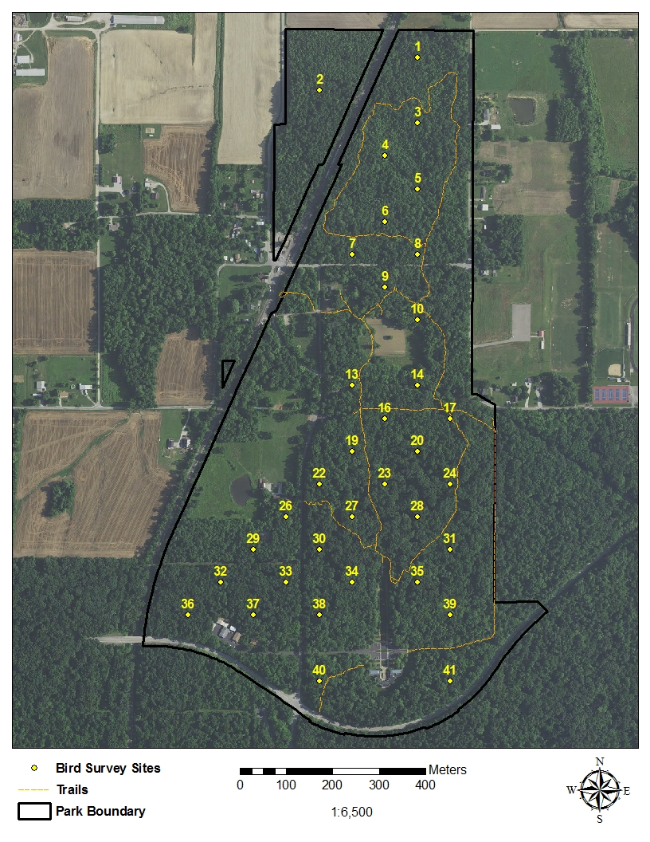

**Figure A7.** Heartland Inventory and Monitoring Network Bird Monitoring Sites at Lincoln Boyhood National Memorial, Indiana.

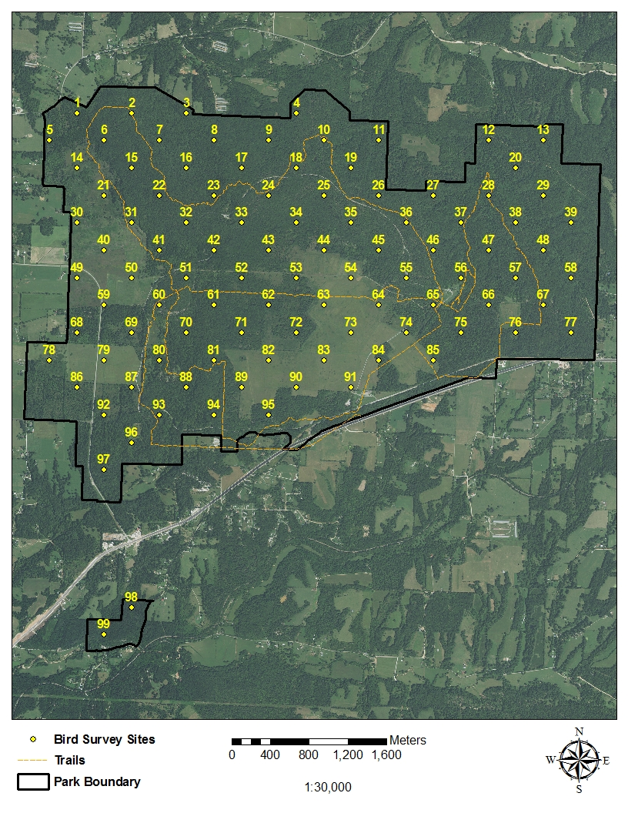

**Figure A8.** Heartland Inventory and Monitoring Network Bird Monitoring Sites at Pea Ridge National Military Park, Arkansas.

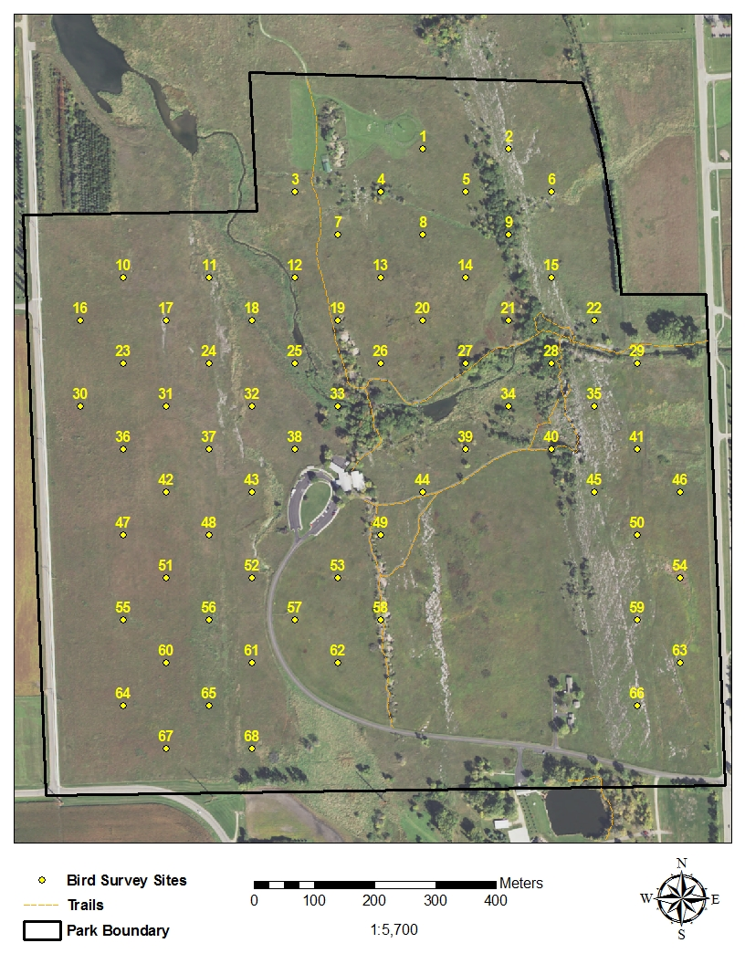

**Figure A9.** Heartland Inventory and Monitoring Network Bird Monitoring Sites at Pipestone National Monument, Minnesota.

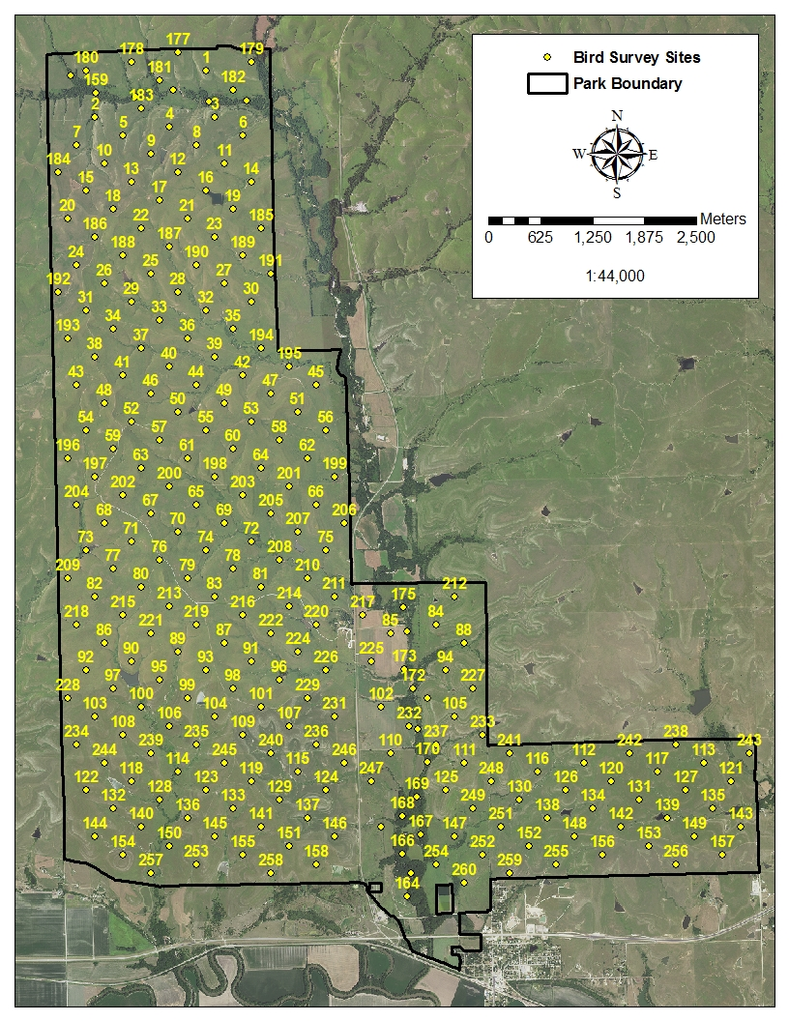

**Figure A10.** Heartland Inventory and Monitoring Network Bird Monitoring Sites at Tallgrass Prairie National Preserve, Kansas.

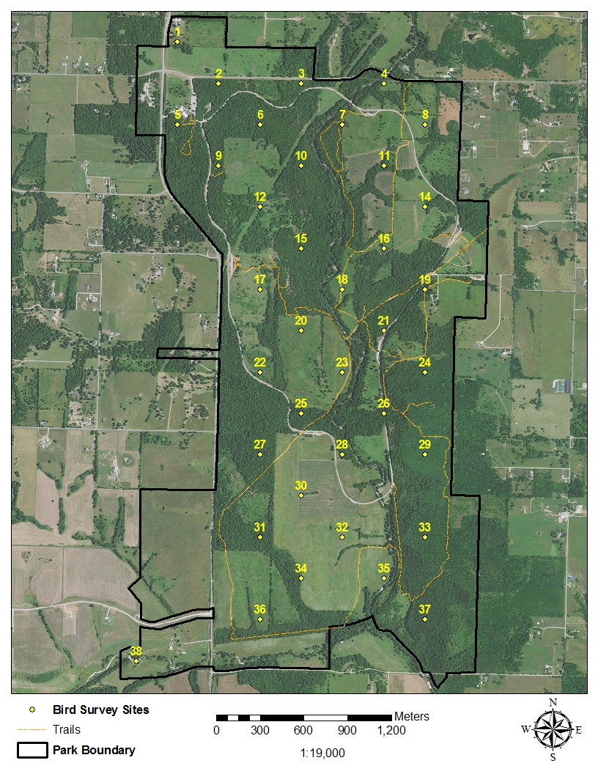

**Figure A11.** Heartland Inventory and Monitoring Network Bird Monitoring Sites at Wilson’s Creek National Battlefield, Missouri.

## Appendix B. Waypoints for Heartland Inventory and Monitoring Network Bird Monitoring Sites, by Park

**Table B1.** Waypoints for Arkansas Post National Memorial, Arkansas - UTM Zone 15 North Datum 1983 (Conus).

|  |  |  |  |
| --- | --- | --- | --- |
| Plot I.D | X Coordinate (Easting) | Y Coordinate (Northing) | Inventory I.D. Number |
| ARPOTweety1 | 652413.656 | 3766221.835 | ARPO_1 |
| ARPOTweety2 | 652979.342 | 3766221.835 | ARPO_2 |
| ARPOTweety3 | 652696.499 | 3765938.992 | ARPO_3 |
| ARPOTweety4 | 652413.656 | 3765656.149 | ARPO_4 |
| ARPOTweety5 | 652696.499 | 3765373.306 | ARPO_5 |
| ARPOTweety6 | 660050.410 | 3761979.194 | ARPO_6 |
| ARPOTweety7 | 660616.095 | 3761979.194 | ARPO_7 |
| ARPOTweety8 | 659767.567 | 3761696.351 | ARPO_8 |
| ARPOTweety9 | 660333.252 | 3761696.351 | ARPO_9 |
| ARPOTweety10 | 660898.938 | 3761696.351 | ARPO_10 |
| ARPOTweety11 | 660050.410 | 3761413.508 | ARPO_11 |
| ARPOTweety12 | 652696.499 | 3766221.835 | ARPO_12 |
| ARPOTweety13 | 653262.184 | 3766221.835 | ARPO_13 |
| ARPOTweety14 | 652555.078 | 3766080.413 | ARPO_14 |
| ARPOTweety15 | 652837.920 | 3766080.413 | ARPO_15 |
| ARPOTweety16 | 653120.763 | 3766080.413 | ARPO_16 |
| ARPOTweety17 | 652413.656 | 3765938.992 | ARPO_17 |
| ARPOTweety18 | 652272.235 | 3765797.571 | ARPO_18 |
| ARPOTweety19 | 652555.078 | 3765797.571 | ARPO_19 |
| ARPOTweety20 | 652837.920 | 3765797.571 | ARPO_20 |
| ARPOTweety21 | 652130.814 | 3765656.149 | ARPO_21 |
| ARPOTweety22 | 652696.499 | 3765656.149 | ARPO_22 |
| ARPOTweety23 | 652555.078 | 3765514.728 | ARPO_23 |
| ARPOTweety24 | 652413.656 | 3765373.306 | ARPO_24 |
| ARPOTweety25 | 652555.078 | 3765231.885 | ARPO_25 |
| ARPOTweety26 | 652837.920 | 3764949.042 | ARPO_26 |
| ARPOTweety27 | 652979.342 | 3764807.621 | ARPO_27 |
| ARPOTweety28 | 659908.988 | 3761837.773 | ARPO_28 |
| ARPOTweety29 | 660191.831 | 3761837.773 | ARPO_29 |
| ARPOTweety30 | 660474.674 | 3761837.773 | ARPO_30 |
| ARPOTweety31 | 660050.410 | 3761696.351 | ARPO_31 |
| ARPOTweety32 | 660616.095 | 3761696.351 | ARPO_32 |
| ARPOTweety33 | 659908.988 | 3761554.930 | ARPO_33 |
| ARPOTweety34 | 660191.831 | 3761554.930 | ARPO_34 |
| ARPOTweety35 | 660333.252 | 3761413.508 | ARPO_35 |
| ARPOTweety36 | 660898.938 | 3761413.508 | ARPO_36 |

**Table B2.** Waypoints for Effigy Mounds National Monument, Iowa – UTM Zone 15 North, Datum 1983 (Conus).

|  |  |  |  |
| --- | --- | --- | --- |
| Plot I.D | X Coordinate (Easting) | Y Coordinate (Northing) | Inventory I.D Number |
| EFMOTweety1 | 647837.313 | 4774424.000 | EFMO_1 |
| EFMOTweety2 | 647783.375 | 4774027.500 | EFMO_2 |
| EFMOTweety3 | 647729.438 | 4773631.000 | EFMO_3 |
| EFMOTweety4 | 645297.438 | 4773558.500 | EFMO_4 |
| EFMOTweety5 | 645693.813 | 4773504.500 | EFMO_5 |
| EFMOTweety6 | Not Sampled* | | EFMO_6 |
| EFMOTweety7 | Not Sampled | | EFMO_7 |
| EFMOTweety8 | 647675.563 | 4773235.000 | EFMO_8 |
| EFMOTweety9 | 648071.875 | 4773181.000 | EFMO_9 |
| EFMOTweety10 | Not Sampled | | EFMO_10 |
| EFMOTweety11 | Not Sampled | | EFMO_11 |
| EFMOTweety12 | 645639.875 | 4773108.000 | EFMO_12 |
| EFMOTweety13 | 646036.250 | 4773054.000 | EFMO_13 |
| EFMOTweety14 | 646432.563 | 4773000.000 | EFMO_14 |
| EFMOTweety15 | 647225.313 | 4772892.500 | EFMO_15 |
| EFMOTweety16 | 647621.625 | 4772838.500 | EFMO_16 |
| EFMOTweety17 | 648018.000 | 4772784.500 | EFMO_17 |
| EFMOTweety18 | 644793.250 | 4772819.500 | EFMO_18 |
| EFMOTweety19 | 645189.625 | 4772765.500 | EFMO_19 |
| EFMOTweety20 | Not Sampled | | EFMO_20 |
| EFMOTweety21 | Not Sampled | | EFMO_21 |
| EFMOTweety22 | 646378.688 | 4772604.000 | EFMO_22 |
| EFMOTweety23 | Not Sampled | | EFMO_23 |
| EFMOTweety24 | 647171.375 | 4772496.000 | EFMO_24 |
| EFMOTweety25 | 647567.750 | 4772442.000 | EFMO_25 |
| EFMOTweety26 | 643946.688 | 4772531.000 | EFMO_26 |
| EFMOTweety27 | 645532.063 | 4772315.500 | EFMO_27 |
| EFMOTweety28 | Not Sampled | | EFMO_28 |
| EFMOTweety29 | Not Sampled | | EFMO_29 |
| EFMOTweety30 | Not Sampled | | EFMO_30 |
| EFMOTweety31 | Not Sampled | | EFMO_31 |
| EFMOTweety32 | Not Sampled | | EFMO_32 |
| EFMOTweety33 | 643892.750 | 4772134.500 | EFMO_33 |
| EFMOTweety34 | 645874.500 | 4771865.000 | EFMO_34 |
| EFMOTweety35 | Not Sampled | | EFMO_35 |
| EFMOTweety36 | Not Sampled | | EFMO_36 |
| EFMOTweety37 | 647459.938 | 4771649.500 | EFMO_37 |
| EFMOTweety38 | 647856.250 | 4771595.500 | EFMO_38 |
| EFMOTweety39 | 645424.250 | 4771522.500 | EFMO_39 |
| EFMOTweety40 | 645820.625 | 4771468.500 | EFMO_40 |
| EFMOTweety41 | 646613.313 | 4771361.000 | EFMO_41 |
| EFMOTweety42 | 647406.000 | 4771253.000 | EFMO_42 |
| EFMOTweety43 | 647802.375 | 4771199.000 | EFMO_43 |
| EFMOTweety44 | 647352.063 | 4770856.500 | EFMO_44 |
| EFMOTweety45 | 647748.438 | 4770803.000 | EFMO_45 |
| EFMOTweety46 | 647298.188 | 4770460.500 | EFMO_46 |
| EFMOTweety47 | 647694.563 | 4770406.500 | EFMO_47 |
| EFMOTweety48 | Not Sampled | | EFMO_48 |
| EFMOTweety49 | Not Sampled | | EFMO_49 |
| EFMOTweety50 | 649428.607 | 4756445.473 | EFMO_50 |
| EFMOTweety51 | 649374.693 | 4756049.123 | EFMO_51 |
| EFMOTweety52 | 649320.780 | 4755652.773 | EFMO_52 |

**\***Denotes plots that were drop from sampling consideration in 2009 because they were in the Yellow River, Founders Pond, on slopes > 40%, or in culturally sensitive areas.

**Table B3.** Waypoints for George Washington Carver National Monument, Missouri – UTM Zone 15 North, Datum 1983 (Conus).

|  |  |  |  |
| --- | --- | --- | --- |
| Plot I.D. | X Coordinate (Easting) | Y Coordinate (Northing) | Inventory I.D. Number |
| GWCATweety1 | 379070.421 | 4094759.924 | GWCA_1 |
| GWCATweety2 | 379211.842 | 4094759.924 | GWCA_2 |
| GWCATweety3 | 379353.263 | 4094759.924 | GWCA_3 |
| GWCATweety4 | 379494.685 | 4094759.924 | GWCA_4 |
| GWCATweety5 | 379636.106 | 4094759.924 | GWCA_5 |
| GWCATweety6 | 379141.131 | 4094689.214 | GWCA_6 |
| GWCATweety7 | 379282.553 | 4094689.214 | GWCA_7 |
| GWCATweety8 | 379423.974 | 4094689.214 | GWCA_8 |
| GWCATweety9 | 379565.395 | 4094689.214 | GWCA_9 |
| GWCATweety10 | 379706.817 | 4094689.214 | GWCA_10 |
| GWCATweety11 | 379070.421 | 4094618.503 | GWCA_11 |
| GWCATweety12 | 379211.842 | 4094618.503 | GWCA_12 |
| GWCATweety13 | 379353.263 | 4094618.503 | GWCA_13 |
| GWCATweety14 | 379494.685 | 4094618.503 | GWCA_14 |
| GWCATweety15 | 379636.106 | 4094618.503 | GWCA_15 |
| GWCATweety16 | 379141.131 | 4094547.792 | GWCA_16 |
| GWCATweety17 | 379282.553 | 4094547.792 | GWCA_17 |
| GWCATweety18 | 379423.974 | 4094547.792 | GWCA_18 |
| GWCATweety19 | 379565.395 | 4094547.792 | GWCA_19 |
| GWCATweety20 | 379706.817 | 4094547.792 | GWCA_20 |
| GWCATweety21 | 379070.421 | 4094477.082 | GWCA_21 |
| GWCATweety22 | 379211.842 | 4094477.082 | GWCA_22 |
| GWCATweety23 | 379353.263 | 4094477.082 | GWCA_23 |
| GWCATweety24 | 379494.685 | 4094477.082 | GWCA_24 |
| GWCATweety25 | 379636.106 | 4094477.082 | GWCA_25 |
| GWCATweety26 | 379141.131 | 4094406.371 | GWCA_26 |
| GWCATweety27 | 379282.553 | 4094406.371 | GWCA_27 |
| GWCATweety28 | 379423.974 | 4094406.371 | GWCA_28 |
| GWCATweety29 | 379565.395 | 4094406.371 | GWCA_29 |
| GWCATweety30 | 379706.817 | 4094406.371 | GWCA_30 |
| GWCATweety31 | 379070.421 | 4094335.660 | GWCA_31 |
| GWCATweety32 | 379211.842 | 4094335.660 | GWCA_32 |
| GWCATweety33 | 379353.263 | 4094335.660 | GWCA_33 |
| GWCATweety34 | 379494.685 | 4094335.660 | GWCA_34 |
| GWCATweety35 | 379636.106 | 4094335.660 | GWCA_35 |
| GWCATweety36 | 379141.131 | 4094264.949 | GWCA_36 |
| GWCATweety37 | 379282.553 | 4094264.949 | GWCA_37 |
| GWCATweety38 | 379423.974 | 4094264.949 | GWCA_38 |
| GWCATweety39 | 379565.395 | 4094264.949 | GWCA_39 |
| GWCATweety40 | 379706.817 | 4094264.949 | GWCA_40 |
| GWCATweety41 | 379070.421 | 4094194.239 | GWCA_41 |
| GWCATweety42 | 379211.842 | 4094194.239 | GWCA_42 |
| GWCATweety43 | 379141.131 | 4094123.528 | GWCA_43 |
| GWCATweety44 | 379282.553 | 4094123.528 | GWCA_44 |
| GWCATweety45 | 379565.395 | 4094123.528 | GWCA_45 |
| GWCATweety46 | 379070.421 | 4094052.817 | GWCA_46 |
| GWCATweety47 | 379353.263 | 4094052.817 | GWCA_47 |
| GWCATweety48 | 379636.106 | 4094052.817 | GWCA_48 |
| GWCATweety49 | 379141.131 | 4093982.107 | GWCA_49 |
| GWCATweety50 | 379282.553 | 4093982.107 | GWCA_50 |
| GWCATweety51 | 379423.974 | 4093982.107 | GWCA_51 |
| GWCATweety52 | 379565.395 | 4093982.107 | GWCA_52 |
| GWCATweety53 | 379070.421 | 4093911.396 | GWCA_53 |
| GWCATweety54 | 379211.842 | 4093911.396 | GWCA_54 |
| GWCATweety55 | 379353.263 | 4093911.396 | GWCA_55 |
| GWCATweety56 | 379494.685 | 4093911.396 | GWCA_56 |
| GWCATweety57 | 379636.106 | 4093911.396 | GWCA_57 |
| GWCATweety58 | 379141.131 | 4093840.685 | GWCA_58 |
| GWCATweety59 | 379282.553 | 4093840.685 | GWCA_59 |
| GWCATweety60 | 379423.974 | 4093840.685 | GWCA_60 |
| GWCATweety61 | 379565.395 | 4093840.685 | GWCA_61 |
| GWCATweety62 | 379070.421 | 4093769.975 | GWCA_62 |
| GWCATweety63 | 379211.842 | 4093769.975 | GWCA_63 |
| GWCATweety64 | 379353.263 | 4093769.975 | GWCA_64 |
| GWCATweety65 | 379494.685 | 4093769.975 | GWCA_65 |
| GWCATweety66 | 379636.106 | 4093769.975 | GWCA_66 |
| GWCATweety67 | 379141.131 | 4093699.264 | GWCA_67 |
| GWCATweety68 | 379282.553 | 4093699.264 | GWCA_68 |
| GWCATweety69 | 379423.974 | 4093699.264 | GWCA_69 |
| GWCATweety70 | 379565.395 | 4093699.264 | GWCA_70 |

**Table B4.** Waypoints for Herbert Hoover National Historic Site, Iowa – UTM Zone 15 North, Datum 1983 (Conus).

|  |  |  |  |
| --- | --- | --- | --- |
| Plot I.D. | X Coordinate (Easting) | Y Coordinate (Northing) | Inventory I.D. Number |
| HEHOTweety1 | 636971.393 | 4614410.700 | HEHO_1 |
| HEHOTweety2 | 637005.863 | 4614129.966 | HEHO_2 |
| HEHOTweety3 | 636882.731 | 4613972.364 | HEHO_3 |
| HEHOTweety4 | 637286.597 | 4614164.436 | HEHO_4 |
| HEHOTweety5 | 637163.465 | 4614006.834 | HEHO_5 |
| HEHOTweety6 | 637040.333 | 4613849.232 | HEHO_6 |
| HEHOTweety7 | 637567.332 | 4614198.906 | HEHO_7 |
| HEHOTweety8 | 637444.200 | 4614041.303 | HEHO_8 |
| HEHOTweety9 | 637321.067 | 4613883.701 | HEHO_9 |
| HEHOTweety10 | 637050.194 | 4614349.134 | HEHO_10 |
| HEHOTweety11 | 636988.628 | 4614270.333 | HEHO_11 |
| HEHOTweety12 | 636927.062 | 4614191.532 | HEHO_12 |
| HEHOTweety13 | 637067.429 | 4614208.767 | HEHO_13 |
| HEHOTweety14 | 636944.297 | 4614051.165 | HEHO_14 |
| HEHOTweety15 | 637146.230 | 4614147.201 | HEHO_15 |
| HEHOTweety16 | 637084.664 | 4614068.400 | HEHO_16 |
| HEHOTweety17 | 637023.098 | 4613989.599 | HEHO_17 |
| HEHOTweety18 | 636961.532 | 4613910.798 | HEHO_18 |
| HEHOTweety19 | 637225.031 | 4614085.635 | HEHO_19 |
| HEHOTweety20 | 637101.899 | 4613928.033 | HEHO_20 |
| HEHOTweety21 | 637426.965 | 4614181.671 | HEHO_21 |
| HEHOTweety22 | 637365.399 | 4614102.870 | HEHO_22 |
| HEHOTweety23 | 637303.832 | 4614024.069 | HEHO_23 |
| HEHOTweety24 | 637242.266 | 4613945.268 | HEHO_24 |
| HEHOTweety25 | 637505.766 | 4614120.105 | HEHO_25 |
| HEHOTweety26 | 637382.633 | 4613962.502 | HEHO_26 |
| HEHOTweety27 | 636892.592 | 4614472.267 | HEHO_27 |
| HEHOTweety28 | 636909.827 | 4614331.899 | HEHO_28 |
| HEHOTweety29 | 637111.760 | 4614427.935 | HEHO_29 |
| HEHOTweety30 | 637190.561 | 4614366.369 | HEHO_30 |
| HEHOTweety31 | 637128.995 | 4614287.568 | HEHO_31 |
| HEHOTweety32 | 637330.929 | 4614383.604 | HEHO_32 |
| HEHOTweety33 | 637269.363 | 4614304.803 | HEHO_33 |
| HEHOTweety34 | 637471.296 | 4614400.839 | HEHO_34 |
| HEHOTweety35 | 637409.730 | 4614322.038 | HEHO_35 |
| HEHOTweety36 | 637348.164 | 4614243.237 | HEHO_36 |
| HEHOTweety37 | 637611.663 | 4614418.074 | HEHO_37 |
| HEHOTweety38 | 637488.531 | 4614260.472 | HEHO_38 |

**Table B5.** Waypoints for Homestead National Monument of America, Nebraska – UTM Zone 14 North, Datum 1983 (Conus).

|  |  |  |  |
| --- | --- | --- | --- |
| Plot I.D. | X Coordinate (Easting) | Y Coordinate (Northing) | Inventory I.D. Number |
| HOMETweety1 | 684124.165 | 4462295.543 | HOME_1 |
| HOMETweety2 | 684194.876 | 4462224.832 | HOME_2 |
| HOMETweety3 | 684124.165 | 4462154.122 | HOME_3 |
| HOMETweety4 | 684053.455 | 4462083.411 | HOME_4 |
| HOMETweety5 | 684194.876 | 4462083.411 | HOME_5 |
| HOMETweety6 | 684124.165 | 4462012.701 | HOME_6 |
| HOMETweety7 | 684194.876 | 4461941.990 | HOME_7 |
| HOMETweety8 | 684336.297 | 4461941.990 | HOME_8 |
| HOMETweety9 | 684477.719 | 4461941.990 | HOME_9 |
| HOMETweety10 | 684619.140 | 4461941.990 | HOME_10 |
| HOMETweety11 | 684124.165 | 4461871.279 | HOME_11 |
| HOMETweety12 | 684265.587 | 4461871.279 | HOME_12 |
| HOMETweety13 | 684407.008 | 4461871.279 | HOME_13 |
| HOMETweety14 | 684548.430 | 4461871.279 | HOME_14 |
| HOMETweety15 | 684053.455 | 4461800.568 | HOME_15 |
| HOMETweety16 | 684194.876 | 4461800.568 | HOME_16 |
| HOMETweety17 | 684336.297 | 4461800.568 | HOME_17 |
| HOMETweety18 | 684477.719 | 4461800.568 | HOME_18 |
| HOMETweety19 | 684619.140 | 4461800.568 | HOME_19 |
| HOMETweety20 | 683841.323 | 4461729.858 | HOME_20 |
| HOMETweety21 | 683982.744 | 4461729.858 | HOME_21 |
| HOMETweety22 | 684124.165 | 4461729.858 | HOME_22 |
| HOMETweety23 | 684265.587 | 4461729.858 | HOME_23 |
| HOMETweety24 | 684407.008 | 4461729.858 | HOME_24 |
| HOMETweety25 | 684548.429 | 4461729.858 | HOME_25 |
| HOMETweety26 | 684689.851 | 4461729.858 | HOME_26 |
| HOMETweety27 | 683770.612 | 4461659.147 | HOME_27 |
| HOMETweety28 | 683912.033 | 4461659.147 | HOME_28 |
| HOMETweety29 | 684053.455 | 4461659.147 | HOME_29 |
| HOMETweety30 | 684194.876 | 4461659.147 | HOME_30 |
| HOMETweety31 | 684194.876 | 4462366.254 | HOME_31 |
| HOMETweety32 | 684053.455 | 4462224.832 | HOME_32 |
| HOMETweety33 | 683982.744 | 4462154.122 | HOME_33 |
| HOMETweety34 | Not Sampled* | | HOME_34 |
| HOMETweety35 | 683629.191 | 4461941.990 | HOME_35 |
| HOMETweety36 | 683770.612 | 4461941.990 | HOME_36 |
| HOMETweety37 | 683912.033 | 4461941.990 | HOME_37 |
| HOMETweety38 | 684053.455 | 4461941.990 | HOME_38 |
| HOMETweety39 | 683558.480 | 4461871.279 | HOME_39 |
| HOMETweety40 | 683699.901 | 4461871.279 | HOME_40 |
| HOMETweety41 | Not Sampled | | HOME_41 |
| HOMETweety42 | Not Sampled | | HOME_42 |
| HOMETweety43 | 683629.191 | 4461800.568 | HOME_43 |
| HOMETweety44 | 683770.612 | 4461800.568 | HOME_44 |
| HOMETweety45 | 683912.033 | 4461800.568 | HOME_45 |
| HOMETweety46 | 683558.480 | 4461729.858 | HOME_46 |
| HOMETweety47 | 683699.901 | 4461729.858 | HOME_47 |
| HOMETweety48 | Not Sampled | | HOME_48 |

* Denotes plots that were drop from sampling consideration in 2009 because they are in Cub Creek.

**Table B6.** Waypoints for Hopewell Cultural National Historical Park, Ohio – UTM Zone 17 North, Datum 1983 (Conus).

|  |  |  |  |
| --- | --- | --- | --- |
| Plot I.D. | X Coordinate (Easting) | Y Coordinate (Northing) | Inventory I.D. Number |
| HOCUTweety1 | 327116.650 | 4360162.840 | MCVCP1 |
| HOCUTweety2 | 327116.650 | 4360562.010 | MCVCP2 |
| HOCUTweety3 | 327116.650 | 4360953.620 | MCVCP4 |
| HOCUTweety4 | 327503.720 | 4360562.010 | MCVCP3 |
| HOCUTweety5 | 329876.420 | 4360965.010 | HTVCP1 |
| HOCUTweety6 | 329534.060 | 4360965.010 | HTVCP2 |
| HOCUTweety7 | 329135.980 | 4360965.010 | HTVCP3 |
| HOCUTweety8 | 329135.980 | 4361364.530 | HTVCP5 |
| HOCUTweety9 | 329534.060 | 4361364.530 | HTVCP6 |
| HOCUTweety10 | 329534.060 | 4361765.480 | HTVCP7 |
| HOCUTweety11 | 329648.180 | 4360790.860 | HTVCP8 |
| HOCUTweety12 | 319135.000 | 4358980.000 | HWVCP1 |
| HOCUTweety13 | 319534.000 | 4359380.000 | HWVCP2 |
| HOCUTweety14 | 319534.000 | 4358980.000 | HWVCP3 |
| HOCUTweety15 | 319625.000 | 4358670.000 | HWVCP4 |
| HOCUTweety16 | 319933.000 | 4358980.000 | HWVCP5 |
| HOCUTweety17 | 319933.000 | 4359380.000 | HWVCP6 |
| HOCUTweety18 | 320332.000 | 4358980.000 | HWVCP7 |
| HOCUTweety19 | 334310.530 | 4350593.650 | HBVCP1 |
| HOCUTweety20 | 334364.530 | 4351727.860 | HBVCP3 |
| HOCUTweety21 | 334310.530 | 4352141.990 | HBVCP4 |
| HOCUTweety22 | 334693.860 | 4351727.860 | HBVCP5 |
| HOCUTweety23 | 334693.860 | 4351337.690 | HBVCP6 |
| HOCUTweety24 | 308213.000 | 4345591.000 | SPVCP1 |
| HOCUTweety25 | 308213.000 | 4345192.000 | SPVCP2 |
| HOCUTweety26 | 308213.000 | 4344810.000 | SPVCP3 |
| HOCUTweety27 | 308802.000 | 4345059.999 | SPVCP4 |

**Table B7.** Waypoints for Lincoln Boyhood National Memorial, Indiana – UTM Zone 16 North, Datum 1983 (Conus).

|  |  |  |  |
| --- | --- | --- | --- |
| Plot I.D. | X Coordinate (Easting) | Y Coordinate (Northing) | Inventory I.D. Number |
| LIBOTweety1 | 500432.278 | 4219695.381 | LIBO_1 |
| LIBOTweety2 | 500220.146 | 4219624.671 | LIBO_2 |
| LIBOTweety3 | 500432.278 | 4219553.960 | LIBO_3 |
| LIBOTweety4 | 500361.567 | 4219483.249 | LIBO_4 |
| LIBOTweety5 | 500432.278 | 4219412.539 | LIBO_5 |
| LIBOTweety6 | 500361.567 | 4219341.828 | LIBO_6 |
| LIBOTweety7 | 500290.856 | 4219271.117 | LIBO_7 |
| LIBOTweety8 | 500432.278 | 4219271.117 | LIBO_8 |
| LIBOTweety9 | 500361.567 | 4219200.407 | LIBO_9 |
| LIBOTweety10 | 500432.278 | 4219129.696 | LIBO_10 |
| LIBOTweety11 | Not Sampled* | | LIBO_11 |
| LIBOTweety12 | Not Sampled | | LIBO_12 |
| LIBOTweety13 | 500290.856 | 4218988.274 | LIBO_13 |
| LIBOTweety14 | 500432.278 | 4218988.274 | LIBO_14 |
| LIBOTweety15 | Not Sampled | | LIBO_15 |
| LIBOTweety16 | 500361.567 | 4218917.564 | LIBO_16 |
| LIBOTweety17 | 500502.988 | 4218917.564 | LIBO_17 |
| LIBOTweety18 | Not Sampled | | LIBO_18 |
| LIBOTweety19 | 500290.856 | 4218846.853 | LIBO_19 |
| LIBOTweety20 | 500432.278 | 4218846.853 | LIBO_20 |
| LIBOTweety21 | Not Sampled | | LIBO_21 |
| LIBOTweety22 | 500220.146 | 4218776.142 | LIBO_22 |
| LIBOTweety23 | 500361.567 | 4218776.142 | LIBO_23 |
| LIBOTweety24 | 500502.988 | 4218776.142 | LIBO_24 |
| LIBOTweety25 | Not Sampled | | LIBO_25 |
| LIBOTweety26 | 500149.435 | 4218705.432 | LIBO_26 |
| LIBOTweety27 | 500290.856 | 4218705.432 | LIBO_27 |
| LIBOTweety28 | 500432.278 | 4218705.432 | LIBO_28 |
| LIBOTweety29 | 500078.724 | 4218634.721 | LIBO_29 |
| LIBOTweety30 | 500220.146 | 4218634.721 | LIBO_30 |
| LIBOTweety31 | 500502.988 | 4218634.721 | LIBO_31 |
| LIBOTweety32 | 500008.014 | 4218564.010 | LIBO_32 |
| LIBOTweety33 | 500149.435 | 4218564.010 | LIBO_33 |
| LIBOTweety34 | 500290.856 | 4218564.010 | LIBO_34 |
| LIBOTweety35 | 500432.278 | 4218564.010 | LIBO_35 |
| LIBOTweety36 | 499937.303 | 4218493.300 | LIBO_36 |
| LIBOTweety37 | 500078.724 | 4218493.300 | LIBO_37 |
| LIBOTweety38 | 500220.146 | 4218493.300 | LIBO_38 |
| LIBOTweety39 | 500502.988 | 4218493.300 | LIBO_39 |
| LIBOTweety40 | 500220.146 | 4218351.878 | LIBO_40 |
| LIBOTweety41 | 500502.988 | 4218351.878 | LIBO_41 |

* Denotes plots that were drop from sampling consideration in 2007 because they are in culturally sensitive areas.

**Table B8.** Waypoints for Pea Ridge National Military Park, Arkansas – UTM Zone 15 North, Datum 1983 (Conus).

|  |  |  |  |
| --- | --- | --- | --- |
| Plot I.D. | X Coordinate (Easting) | Y Coordinate (Northing) | Inventory I.D. Number |
| PERITweety1 | 405072.520 | 4036536.798 | PERI_1 |
| PERITweety2 | 405638.205 | 4036536.798 | PERI_2 |
| PERITweety3 | 406203.891 | 4036536.798 | PERI_3 |
| PERITweety4 | 407335.262 | 4036536.798 | PERI_4 |
| PERITweety5 | 404789.677 | 4036253.955 | PERI_5 |
| PERITweety6 | 405355.363 | 4036253.955 | PERI_6 |
| PERITweety7 | 405921.048 | 4036253.955 | PERI_7 |
| PERITweety8 | 406486.733 | 4036253.955 | PERI_8 |
| PERITweety9 | 407052.419 | 4036253.955 | PERI_9 |
| PERITweety10 | 407618.104 | 4036253.955 | PERI_10 |
| PERITweety11 | 408183.790 | 4036253.955 | PERI_11 |
| PERITweety12 | 409315.161 | 4036253.955 | PERI_12 |
| PERITweety13 | 409880.846 | 4036253.955 | PERI_13 |
| PERITweety14 | 405072.520 | 4035971.112 | PERI_14 |
| PERITweety15 | 405638.205 | 4035971.112 | PERI_15 |
| PERITweety16 | 406203.891 | 4035971.112 | PERI_16 |
| PERITweety17 | 406769.576 | 4035971.112 | PERI_17 |
| PERITweety18 | 407335.262 | 4035971.112 | PERI_18 |
| PERITweety19 | 407900.947 | 4035971.112 | PERI_19 |
| PERITweety20 | 409598.003 | 4035971.112 | PERI_20 |
| PERITweety21 | 405355.363 | 4035688.269 | PERI_21 |
| PERITweety22 | 405921.048 | 4035688.269 | PERI_22 |
| PERITweety23 | 406486.733 | 4035688.269 | PERI_23 |
| PERITweety24 | 407052.419 | 4035688.269 | PERI_24 |
| PERITweety25 | 407618.104 | 4035688.269 | PERI_25 |
| PERITweety26 | 408183.790 | 4035688.269 | PERI_26 |
| PERITweety27 | 408749.475 | 4035688.269 | PERI_27 |
| PERITweety28 | 409315.161 | 4035688.269 | PERI_28 |
| PERITweety29 | 409880.846 | 4035688.269 | PERI_29 |
| PERITweety30 | 405072.520 | 4035405.427 | PERI_30 |
| PERITweety31 | 405638.205 | 4035405.427 | PERI_31 |
| PERITweety32 | 406203.891 | 4035405.427 | PERI_32 |
| PERITweety33 | 406769.576 | 4035405.427 | PERI_33 |
| PERITweety34 | 407335.262 | 4035405.427 | PERI_34 |
| PERITweety35 | 407900.947 | 4035405.427 | PERI_35 |
| PERITweety36 | 408466.632 | 4035405.427 | PERI_36 |
| PERITweety37 | 409032.318 | 4035405.427 | PERI_37 |
| PERITweety38 | 409598.003 | 4035405.427 | PERI_38 |
| PERITweety39 | 410163.689 | 4035405.427 | PERI_39 |
| PERITweety40 | 405355.363 | 4035122.584 | PERI_40 |
| PERITweety41 | 405921.048 | 4035122.584 | PERI_41 |
| PERITweety42 | 406486.733 | 4035122.584 | PERI_42 |
| PERITweety43 | 407052.419 | 4035122.584 | PERI_43 |
| PERITweety44 | 407618.104 | 4035122.584 | PERI_44 |
| PERITweety45 | 408183.790 | 4035122.584 | PERI_45 |
| PERITweety46 | 408749.475 | 4035122.584 | PERI_46 |
| PERITweety47 | 409315.161 | 4035122.584 | PERI_47 |
| PERITweety48 | 409880.846 | 4035122.584 | PERI_48 |
| PERITweety49 | 405072.520 | 4034839.741 | PERI_49 |
| PERITweety50 | 405638.205 | 4034839.741 | PERI_50 |
| PERITweety51 | 406203.891 | 4034839.741 | PERI_51 |
| PERITweety52 | 406769.576 | 4034839.741 | PERI_52 |
| PERITweety53 | 407335.262 | 4034839.741 | PERI_53 |
| PERITweety54 | 407900.947 | 4034839.741 | PERI_54 |
| PERITweety55 | 408466.632 | 4034839.741 | PERI_55 |
| PERITweety56 | 409032.318 | 4034839.741 | PERI_56 |
| PERITweety57 | 409598.003 | 4034839.741 | PERI_57 |
| PERITweety58 | 410163.689 | 4034839.741 | PERI_58 |
| PERITweety59 | 405355.363 | 4034556.899 | PERI_59 |
| PERITweety60 | 405921.048 | 4034556.899 | PERI_60 |
| PERITweety61 | 406486.733 | 4034556.899 | PERI_61 |
| PERITweety62 | 407052.419 | 4034556.899 | PERI_62 |
| PERITweety63 | 407618.104 | 4034556.899 | PERI_63 |
| PERITweety64 | 408183.790 | 4034556.899 | PERI_64 |
| PERITweety65 | 408749.475 | 4034556.899 | PERI_65 |
| PERITweety66 | 409315.161 | 4034556.899 | PERI_66 |
| PERITweety67 | 409880.846 | 4034556.899 | PERI_67 |
| PERITweety68 | 405072.520 | 4034274.056 | PERI_68 |
| PERITweety69 | 405638.205 | 4034274.056 | PERI_69 |
| PERITweety70 | 406203.891 | 4034274.056 | PERI_70 |
| PERITweety71 | 406769.576 | 4034274.056 | PERI_71 |
| PERITweety72 | 407335.262 | 4034274.056 | PERI_72 |
| PERITweety73 | 407900.947 | 4034274.056 | PERI_73 |
| PERITweety74 | 408466.632 | 4034274.056 | PERI_74 |
| PERITweety75 | 409032.318 | 4034274.056 | PERI_75 |
| PERITweety76 | 409598.003 | 4034274.056 | PERI_76 |
| PERITweety77 | 410163.689 | 4034274.056 | PERI_77 |
| PERITweety78 | 404789.677 | 4033991.213 | PERI_78 |
| PERITweety79 | 405355.363 | 4033991.213 | PERI_79 |
| PERITweety80 | 405921.048 | 4033991.213 | PERI_80 |
| PERITweety81 | 406486.733 | 4033991.213 | PERI_81 |
| PERITweety82 | 407052.419 | 4033991.213 | PERI_82 |
| PERITweety83 | 407618.104 | 4033991.213 | PERI_83 |
| PERITweety84 | 408183.790 | 4033991.213 | PERI_84 |
| PERITweety85 | 408749.475 | 4033991.213 | PERI_85 |
| PERITweety86 | 405072.520 | 4033708.370 | PERI_86 |
| PERITweety87 | 405638.205 | 4033708.370 | PERI_87 |
| PERITweety88 | 406203.891 | 4033708.370 | PERI_88 |
| PERITweety89 | 406769.576 | 4033708.370 | PERI_89 |
| PERITweety90 | 407335.262 | 4033708.370 | PERI_90 |
| PERITweety91 | 407900.947 | 4033708.370 | PERI_91 |
| PERITweety92 | 405355.363 | 4033425.528 | PERI_92 |
| PERITweety93 | 405921.048 | 4033425.528 | PERI_93 |
| PERITweety94 | 406486.733 | 4033425.528 | PERI_94 |
| PERITweety95 | 407052.419 | 4033425.528 | PERI_95 |
| PERITweety96 | 405638.205 | 4033142.685 | PERI_96 |
| PERITweety97 | 405355.363 | 4032859.842 | PERI_97 |
| PERITweety98 | 405638.205 | 4031445.629 | PERI_98 |
| PERITweety99 | 405355.363 | 4031162.786 | PERI_99 |

**Table B9.** Waypoints for Pipestone National Monument, Minnesota – UTM Zone 14 North, Datum 1983 (Conus).

|  |  |  |  |
| --- | --- | --- | --- |
| Plot I.D. | X Coordinate (Easting) | Y Coordinate (Northing) | Inventory I.D. Number |
| PIPETweety1 | 714523.683 | 4877379.195 | PIPE_1 |
| PIPETweety2 | 714665.105 | 4877379.195 | PIPE_2 |
| PIPETweety3 | 714311.551 | 4877308.484 | PIPE_3 |
| PIPETweety4 | 714452.973 | 4877308.484 | PIPE_4 |
| PIPETweety5 | 714594.394 | 4877308.484 | PIPE_5 |
| PIPETweety6 | 714735.815 | 4877308.484 | PIPE_6 |
| PIPETweety7 | 714382.262 | 4877237.774 | PIPE_7 |
| PIPETweety8 | 714523.683 | 4877237.774 | PIPE_8 |
| PIPETweety9 | 714665.105 | 4877237.774 | PIPE_9 |
| PIPETweety10 | 714028.708 | 4877167.063 | PIPE_10 |
| PIPETweety11 | 714170.130 | 4877167.063 | PIPE_11 |
| PIPETweety12 | 714311.551 | 4877167.063 | PIPE_12 |
| PIPETweety13 | 714452.973 | 4877167.063 | PIPE_13 |
| PIPETweety14 | 714594.394 | 4877167.063 | PIPE_14 |
| PIPETweety15 | 714735.815 | 4877167.063 | PIPE_15 |
| PIPETweety16 | 713957.998 | 4877096.352 | PIPE_16 |
| PIPETweety17 | 714099.419 | 4877096.352 | PIPE_17 |
| PIPETweety18 | 714240.841 | 4877096.352 | PIPE_18 |
| PIPETweety19 | 714382.262 | 4877096.352 | PIPE_19 |
| PIPETweety20 | 714523.683 | 4877096.352 | PIPE_20 |
| PIPETweety21 | 714665.105 | 4877096.352 | PIPE_21 |
| PIPETweety22 | 714806.526 | 4877096.352 | PIPE_22 |
| PIPETweety23 | 714028.708 | 4877025.642 | PIPE_23 |
| PIPETweety24 | 714170.130 | 4877025.642 | PIPE_24 |
| PIPETweety25 | 714311.551 | 4877025.642 | PIPE_25 |
| PIPETweety26 | 714452.973 | 4877025.642 | PIPE_26 |
| PIPETweety27 | 714594.394 | 4877025.642 | PIPE_27 |
| PIPETweety28 | 714735.815 | 4877025.642 | PIPE_28 |
| PIPETweety29 | 714877.237 | 4877025.642 | PIPE_29 |
| PIPETweety30 | 713957.998 | 4876954.931 | PIPE_30 |
| PIPETweety31 | 714099.419 | 4876954.931 | PIPE_31 |
| PIPETweety32 | 714240.841 | 4876954.931 | PIPE_32 |
| PIPETweety33 | 714382.262 | 4876954.931 | PIPE_33 |
| PIPETweety34 | 714665.105 | 4876954.931 | PIPE_34 |
| PIPETweety35 | 714806.526 | 4876954.931 | PIPE_35 |
| PIPETweety36 | 714028.708 | 4876884.220 | PIPE_36 |
| PIPETweety37 | 714170.130 | 4876884.220 | PIPE_37 |
| PIPETweety38 | 714311.551 | 4876884.220 | PIPE_38 |
| PIPETweety39 | 714594.394 | 4876884.220 | PIPE_39 |
| PIPETweety40 | 714735.815 | 4876884.220 | PIPE_40 |
| PIPETweety41 | 714877.237 | 4876884.220 | PIPE_41 |
| PIPETweety42 | 714099.419 | 4876813.510 | PIPE_42 |
| PIPETweety43 | 714240.841 | 4876813.510 | PIPE_43 |
| PIPETweety44 | 714523.683 | 4876813.510 | PIPE_44 |
| PIPETweety45 | 714806.526 | 4876813.510 | PIPE_45 |
| PIPETweety46 | 714947.947 | 4876813.510 | PIPE_46 |
| PIPETweety47 | 714028.708 | 4876742.799 | PIPE_47 |
| PIPETweety48 | 714170.130 | 4876742.799 | PIPE_48 |
| PIPETweety49 | 714452.973 | 4876742.799 | PIPE_49 |
| PIPETweety50 | 714877.237 | 4876742.799 | PIPE_50 |
| PIPETweety51 | 714099.419 | 4876672.088 | PIPE_51 |
| PIPETweety52 | 714240.841 | 4876672.088 | PIPE_52 |
| PIPETweety53 | 714382.262 | 4876672.088 | PIPE_53 |
| PIPETweety54 | 714947.947 | 4876672.088 | PIPE_54 |
| PIPETweety55 | 714028.708 | 4876601.378 | PIPE_55 |
| PIPETweety56 | 714170.130 | 4876601.378 | PIPE_56 |
| PIPETweety57 | 714311.551 | 4876601.378 | PIPE_57 |
| PIPETweety58 | 714452.973 | 4876601.378 | PIPE_58 |
| PIPETweety59 | 714877.237 | 4876601.378 | PIPE_59 |
| PIPETweety60 | 714099.419 | 4876530.667 | PIPE_60 |
| PIPETweety61 | 714240.841 | 4876530.667 | PIPE_61 |
| PIPETweety62 | 714382.262 | 4876530.667 | PIPE_62 |
| PIPETweety63 | 714947.947 | 4876530.667 | PIPE_63 |
| PIPETweety64 | 714028.708 | 4876459.956 | PIPE_64 |
| PIPETweety65 | 714170.130 | 4876459.956 | PIPE_65 |
| PIPETweety66 | 714877.237 | 4876459.956 | PIPE_66 |
| PIPETweety67 | 714099.419 | 4876389.245 | PIPE_67 |
| PIPETweety68 | 714240.841 | 4876389.245 | PIPE_68 |

**Table B10.** Waypoints for Tallgrass Prairie National Preserve, Kansas – UTM Zone 14 North, Datum 1983 (Conus).

|  |  |  |  |
| --- | --- | --- | --- |
| Plot I.D. | X Coordinate (Easting) | Y Coordinate (Northing) | Inventory I.D. Number |
| TAPRTweety1 | 711444.688 | 4263461.000 | TAPR_1 |
| TAPRTweety2 | 710113.438 | 4262906.000 | TAPR_2 |
| TAPRTweety3 | 711555.625 | 4262906.000 | TAPR_3 |
| TAPRTweety4 | 711000.938 | 4262795.500 | TAPR_4 |
| TAPRTweety5 | 710446.250 | 4262684.500 | TAPR_5 |
| TAPRTweety6 | 711888.438 | 4262684.500 | TAPR_6 |
| TAPRTweety7 | 709891.563 | 4262573.500 | TAPR_7 |
| TAPRTweety8 | 711333.750 | 4262573.500 | TAPR_8 |
| TAPRTweety9 | 710779.063 | 4262462.500 | TAPR_9 |
| TAPRTweety10 | 710224.375 | 4262351.500 | TAPR_10 |
| TAPRTweety11 | 711666.563 | 4262351.500 | TAPR_11 |
| TAPRTweety12 | 711111.875 | 4262240.500 | TAPR_12 |
| TAPRTweety13 | 710557.188 | 4262129.500 | TAPR_13 |
| TAPRTweety14 | 711999.375 | 4262129.500 | TAPR_14 |
| TAPRTweety15 | 710002.500 | 4262018.500 | TAPR_15 |
| TAPRTweety16 | 711444.688 | 4262018.500 | TAPR_16 |
| TAPRTweety17 | 710890.000 | 4261907.500 | TAPR_17 |
| TAPRTweety18 | 710335.313 | 4261797.000 | TAPR_18 |
| TAPRTweety19 | 711777.500 | 4261797.000 | TAPR_19 |
| TAPRTweety20 | 709780.563 | 4261686.000 | TAPR_20 |
| TAPRTweety21 | 711222.813 | 4261686.000 | TAPR_21 |
| TAPRTweety22 | 710668.125 | 4261575.000 | TAPR_22 |
| TAPRTweety23 | 711555.625 | 4261464.000 | TAPR_23 |
| TAPRTweety24 | 709891.563 | 4261131.000 | TAPR_24 |
| TAPRTweety25 | 710779.063 | 4261020.000 | TAPR_25 |
| TAPRTweety26 | 710224.375 | 4260909.500 | TAPR_26 |
| TAPRTweety27 | 711666.563 | 4260909.500 | TAPR_27 |
| TAPRTweety28 | 711111.875 | 4260798.500 | TAPR_28 |
| TAPRTweety29 | 710557.188 | 4260687.500 | TAPR_29 |
| TAPRTweety30 | 711999.375 | 4260687.500 | TAPR_30 |
| TAPRTweety31 | 710002.500 | 4260576.500 | TAPR_31 |
| TAPRTweety32 | 711444.688 | 4260576.500 | TAPR_32 |
| TAPRTweety33 | 710890.000 | 4260465.500 | TAPR_33 |
| TAPRTweety34 | 710335.313 | 4260354.500 | TAPR_34 |
| TAPRTweety35 | 711777.500 | 4260354.500 | TAPR_35 |
| TAPRTweety36 | 711222.813 | 4260243.500 | TAPR_36 |
| TAPRTweety37 | 710668.125 | 4260132.500 | TAPR_37 |
| TAPRTweety38 | 710113.438 | 4260022.000 | TAPR_38 |
| TAPRTweety39 | 711555.625 | 4260022.000 | TAPR_39 |
| TAPRTweety40 | 711000.938 | 4259911.000 | TAPR_40 |
| TAPRTweety41 | 710446.250 | 4259800.000 | TAPR_41 |
| TAPRTweety42 | 711888.438 | 4259800.000 | TAPR_42 |
| TAPRTweety43 | 709891.563 | 4259689.000 | TAPR_43 |
| TAPRTweety44 | 711333.750 | 4259689.000 | TAPR_44 |
| TAPRTweety45 | 712776.000 | 4259689.000 | TAPR_45 |
| TAPRTweety46 | 710779.063 | 4259578.000 | TAPR_46 |
| TAPRTweety47 | 712221.250 | 4259578.000 | TAPR_47 |
| TAPRTweety48 | 710224.375 | 4259467.000 | TAPR_48 |
| TAPRTweety49 | 711666.563 | 4259467.000 | TAPR_49 |
| TAPRTweety50 | 711111.875 | 4259356.000 | TAPR_50 |
| TAPRTweety51 | 712554.063 | 4259356.000 | TAPR_51 |
| TAPRTweety52 | 710557.188 | 4259245.000 | TAPR_52 |
| TAPRTweety53 | 711999.375 | 4259245.000 | TAPR_53 |
| TAPRTweety54 | 710002.500 | 4259134.000 | TAPR_54 |
| TAPRTweety55 | 711444.688 | 4259134.000 | TAPR_55 |
| TAPRTweety56 | 712886.938 | 4259134.000 | TAPR_56 |
| TAPRTweety57 | 710890.000 | 4259023.500 | TAPR_57 |
| TAPRTweety58 | 712332.188 | 4259023.500 | TAPR_58 |
| TAPRTweety59 | 710335.313 | 4258912.500 | TAPR_59 |
| TAPRTweety60 | 711777.500 | 4258912.500 | TAPR_60 |
| TAPRTweety61 | 711222.813 | 4258801.500 | TAPR_61 |
| TAPRTweety62 | 712665.063 | 4258801.500 | TAPR_62 |
| TAPRTweety63 | 710668.125 | 4258690.500 | TAPR_63 |
| TAPRTweety64 | 712110.313 | 4258690.500 | TAPR_64 |
| TAPRTweety65 | 711333.750 | 4258246.500 | TAPR_65 |
| TAPRTweety66 | 712776.000 | 4258246.500 | TAPR_66 |
| TAPRTweety67 | 710779.063 | 4258136.000 | TAPR_67 |
| TAPRTweety68 | 710224.375 | 4258025.000 | TAPR_68 |
| TAPRTweety69 | 711666.563 | 4258025.000 | TAPR_69 |
| TAPRTweety70 | 711111.875 | 4257914.000 | TAPR_70 |
| TAPRTweety71 | 710557.188 | 4257803.000 | TAPR_71 |
| TAPRTweety72 | 711999.375 | 4257803.000 | TAPR_72 |
| TAPRTweety73 | 710002.500 | 4257692.000 | TAPR_73 |
| TAPRTweety74 | 711444.688 | 4257692.000 | TAPR_74 |
| TAPRTweety75 | 712886.938 | 4257692.000 | TAPR_75 |
| TAPRTweety76 | 710890.000 | 4257581.000 | TAPR_76 |
| TAPRTweety77 | 710335.313 | 4257470.000 | TAPR_77 |
| TAPRTweety78 | 711777.500 | 4257470.000 | TAPR_78 |
| TAPRTweety79 | 711222.813 | 4257359.000 | TAPR_79 |
| TAPRTweety80 | 710668.125 | 4257248.500 | TAPR_80 |
| TAPRTweety81 | 712110.313 | 4257248.500 | TAPR_81 |
| TAPRTweety82 | 710113.438 | 4257137.500 | TAPR_82 |
| TAPRTweety83 | 711555.625 | 4257137.500 | TAPR_83 |
| TAPRTweety84 | 714218.188 | 4256804.500 | TAPR_84 |
| TAPRTweety85 | 713663.500 | 4256693.500 | TAPR_85 |
| TAPRTweety86 | 710224.375 | 4256582.500 | TAPR_86 |
| TAPRTweety87 | 711666.563 | 4256582.500 | TAPR_87 |
| TAPRTweety88 | 714551.000 | 4256582.500 | TAPR_88 |
| TAPRTweety89 | 711111.875 | 4256471.500 | TAPR_89 |
| TAPRTweety90 | 710557.188 | 4256360.500 | TAPR_90 |
| TAPRTweety91 | 711999.375 | 4256360.500 | TAPR_91 |
| TAPRTweety92 | 710002.500 | 4256250.000 | TAPR_92 |
| TAPRTweety93 | 711444.688 | 4256250.000 | TAPR_93 |
| TAPRTweety94 | 714329.125 | 4256250.000 | TAPR_94 |
| TAPRTweety95 | 710890.000 | 4256139.000 | TAPR_95 |
| TAPRTweety96 | 712332.188 | 4256139.000 | TAPR_96 |
| TAPRTweety97 | 710335.313 | 4256028.000 | TAPR_97 |
| TAPRTweety98 | 711777.500 | 4256028.000 | TAPR_98 |
| TAPRTweety99 | 711222.813 | 4255917.000 | TAPR_99 |
| TAPRTweety100 | 710668.125 | 4255806.000 | TAPR_100 |
| TAPRTweety101 | 712110.313 | 4255806.000 | TAPR_101 |
| TAPRTweety102 | 713552.563 | 4255806.000 | TAPR_102 |
| TAPRTweety103 | 710113.438 | 4255695.000 | TAPR_103 |
| TAPRTweety104 | 711555.625 | 4255695.000 | TAPR_104 |
| TAPRTweety105 | 714440.063 | 4255695.000 | TAPR_105 |
| TAPRTweety106 | 711000.938 | 4255584.000 | TAPR_106 |
| TAPRTweety107 | 712443.125 | 4255584.000 | TAPR_107 |
| TAPRTweety108 | 710446.250 | 4255473.000 | TAPR_108 |
| TAPRTweety109 | 711888.438 | 4255473.000 | TAPR_109 |
| TAPRTweety110 | 713663.500 | 4255251.500 | TAPR_110 |
| TAPRTweety111 | 714551.000 | 4255140.500 | TAPR_111 |
| TAPRTweety112 | 715993.250 | 4255140.500 | TAPR_112 |
| TAPRTweety113 | 717435.438 | 4255140.500 | TAPR_113 |
| TAPRTweety114 | 711111.875 | 4255029.500 | TAPR_114 |
| TAPRTweety115 | 712554.063 | 4255029.500 | TAPR_115 |
| TAPRTweety116 | 715438.563 | 4255029.500 | TAPR_116 |
| TAPRTweety117 | 716880.750 | 4255029.500 | TAPR_117 |
| TAPRTweety118 | 710557.188 | 4254918.500 | TAPR_118 |
| TAPRTweety119 | 711999.375 | 4254918.500 | TAPR_119 |
| TAPRTweety120 | 716326.063 | 4254918.500 | TAPR_120 |
| TAPRTweety121 | 717768.250 | 4254918.500 | TAPR_121 |
| TAPRTweety122 | 710002.500 | 4254807.500 | TAPR_122 |
| TAPRTweety123 | 711444.688 | 4254807.500 | TAPR_123 |
| TAPRTweety124 | 712886.938 | 4254807.500 | TAPR_124 |
| TAPRTweety125 | 714329.125 | 4254807.500 | TAPR_125 |
| TAPRTweety126 | 715771.375 | 4254807.500 | TAPR_126 |
| TAPRTweety127 | 717213.563 | 4254807.500 | TAPR_127 |
| TAPRTweety128 | 710890.000 | 4254696.500 | TAPR_128 |
| TAPRTweety129 | 712332.188 | 4254696.500 | TAPR_129 |
| TAPRTweety130 | 715216.625 | 4254696.500 | TAPR_130 |
| TAPRTweety131 | 716658.875 | 4254696.500 | TAPR_131 |
| TAPRTweety132 | 710335.313 | 4254585.500 | TAPR_132 |
| TAPRTweety133 | 711777.500 | 4254585.500 | TAPR_133 |
| TAPRTweety134 | 716104.188 | 4254585.500 | TAPR_134 |
| TAPRTweety135 | 717546.375 | 4254585.500 | TAPR_135 |
| TAPRTweety136 | 711222.813 | 4254475.000 | TAPR_136 |
| TAPRTweety137 | 712665.063 | 4254475.000 | TAPR_137 |
| TAPRTweety138 | 715549.500 | 4254475.000 | TAPR_138 |
| TAPRTweety139 | 716991.688 | 4254475.000 | TAPR_139 |
| TAPRTweety140 | 710668.125 | 4254364.000 | TAPR_140 |
| TAPRTweety141 | 712110.313 | 4254364.000 | TAPR_141 |
| TAPRTweety142 | 716437.000 | 4254364.000 | TAPR_142 |
| TAPRTweety143 | 717879.188 | 4254364.000 | TAPR_143 |
| TAPRTweety144 | 710113.438 | 4254253.000 | TAPR_144 |
| TAPRTweety145 | 711555.625 | 4254253.000 | TAPR_145 |
| TAPRTweety146 | 712997.875 | 4254253.000 | TAPR_146 |
| TAPRTweety147 | 714440.063 | 4254253.000 | TAPR_147 |
| TAPRTweety148 | 715882.313 | 4254253.000 | TAPR_148 |
| TAPRTweety149 | 717324.500 | 4254253.000 | TAPR_149 |
| TAPRTweety150 | 711000.938 | 4254142.000 | TAPR_150 |
| TAPRTweety151 | 712443.125 | 4254142.000 | TAPR_151 |
| TAPRTweety152 | 715327.625 | 4254142.000 | TAPR_152 |
| TAPRTweety153 | 716769.813 | 4254142.000 | TAPR_153 |
| TAPRTweety154 | 710446.250 | 4254031.000 | TAPR_154 |
| TAPRTweety155 | 711888.438 | 4254031.000 | TAPR_155 |
| TAPRTweety156 | 716215.125 | 4254031.000 | TAPR_156 |
| TAPRTweety157 | 717657.313 | 4254031.000 | TAPR_157 |
| TAPRTweety158 | 712776.000 | 4253920.000 | TAPR_158 |
| TAPRTweety159 | 710124.563 | 4263197.500 | TAPR_159 |
| TAPRTweety160 | 710595.688 | 4263155.500 | TAPR_160 |
| TAPRTweety161 | 711047.063 | 4263231.000 | TAPR_161 |
| TAPRTweety162 | 711485.500 | 4263098.000 | TAPR_162 |
| TAPRTweety163 | 711937.875 | 4263106.500 | TAPR_163 |
| TAPRTweety164 | 713868.747 | 4253532.017 | TAPR_164 |
| TAPRTweety165 | 713917.305 | 4253809.841 | TAPR_165 |
| TAPRTweety166 | 713812.750 | 4254043.000 | TAPR_166 |
| TAPRTweety167 | 714030.250 | 4254271.500 | TAPR_167 |
| TAPRTweety168 | 713809.000 | 4254492.500 | TAPR_168 |
| TAPRTweety169 | 713985.612 | 4254725.183 | TAPR_169 |
| TAPRTweety170 | 714108.110 | 4255143.297 | TAPR_170 |
| TAPRTweety171 | 714000.500 | 4255541.500 | TAPR_171 |
| TAPRTweety172 | 713937.750 | 4256031.000 | TAPR_172 |
| TAPRTweety173 | 713834.688 | 4256265.000 | TAPR_173 |
| TAPRTweety174 | 713867.938 | 4256715.000 | TAPR_174 |
| TAPRTweety175 | 713817.500 | 4257008.000 | TAPR_175 |
| TAPRTweety176 | 709815.813 | 4263404.000 | TAPR_176 |
| TAPRTweety177 | 711111.875 | 4263683.000 | TAPR_177 |
| TAPRTweety178 | 710557.188 | 4263572.000 | TAPR_178 |
| TAPRTweety179 | 711999.375 | 4263572.000 | TAPR_179 |
| TAPRTweety180 | 710002.500 | 4263461.000 | TAPR_180 |
| TAPRTweety181 | 710890.000 | 4263350.000 | TAPR_181 |
| TAPRTweety182 | 711777.500 | 4263239.000 | TAPR_182 |
| TAPRTweety183 | 710668.125 | 4263017.000 | TAPR_183 |
| TAPRTweety184 | 709669.625 | 4262240.500 | TAPR_184 |
| TAPRTweety185 | 712110.313 | 4261575.000 | TAPR_185 |
| TAPRTweety186 | 710113.438 | 4261464.000 | TAPR_186 |
| TAPRTweety187 | 711000.938 | 4261353.000 | TAPR_187 |
| TAPRTweety188 | 710446.250 | 4261242.000 | TAPR_188 |
| TAPRTweety189 | 711888.438 | 4261242.000 | TAPR_189 |
| TAPRTweety190 | 711333.750 | 4261131.000 | TAPR_190 |
| TAPRTweety191 | 712221.250 | 4261020.000 | TAPR_191 |
| TAPRTweety192 | 709669.625 | 4260798.500 | TAPR_192 |
| TAPRTweety193 | 709780.563 | 4260243.500 | TAPR_193 |
| TAPRTweety194 | 712110.313 | 4260132.500 | TAPR_194 |
| TAPRTweety195 | 712443.125 | 4259911.000 | TAPR_195 |
| TAPRTweety196 | 709780.563 | 4258801.500 | TAPR_196 |
| TAPRTweety197 | 710113.438 | 4258579.500 | TAPR_197 |
| TAPRTweety198 | 711555.625 | 4258579.500 | TAPR_198 |
| TAPRTweety199 | 712997.875 | 4258579.500 | TAPR_199 |
| TAPRTweety200 | 711000.938 | 4258468.500 | TAPR_200 |
| TAPRTweety201 | 712443.125 | 4258468.500 | TAPR_201 |
| TAPRTweety202 | 710446.250 | 4258357.500 | TAPR_202 |
| TAPRTweety203 | 711888.438 | 4258357.500 | TAPR_203 |
| TAPRTweety204 | 709891.563 | 4258246.500 | TAPR_204 |
| TAPRTweety205 | 712221.250 | 4258136.000 | TAPR_205 |
| TAPRTweety206 | 713108.813 | 4258025.000 | TAPR_206 |
| TAPRTweety207 | 712554.063 | 4257914.000 | TAPR_207 |
| TAPRTweety208 | 712332.188 | 4257581.000 | TAPR_208 |
| TAPRTweety209 | 709780.563 | 4257359.000 | TAPR_209 |
| TAPRTweety210 | 712665.063 | 4257359.000 | TAPR_210 |
| TAPRTweety211 | 712997.875 | 4257137.500 | TAPR_ 211 |
| TAPRTweety212 | 714440.063 | 4257137.500 | TAPR_212 |
| TAPRTweety213 | 711000.938 | 4257026.500 | TAPR_213 |
| TAPRTweety214 | 712443.125 | 4257026.500 | TAPR_214 |
| TAPRTweety215 | 710446.250 | 4256915.500 | TAPR_215 |
| TAPRTweety216 | 711888.438 | 4256915.500 | TAPR_216 |
| TAPRTweety217 | 713330.688 | 4256915.500 | TAPR_217 |
| TAPRTweety218 | 709891.563 | 4256804.500 | TAPR_218 |
| TAPRTweety219 | 711333.750 | 4256804.500 | TAPR_219 |
| TAPRTweety220 | 712776.000 | 4256804.500 | TAPR_220 |
| TAPRTweety221 | 710779.063 | 4256693.500 | TAPR_221 |
| TAPRTweety222 | 712221.250 | 4256693.500 | TAPR_222 |
| TAPRTweety223 | Not Sampled* | | TAPR_223 |
| TAPRTweety224 | 712554.063 | 4256471.500 | TAPR_224 |
| TAPRTweety225 | 713441.625 | 4256360.500 | TAPR_225 |
| TAPRTweety226 | 712886.938 | 4256250.000 | TAPR_226 |
| TAPRTweety227 | 714661.938 | 4256028.000 | TAPR_227 |
| TAPRTweety228 | 709780.563 | 4255917.000 | TAPR_228 |
| TAPRTweety229 | 712665.063 | 4255917.000 | TAPR_229 |
| TAPRTweety230 | 714107.250 | 4255917.000 | TAPR_230 |
| TAPRTweety231 | 712997.875 | 4255695.000 | TAPR_231 |
| TAPRTweety232 | 713885.375 | 4255584.000 | TAPR_232 |
| TAPRTweety233 | 714772.875 | 4255473.000 | TAPR_233 |
| TAPRTweety234 | 709891.563 | 4255362.500 | TAPR_234 |
| TAPRTweety235 | 711333.750 | 4255362.500 | TAPR_235 |
| TAPRTweety236 | 712776.000 | 4255362.500 | TAPR_236 |
| TAPRTweety237 | 714218.188 | 4255362.500 | TAPR_237 |
| TAPRTweety238 | 717102.625 | 4255362.500 | TAPR_238 |
| TAPRTweety239 | 710779.063 | 4255251.500 | TAPR_239 |
| TAPRTweety240 | 712221.250 | 4255251.500 | TAPR_240 |
| TAPRTweety241 | 715105.688 | 4255251.500 | TAPR_241 |
| TAPRTweety242 | 716547.938 | 4255251.500 | TAPR_242 |
| TAPRTweety243 | 717990.125 | 4255251.500 | TAPR_243 |
| TAPRTweety244 | 710224.375 | 4255140.500 | TAPR_244 |
| TAPRTweety245 | 711666.563 | 4255140.500 | TAPR_245 |
| TAPRTweety246 | 713108.813 | 4255140.500 | TAPR_246 |
| TAPRTweety247 | 713441.625 | 4254918.500 | TAPR_247 |
| TAPRTweety248 | 714883.813 | 4254918.500 | TAPR_248 |
| TAPRTweety249 | 714661.938 | 4254585.500 | TAPR_249 |
| TAPRTweety250 | 713552.563 | 4254364.000 | TAPR_250 |
| TAPRTweety251 | 714994.750 | 4254364.000 | TAPR_251 |
| TAPRTweety252 | 714772.875 | 4254031.000 | TAPR_252 |
| TAPRTweety253 | 711333.750 | 4253920.000 | TAPR_253 |
| TAPRTweety254 | 714218.188 | 4253920.000 | TAPR_254 |
| TAPRTweety255 | 715660.438 | 4253920.000 | TAPR_255 |
| TAPRTweety256 | 717102.625 | 4253920.000 | TAPR_256 |
| TAPRTweety257 | 710779.063 | 4253809.000 | TAPR_257 |
| TAPRTweety258 | 712221.250 | 4253809.000 | TAPR_258 |
| TAPRTweety259 | 715105.688 | 4253809.000 | TAPR_259 |
| TAPRTweety260 | 714551.000 | 4253698.000 | TAPR_260 |

* Denotes plot that was dropped from sampling in 2014 after the Visitor Center was constructed on its location.

**Table B11.** Waypoints for Wilson’s Creek National Battlefield, Missouri – UTM Zone 15 North, Datum 1983 (Conus).

|  |  |  |  |
| --- | --- | --- | --- |
| Plot I.D. | X Coordinate (Easting) | Y Coordinate (Northing) | Inventory I.D. Number |
| WICRTweety1 | 462677.994 | 4108243.010 | WICR_1 |
| WICRTweety2 | 462960.837 | 4107960.167 | WICR_2 |
| WICRTweety3 | 463526.522 | 4107960.167 | WICR_3 |
| WICRTweety4 | 464092.207 | 4107960.167 | WICR_4 |
| WICRTweety5 | 462677.994 | 4107677.325 | WICR_5 |
| WICRTweety6 | 463243.679 | 4107677.325 | WICR_6 |
| WICRTweety7 | 463809.365 | 4107677.325 | WICR_7 |
| WICRTweety8 | 464375.050 | 4107677.325 | WICR_8 |
| WICRTweety9 | 462960.837 | 4107394.482 | WICR_9 |
| WICRTweety10 | 463526.522 | 4107394.482 | WICR_10 |
| WICRTweety11 | 464092.207 | 4107394.482 | WICR_11 |
| WICRTweety12 | 463243.679 | 4107111.639 | WICR_12 |
| WICRTweety13 | Not Sampled* | | WICR_13 |
| WICRTweety14 | 464375.050 | 4107111.639 | WICR_14 |
| WICRTweety15 | 463526.522 | 4106828.796 | WICR_15 |
| WICRTweety16 | 464092.207 | 4106828.796 | WICR_16 |
| WICRTweety17 | 463243.679 | 4106545.954 | WICR_17 |
| WICRTweety18 | 463809.365 | 4106545.954 | WICR_18 |
| WICRTweety19 | 464375.050 | 4106545.954 | WICR_19 |
| WICRTweety20 | 463526.522 | 4106263.111 | WICR_20 |
| WICRTweety21 | 464092.207 | 4106263.111 | WICR_21 |
| WICRTweety22 | 463243.679 | 4105980.268 | WICR_22 |
| WICRTweety23 | 463809.365 | 4105980.268 | WICR_23 |
| WICRTweety24 | 464375.050 | 4105980.268 | WICR_24 |
| WICRTweety25 | 463526.522 | 4105697.426 | WICR_25 |
| WICRTweety26 | 464092.207 | 4105697.426 | WICR_26 |
| WICRTweety27 | 463243.679 | 4105414.583 | WICR_27 |
| WICRTweety28 | 463809.365 | 4105414.583 | WICR_28 |
| WICRTweety29 | 464375.050 | 4105414.583 | WICR_29 |
| WICRTweety30 | 463526.522 | 4105131.740 | WICR_30 |
| WICRTweety31 | 463243.679 | 4104848.897 | WICR_31 |
| WICRTweety32 | 463809.365 | 4104848.897 | WICR_32 |
| WICRTweety33 | 464375.050 | 4104848.897 | WICR_33 |
| WICRTweety34 | 463526.522 | 4104566.055 | WICR_34 |
| WICRTweety35 | 464092.207 | 4104566.055 | WICR_35 |
| WICRTweety36 | 463243.679 | 4104283.212 | WICR_36 |
| WICRTweety37 | 464375.050 | 4104283.212 | WICR_37 |
| WICRTweety38 | 462395.151 | 4104000.369 | WICR_38 |

* Denotes plot that was dropped from sampling consideration in 2008 because it is in Wilson’s Creek.

## Appendix C. Lists of Potential Bird Species for Heartland Inventory and Monitoring Network, by Park

| **Table C1.** List of Possible Resident Bird Species for Arkansas Post National Memorial, Arkansas. Asterisks denote species observed as residents in the park as of 2019. Habitat on the park would in all likelihood not support highlighted species. | | | | |
| --- | --- | --- | --- | --- |
| Common Name | AOU Code |  | Common Name | AOU Code |
| Acadian Flycatcher* | ACFL |  | Hairy Woodpecker* | HAWO |
| American Coot* | AMCO |  | Hooded Merganser | HOME |
| American Crow* | AMCR |  | Hooded Warbler | HOWA |
| American Goldfinch | AMGO |  | Horned Lark | HOLA |
| American Kestrel* | AMKE |  | House Sparrow* | HOSP |
| American Redstart* | AMRE |  | House Wren* | HOWR |
| American Robin | AMRO |  | Indigo Bunting* | INBU |
| American Woodcock | AMWO |  | Kentucky Warbler* | KEWA |
| Anhinga* | ANHI |  | Killdeer* | KILL |
| Bachman’s Sparrow* | BACS |  | King Rail | KIRA |
| Bald Eagle* | BAEA |  | Least Bittern | LEBI |
| Baltimore Oriole* | BAOR |  | Least Tern* | LETE |
| Barn Owl | BNOW |  | Little Blue Heron* | LBHE |
| Barn Swallow* | BARS |  | Loggerhead Shrike* | LOSH |
| Barred Owl* | BDOW |  | Mallard* | MALL |
| Bell’s Vireo | BEVI |  | Mississippi Kite* | MIKI |
| Belted Kingfisher | BEKI |  | Mourning Dove* | MODO |
| Bewick’s Wren | BEWR |  | Northern Bobwhite* | NOBO |
| Black-and-White Warbler* | BAWW |  | Northern Cardinal* | NOCA |
| Black-crowned Night Heron* | BCNH |  | Northern Flicker | YSFL |
| Black Vulture* | BLVU |  | Northern Mockingbird* | NOMO |
| Blue-gray Gnatcatcher* | BGGN |  | Northern Parula* | NOPA |
| Blue Grosbeak* | BLGR |  | Northern Rough-winged Swallow | NRWS |
| Blue Jay* | BLJA |  | Orchard Oriole* | OROR |
| Broad-winged Hawk | BWHA |  | Painted Bunting | PABU |
| Brown-headed Cowbird* | BHCO |  | Pied-billed Grebe* | PBGR |
| Brown Thrasher* | BRTH |  | Pileated Woodpecker* | PIWO |
| Canada Goose* | CAGO |  | Pine Warbler* | PIWA |
| Carolina Chickadee* | CACH |  | Prairie Warbler | PRAW |
| Carolina Wren* | CARW |  | Prothonotary Warbler* | PROW |
| Cattle Egret | CAEG |  | Purple Gallinule* | PUGA |
| Cerulean Warbler | CERW |  | Purple Martin | PUMA |
| Chimney Swift* | CHSW |  | Red-bellied Woodpecker* | RBWO |
| Chipping Sparrow* | CHSP |  | Red-eyed Vireo* | REVI |
| Chuck-will’s-widow | CWWI |  | Red-headed Woodpecker* | RHWO |
| Common Grackle* | COGR |  | Red-shouldered Hawk* | RSHA |
| Common Moorhen* | COMO |  | Red-tailed Hawk* | RTHA |
| Common Nighthawk | CONI |  | Red-winged Blackbird* | RWBL |
| Common Yellowthroat* | COYE |  | Rock Dove | RODO |
| Dickcissel* | DICK |  | Ruby-throated Hummingbird* | RTHU |
| Downy Woodpecker* | DOWO |  | Scissor-tailed Flycatcher | STFL |
| Eastern Bluebird* | EABL |  | Summer Tanager* | SUTA |
| Eastern Kingbird* | EAKI |  | Swainson’s Warbler | SWWA |
| Eastern Meadowlark* | EAME |  | Tufted Titmouse* | TUTI |
| Eastern Phoebe* | EAPH |  | Turkey Vulture* | TUVU |
| Eastern Screech Owl | EASO |  | Warbling Vireo | WAVI |
| Eastern Towhee* | EATO |  | White-breasted Nuthatch* | WBNU |
| Eastern Wood-pewee* | EAWP |  | White-eyed Vireo* | WEVI |
| European Starling* | EUST |  | Wild Turkey* | WITU |
| Field Sparrow | FISP |  | Wood Duck* | WODU |
| Fish Crow* | FICR |  | Wood Thrush* | WOTH |
| Grasshopper Sparrow | GRSP |  | Worm-eating Warbler | WEWA |
| Gray Catbird* | GRCA |  | Yellow-billed Cuckoo* | YBCU |
| Great Blue Heron* | GBHE |  | Yellow-breasted Chat* | YBCH |
| Great Crested Flycatcher* | GCFL |  | Yellow-crowned Night Heron | YCNH |
| Great Egret* | GREG |  | Yellow-throated Vireo* | YTVI |
| Great Horned Owl | GHOW |  | Yellow-throated Warbler* | YTWA |
| Green Heron* | GRHE |  |  |  |

| **Table C2.** List of Possible Resident Bird Species for Effigy Mounds National Monument, Iowa. Asterisks denote species observed as residents in the park as of 2019. Habitat on the park would in all likelihood not support highlighted species. | | | | |
| --- | --- | --- | --- | --- |
| Common Name | AOU Code |  | Common Name | AOU Code |
| Acadian Flycatcher* | ACFL |  | Horned Lark | HOLA |
| American Coot | AMCO |  | House Sparrow | HOSP |
| American Crow* | AMCR |  | House Wren* | HOWR |
| American Goldfinch* | AMGO |  | Indigo Bunting* | INBU |
| American Kestrel | AMKE |  | Kentucky Warbler* | KEWA |
| American Redstart* | AMRE |  | Killdeer | KILL |
| American Robin* | AMRO |  | King Rail | KIRA |
| American Wigeon | AMWI |  | Lark Sparrow | LASP |
| American Woodcock | AMWO |  | Least Flycatcher* | LEFL |
| Bald Eagle* | BAEA |  | Long-eared Owl | LEOW |
| Baltimore Oriole* | BAOR |  | Louisiana Waterthrush | LOWA |
| Bank Swallow | BANS |  | Mallard* | MALL |
| Barn Swallow* | BARS |  | Marsh Wren | MAWR |
| Barred Owl | BDOW |  | Mourning Dove* | MODO |
| Bell’s Vireo | BEVI |  | Northern Cardinal* | NOCA |
| Belted Kingfisher* | BEKI |  | Northern Flicker* | YSFL |
| Black-billed Cuckoo* | BBCU |  | Northern Parula* | NOPA |
| Black-capped Chickadee* | BCCH |  | Northern Rough-winged Swallow* | NRWS |
| Blue-gray Gnatcatcher* | BGGN |  | Orchard Oriole | OROR |
| Blue Jay* | BLJA |  | Ovenbird* | OVEN |
| Blue-winged Teal | BWTE |  | Pied-billed Grebe | PBGR |
| Blue-winged Warbler* | BWWA |  | Pileated Woodpecker* | PIWO |
| Bobolink | BOBO |  | Prothonotary Warbler* | PROW |
| Broad-winged Hawk | BWHA |  | Purple Martin | PUMA |
| Brown Creeper* | BRCR |  | Red-bellied Woodpecker* | RBWO |
| Brown-headed Cowbird* | BHCO |  | Red-eyed Vireo* | REVI |
| Brown Thrasher* | BRTH |  | Red-headed Woodpecker* | RHWO |
| Canada Goose* | CAGO |  | Red-shouldered Hawk* | RSHA |
| Carolina Wren* | CARW |  | Red-tailed Hawk* | RTHA |
| Cedar Waxwing* | CEDW |  | Red-winged Blackbird* | RWBL |
| Cerulean Warbler* | CERW |  | Ring-necked Pheasant | RPHE |
| Chestnut-sided Warbler | CSWA |  | Rock Dove | RODO |
| Chimney Swift* | CHSW |  | Rose-breasted Grosbeak* | RBGR |
| Chipping Sparrow* | CHSP |  | Ruby-throated Hummingbird* | RTHU |
| Cliff Swallow* | CLSW |  | Ruffed Grouse | RUGR |
| Common Grackle* | COGR |  | Savannah Sparrow | SAVS |
| Common Moorhen | COMO |  | Scarlet Tanager* | SCTA |
| Common Nighthawk | CONI |  | Sedge Wren | SEWR |
| Common Yellowthroat* | COYE |  | Song Sparrow* | SOSP |
| Cooper’s Hawk | COHA |  | Sora | SORA |
| Dickcissel | DICK |  | Spotted Sandpiper | SPSA |
| Double-crested Cormorant | DCCO |  | Swamp Sparrow | SWSP |
| Downy Woodpecker* | DOWO |  | Tree Swallow* | TRES |
| Eastern Bluebird* | EABL |  | Tufted Titmouse* | TUTI |
| Eastern Kingbird* | EAKI |  | Turkey Vulture* | TUVU |
| Eastern Meadowlark* | EAME |  | Upland Sandpiper | UPSA |
| Eastern Phoebe* | EAPH |  | Veery* | VEER |
| Eastern Screech Owl | EASO |  | Vesper Sparrow | VESP |
| Eastern Towhee* | EATO |  | Virginia Rail | VIRA |
| Eastern Whip-poor-will | EWPW |  | Warbling Vireo* | WAVI |
| Eastern Wood-pewee* | EAWP |  | Western Meadowlark | WEME |
| European Starling* | EUST |  | White-breasted Nuthatch* | WBNU |
| Field Sparrow* | FISP |  | White-eyed Vireo | WEVI |
| Grasshopper Sparrow* | GRSP |  | Wild Turkey* | WITU |
| Gray Catbird* | GRCA |  | Willow Flycatcher* | WIFL |
| Great Blue Heron* | GBHE |  | Wood Duck* | WODU |
| Great Crested Flycatcher* | GCFL |  | Wood Thrush* | WOTH |
| Great Egret | GREG |  | Yellow-bellied Sapsucker* | YBSA |
| Great Horned Owl | GHOW |  | Yellow-billed Cuckoo* | YBCU |
| Green Heron | GRHE |  | Yellow-breasted Chat | YBCH |
| Green-winged Teal | GWTE |  | Yellow-headed Blackbird | YHBL |
| Hairy Woodpecker* | HAWO |  | Yellow-throated Vireo* | YTVI |
| Hooded Merganser* | HOME |  | Yellow Warbler* | YEWA |
| Hooded Warbler | HOWA |  |  |  |

| **Table C3.** List of Possible Resident Bird Species for George Washington Carver National Monument, Missouri. Asterisks denote species observed as residents in the park as of 2019. Habitat on the park would in all likelihood not support highlighted species. | | | | |
| --- | --- | --- | --- | --- |
| Common Name | AOU Code |  | Common Name | AOU Code |
| Acadian Flycatcher* | ACFL |  | Hairy Woodpecker* | HAWO |
| American Crow* | AMCR |  | Henslow’s Sparrow* | HESP |
| American Goldfinch* | AMGO |  | Hooded Warbler | HOWA |
| American Kestrel* | AMKE |  | Horned Lark | HOLA |
| American Redstart | AMRE |  | House Finch* | HOFI |
| American Robin* | AMRO |  | House Sparrow* | HOSP |
| American Woodcock* | AMWO |  | House Wren* | HOWR |
| Bachman’s Sparrow | BACS |  | Indigo Bunting* | INBU |
| Bald Eagle | BAEA |  | Kentucky Warbler* | KEWA |
| Baltimore Oriole* | BAOR |  | Killdeer* | KILL |
| Bank Swallow* | BANS |  | King Rail | KIRA |
| Barn Owl | BNOW |  | Lark Sparrow* | LASP |
| Barn Swallow* | BARS |  | Loggerhead Shrike* | LOSH |
| Barred Owl* | BDOW |  | Long-eared Owl | LEOW |
| Bell’s Vireo* | BEVI |  | Louisiana Waterthrush* | LOWA |
| Belted Kingfisher* | BEKI |  | Mallard | MALL |
| Bewick’s Wren | BEWR |  | Mourning Dove* | MODO |
| Black-and-White Warbler | BAWW |  | Northern Bobwhite* | NOBO |
| Black-billed Cuckoo | BBCU |  | Northern Cardinal* | NOCA |
| Black Vulture | BLVU |  | Northern Flicker* | YSFL |
| Blue-gray Gnatcatcher* | BGGN |  | Northern Harrier* | NOHA |
| Blue Grosbeak* | BLGR |  | Northern Mockingbird* | NOMO |
| Blue Jay* | BLJA |  | Northern Parula* | NOPA |
| Blue-winged Warbler | BWWA |  | Northern Rough-winged Swallow | NRWS |
| Broad-winged Hawk | BWHA |  | Orchard Oriole* | OROR |
| Brown-headed Cowbird* | BHCO |  | Ovenbird | OVEN |
| Brown Thrasher* | BRTH |  | Painted Bunting | PABU |
| Canada Goose* | CAGO |  | Pied-billed Grebe | PBGR |
| Carolina Chickadee* | CACH |  | Pileated Woodpecker* | PIWO |
| Carolina Wren* | CARW |  | Prairie Warbler | PRAW |
| Cedar Waxwing* | CEDW |  | Prothonotary Warbler | PROW |
| Cerulean Warbler* | CERW |  | Purple Martin* | PUMA |
| Chimney Swift* | CHSW |  | Red-bellied Woodpecker* | RBWO |
| Chipping Sparrow* | CHSP |  | Red-eyed Vireo* | REVI |
| Chuck-will’s-widow | CWWI |  | Red-headed Woodpecker* | RHWO |
| Cliff Swallow* | CLSW |  | Red-shouldered Hawk* | RSHA |
| Common Grackle* | COGR |  | Red-tailed Hawk* | RTHA |
| Common Nighthawk* | CONI |  | Red-winged Blackbird* | RWBL |
| Common Yellowthroat* | COYE |  | Rock Dove* | RODO |
| Cooper’s Hawk* | COHA |  | Ruby-throated Hummingbird* | RTHU |
| Dickcissel* | DICK |  | Scarlet Tanager | SCTA |
| Downy Woodpecker* | DOWO |  | Scissor-tailed Flycatcher* | STFL |
| Eastern Bluebird* | EABL |  | Sharp-shinned Hawk | SSHA |
| Eastern Kingbird* | EAKI |  | Spotted Sandpiper | SPSA |
| Eastern Meadowlark* | EAME |  | Summer Tanager* | SUTA |
| Eastern Phoebe* | EAPH |  | Tufted Titmouse* | TUTI |
| Eastern Screech-Owl | EASO |  | Turkey Vulture* | TUVU |
| Eastern Towhee* | EATO |  | Warbling Vireo* | WAVI |
| Eastern Whip-poor-will | EWPW |  | White-breasted Nuthatch* | WBNU |
| Eastern Wood-Pewee* | EAWP |  | White-eyed Vireo* | WEVI |
| European Starling* | EUST |  | Wild Turkey* | WITU |
| Field Sparrow* | FISP |  | Willow Flycatcher | WIFL |
| Grasshopper Sparrow* | GRSP |  | Worm-eating Warbler | WEWA |
| Gray Catbird* | GRCA |  | Yellow-billed Cuckoo* | YBCU |
| Great Blue Heron* | GBHE |  | Yellow-breasted Chat* | YBCH |
| Great Crested Flycatcher* | GCFL |  | Yellow-throated Vireo* | YTVI |
| Great Horned Owl | GHOW |  | Yellow-throated Warbler* | YTWA |
| Greater Roadrunner | GRRO |  | Yellow Warbler* | YEWA |
| Green Heron* | GRHE |  |  |  |

| **Table C4.** List of Possible Resident Bird Species for Herbert Hoover National Historic Site, Iowa. Asterisks denote species observed as residents in the park as of 2019. Habitat on the park would in all likelihood not support highlighted species. | | | | |
| --- | --- | --- | --- | --- |
| Common Name | AOU Code |  | Common Name | AOU Code |
| Acadian Flycatcher | ACFL |  | Henslow’s Sparrow* | HESP |
| American Crow* | AMCR |  | Horned Lark | HOLA |
| American Goldfinch* | AMGO |  | House Finch* | HOFI |
| American Kestrel | AMKE |  | House Sparrow* | HOSP |
| American Redstart* | AMRE |  | House Wren* | HOWR |
| American Robin* | AMRO |  | Indigo Bunting* | INBU |
| American Woodcock | AMWO |  | Kentucky Warbler | KEWA |
| Baltimore Oriole* | BAOR |  | Killdeer* | KILL |
| Bank Swallow* | BANS |  | Lark Sparrow | LASP |
| Barn Swallow* | BARS |  | Loggerhead Shrike | LOSH |
| Barred Owl* | BDOW |  | Mallard* | MALL |
| Bell’s Vireo | BEVI |  | Mourning Dove* | MODO |
| Belted Kingfisher | BEKI |  | Northern Bobwhite | NOBO |
| Black-billed Cuckoo | BBCU |  | Northern Cardinal* | NOCA |
| Black-capped Chickadee* | BCCH |  | Northern Flicker* | YSFL |
| Black-crowned Night Heron | BCNH |  | Northern Mockingbird* | NOMO |
| Blue-gray Gnatcatcher* | BGGN |  | Northern Rough-winged Swallow | NRWS |
| Blue Jay* | BLJA |  | Orchard Oriole | OROR |
| Blue-winged Warbler* | BWWA |  | Ovenbird | OVEN |
| Bobolink | BOBO |  | Pileated Woodpecker | PIWO |
| Broad-winged Hawk | BWHA |  | Pine Siskin | PISI |
| Brown Creeper | BRCR |  | Prothonotary Warbler | PROW |
| Brown-headed Cowbird* | BHCO |  | Purple Martin* | PUMA |
| Brown Thrasher* | BRTH |  | Red-bellied Woodpecker* | RBWO |
| Canada Goose* | CAGO |  | Red-eyed Vireo | REVI |
| Carolina Wren | CARW |  | Red-headed Woodpecker* | RHWO |
| Cedar Waxwing* | CEDW |  | Red-tailed Hawk* | RTHA |
| Chimney Swift* | CHSW |  | Red-winged Blackbird* | RWBL |
| Chipping Sparrow* | CHSP |  | Ring-necked Pheasant* | RPHE |
| Cliff Swallow* | CLSW |  | Rock Dove* | RODO |
| Common Grackle* | COGR |  | Rose-breasted Grosbeak* | RBGR |
| Common Nighthawk* | CONI |  | Ruby-throated Hummingbird* | RTHU |
| Common Yellowthroat* | COYE |  | Savannah Sparrow | SAVS |
| Cooper’s Hawk | COHA |  | Scarlet Tanager | SCTA |
| Dickcissel* | DICK |  | Sedge Wren* | SEWR |
| Downy Woodpecker* | DOWO |  | Song Sparrow* | SOSP |
| Eastern Bluebird* | EABL |  | Spotted Sandpiper | SPSA |
| Eastern Kingbird* | EAKI |  | Summer Tanager | SUTA |
| Eastern Meadowlark* | EAME |  | Swamp Sparrow* | SWSP |
| Eastern Phoebe* | EAPH |  | Tree Swallow* | TRES |
| Eastern Screech Owl | EASO |  | Tufted Titmouse | TUTI |
| Eastern Towhee* | EATO |  | Turkey Vulture* | TUVU |
| Eastern Wood-Pewee* | EAWP |  | Veery | VEER |
| European Starling* | EUST |  | Vesper Sparrow | VESP |
| Field Sparrow* | FISP |  | Warbling Vireo* | WAVI |
| Grasshopper Sparrow* | GRSP |  | Western Meadowlark | WEME |
| Gray Catbird* | GRCA |  | White-breasted Nuthatch | WBNU |
| Gray Partridge | GRPA |  | Wild Turkey* | WITU |
| Great Blue Heron* | GBHE |  | Willow Flycatcher* | WIFL |
| Great Crested Flycatcher* | GCFL |  | Wood Duck | WODU |
| Great Egret | GREG |  | Wood Thrush | WOTH |
| Great Horned Owl* | GHOW |  | Yellow-billed Cuckoo | YBCU |
| Green Heron | GRHE |  | Yellow-throated Vireo* | YTVI |
| Hairy Woodpecker | HAWO |  | Yellow Warbler* | YEWA |

| **Table C5.** List of Possible Resident Bird Species for Homestead National Monument of America, Nebraska. Asterisks denote species observed as residents in the park as of 2019. Habitat on the park would in all likelihood not support highlighted species. | | | | |
| --- | --- | --- | --- | --- |
| Common Name | AOU Code |  | Common Name | AOU Code |
| Acadian Flycatcher | ACFL |  | Kentucky Warbler | KEWA |
| American Coot | AMCO |  | Killdeer* | KILL |
| American Crow* | AMCR |  | King Rail | KIRA |
| American Goldfinch* | AMGO |  | Lark Sparrow* | LASP |
| (American) Green-winged Teal | GWTE |  | Least Bittern | LEBI |
| American Kestrel | AMKE |  | Loggerhead Shrike | LOSH |
| American Redstart* | AMRE |  | Long-eared Owl | LEOW |
| American Robin* | AMRO |  | Louisiana Waterthrush | LOWA |
| American Woodcock* | AMWO |  | Mallard | MALL |
| Bald Eagle | BAEA |  | Mourning Dove* | MODO |
| Baltimore Oriole* | BAOR |  | Northern Bobwhite* | NOBO |
| Bank Swallow* | BANS |  | Northern Cardinal* | NOCA |
| Barn Swallow* | BARS |  | Northern Flicker* | YSFL |
| Barred Owl* | BDOW |  | Northern Harrier | NOHA |
| Bell’s Vireo* | BEVI |  | Northern Mockingbird | NOMO |
| Belted Kingfisher* | BEKI |  | Northern Parula | NOPA |
| Black-billed Cuckoo | BBCU |  | Northern Pintail | NOPI |
| Black-capped Chickadee* | BCCH |  | Northern Rough-winged Swallow* | NRWS |
| Blue-gray Gnatcatcher* | BGGN |  | Northern Shoveler* | NSHO |
| Blue Grosbeak | BLGR |  | Orchard Oriole* | OROR |
| Blue Jay* | BLJA |  | Ovenbird | OVEN |
| Blue-winged Teal | BWTE |  | Pied-billed Grebe | PBGR |
| Broad-winged Hawk | BWHA |  | Prothonotary Warbler | PROW |
| Brown Creeper* | BRCR |  | Purple Martin | PUMA |
| Brown-headed Cowbird* | BHCO |  | Red-bellied Woodpecker* | RBWO |
| Brown Thrasher* | BRTH |  | Red-eyed Vireo* | REVI |
| Canada Goose* | CAGO |  | Red-headed Woodpecker* | RHWO |
| Carolina Wren* | CARW |  | Red-tailed Hawk* | RTHA |
| Cedar Waxwing* | CEDW |  | Red-winged Blackbird* | RWBL |
| Cerulean Warbler | CERW |  | Ring-necked Pheasant* | RPHE |
| Chimney Swift* | CHSW |  | Rock Dove | RODO |
| Chipping Sparrow* | CHSP |  | Rose-breasted Grosbeak* | RBGR |
| Chuck-will’s-widow | CWWI |  | Ruby-throated Hummingbird* | RTHU |
| Cliff Swallow* | CLSW |  | Scarlet Tanager | SCTA |
| Common Grackle* | COGR |  | Scissor-tailed Flycatcher | STFL |
| Common Moorhen | COMO |  | Sedge Wren | SEWR |
| Common Nighthawk | CONI |  | Sharp-shinned Hawk | SSHA |
| Common Snipe | COSN |  | Short-eared Owl | SEOW |
| Common Yellowthroat* | COYE |  | Song Sparrow* | SOSP |
| Cooper’s Hawk* | COHA |  | Sora | SORA |
| Dickcissel* | DICK |  | Spotted Sandpiper | SPSA |
| Downy Woodpecker* | DOWO |  | Spotted Towhee* | SPTO |
| Eastern Bluebird* | EABL |  | Summer Tanager* | SUTA |
| Eastern Kingbird* | EAKI |  | Swainson's Hawk | SWHA |
| Eastern Meadowlark* | EAME |  | Tree Swallow | TRES |
| Eastern Phoebe* | EAPH |  | Tufted Titmouse* | TUTI |
| Eastern Screech Owl | EASO |  | Turkey Vulture* | TUVU |
| Eastern Towhee* | EATO |  | Upland Sandpiper | UPSA |
| Eastern Whip-poor-will | EWPW |  | Vesper Sparrow | VESP |
| Eastern Wood-Pewee* | EAWP |  | Virginia Rail | VIRA |
| European Starling* | EUST |  | Warbling Vireo* | WAVI |
| Field Sparrow* | FISP |  | Western Kingbird | WEKI |
| Grasshopper Sparrow* | GRSP |  | Western Meadowlark | WEME |
| Gray Catbird* | GRCA |  | White-breasted Nuthatch* | WBNU |
| Great Blue Heron* | GBHE |  | Wild Turkey* | WITU |
| Great Crested Flycatcher* | GCFL |  | Willow Flycatcher | WIFL |
| Great Horned Owl | GHOW |  | Wilson’s Phalarope | WIPH |
| Great-tailed Grackle | GTGR |  | Wood Duck* | WODU |
| Green Heron | GRHE |  | Wood Thrush | WOTH |
| Hairy Woodpecker* | HAWO |  | Yellow-billed Cuckoo* | YBCU |
| Horned Lark | HOLA |  | Yellow-crowned Night Heron | YCNH |
| House Finch | HOFI |  | Yellow-headed Blackbird | YHBL |
| House Sparrow* | HOSP |  | Yellow-throated Vireo* | YTVI |
| House Wren* | HOWR |  | Yellow-throated Warbler | YTWA |
| Indigo Bunting* | INBU |  | Yellow Warbler* | YEWA |

| **Table C6.** List of Possible Resident Bird Species for Hopewell Culture National Historical Park, Ohio. Asterisks denote species observed as residents in the park as of 2019. Habitat on the park would in all likelihood not support highlighted species. | | | | |
| --- | --- | --- | --- | --- |
| Common Name | AOU Code |  | Common Name | AOU Code |
| Acadian Flycatcher* | ACFL |  | Henslow’s Sparrow* | HESP |
| American Coot | AMCO |  | Hooded Warbler | HOWA |
| American Crow* | AMCR |  | Horned Lark* | HOLA |
| American Goldfinch* | AMGO |  | House Finch* | HOFI |
| American Kestrel | AMKE |  | House Sparrow* | HOSP |
| American Redstart* | AMRE |  | House Wren* | HOWR |
| American Robin* | AMRO |  | Indigo Bunting* | INBU |
| American Woodcock* | AMWO |  | Kentucky Warbler | KEWA |
| Bald Eagle* | BAEA |  | Killdeer* | KILL |
| Baltimore Oriole* | BAOR |  | Louisiana Waterthrush | LOWA |
| Bank Swallow* | BANS |  | Mallard* | MALL |
| Barn Owl | BNOW |  | Mourning Dove* | MODO |
| Barn Swallow* | BARS |  | Northern Bobwhite* | NOBO |
| Barred Owl | BDOW |  | Northern Cardinal* | NOCA |
| Belted Kingfisher* | BEKI |  | Northern Flicker* | YSFL |
| Bewick’s Wren* | BEWR |  | Northern Mockingbird* | NOMO |
| Black-and-White Warbler | BAWW |  | Northern Parula* | NOPA |
| Black-billed Cuckoo | BBCU |  | Northern Rough-winged Swallow* | NRWS |
| Black-throated Green Warbler | BTNW |  | Orchard Oriole* | OROR |
| Black Vulture | BLVU |  | Ovenbird | OVEN |
| Blue-gray Gnatcatcher* | BGGN |  | Pileated Woodpecker* | PIWO |
| Blue Grosbeak* | BLGR |  | Pine Warbler | PIWA |
| Blue Jay* | BLJA |  | Prairie Warbler* | PRAW |
| Blue-headed Vireo | BHVI |  | Prothonotary Warbler* | PROW |
| Blue-winged Warbler* | BWWA |  | Purple Martin* | PUMA |
| Broad-winged Hawk | BWHA |  | Red-bellied Woodpecker* | RBWO |
| Brown-headed Cowbird* | BHCO |  | Red-eyed Vireo* | REVI |
| Brown Thrasher* | BRTH |  | Red-headed Woodpecker | RHWO |
| Canada Goose* | CAGO |  | Red-shouldered Hawk | RSHA |
| Carolina Chickadee* | CACH |  | Red-tailed Hawk* | RTHA |
| Carolina Wren* | CARW |  | Red-winged Blackbird* | RWBL |
| Cedar Waxwing* | CEDW |  | Ring-necked Pheasant* | RPHE |
| Cerulean Warbler | CERW |  | Rock Dove* | RODO |
| Chimney Swift* | CHSW |  | Ruby-throated Hummingbird* | RTHU |
| Chipping Sparrow* | CHSP |  | Ruffed Grouse | RUGR |
| Chuck-will's-widow | CWWI |  | Savannah Sparrow* | SAVS |
| Cliff Swallow* | CLSW |  | Scarlet Tanager* | SCTA |
| Common Grackle* | COGR |  | Sharp-shinned Hawk | SSHA |
| Common Moorhen | COMO |  | Song Sparrow* | SOSP |
| Common Yellowthroat* | COYE |  | Spotted Sandpiper | SPSA |
| Cooper’s Hawk* | COHA |  | Summer Tanager* | SUTA |
| Dickcissel* | DICK |  | Tree Swallow* | TRES |
| Downy Woodpecker* | DOWO |  | Tufted Titmouse* | TUTI |
| Eastern Bluebird* | EABL |  | Turkey Vulture* | TUVU |
| Eastern Kingbird* | EAKI |  | Vesper Sparrow* | VESP |
| Eastern Meadowlark* | EAME |  | Warbling Vireo* | WAVI |
| Eastern Phoebe* | EAPH |  | White-breasted Nuthatch* | WBNU |
| Eastern Screech Owl | EASO |  | White-eyed Vireo* | WEVI |
| Eastern Towhee* | EATO |  | Wild Turkey* | WITU |
| Eastern Whip-poor-will | EWPW |  | Willow Flycatcher* | WIFL |
| Eastern Wood-Pewee* | EAWP |  | Wood Duck* | WODU |
| European Starling* | EUST |  | Wood Thrush* | WOTH |
| Field Sparrow* | FISP |  | Worm-eating Warbler | WEWA |
| Grasshopper Sparrow* | GRSP |  | Yellow-billed Cuckoo* | YBCU |
| Gray Catbird* | GRCA |  | Yellow-breasted Chat* | YBCH |
| Great Blue Heron* | GBHE |  | Yellow-crowned Night Heron | YCNH |
| Great Crested Flycatcher* | GCFL |  | Yellow-throated Vireo* | YTVI |
| Great Horned Owl | GHOW |  | Yellow-throated Warbler* | YTWA |
| Green Heron* | GRHE |  | Yellow Warbler* | YEWA |
| Hairy Woodpecker | HAWO |  |  |  |

| **Table C7.** List of Possible Resident Bird Species for Lincoln Boyhood National Memorial, Indiana. Asterisks denote species observed as residents in the park as of 2019. Habitat on the park would in all likelihood not support highlighted species. | | | | |
| --- | --- | --- | --- | --- |
| Common Name | AOU Code |  | Common Name | AOU Code |
| Acadian Flycatcher* | ACFL |  | Hooded Merganser | HOME |
| American Coot | AMCO |  | Hooded Warbler | HOWA |
| American Crow* | AMCR |  | Horned Lark | HOLA |
| American Goldfinch | AMGO |  | House Sparrow* | HOSP |
| American Kestrel | AMKE |  | House Wren* | HOWR |
| American Redstart | AMRE |  | Indigo Bunting* | INBU |
| American Robin* | AMRO |  | Kentucky Warbler* | KEWA |
| American Woodcock* | AMWO |  | Killdeer | KILL |
| Bachman’s Sparrow | BACS |  | King Rail | KIRA |
| Baltimore Oriole* | BAOR |  | Lark Sparrow | LASP |
| Bank Swallow | BANS |  | Louisiana Waterthrush | LOWA |
| Barn Owl | BNOW |  | Mallard | MALL |
| Barn Swallow | BARS |  | Mourning Dove* | MODO |
| Barred Owl | BDOW |  | Northern Bobwhite* | NOBO |
| Bell’s Vireo | BEVI |  | Northern Cardinal* | NOCA |
| Belted Kingfisher | BEKI |  | Northern Flicker* | YSFL |
| Black-and-White Warbler | BAWW |  | Northern Harrier | NOHA |
| Black-billed Cuckoo | BBCU |  | Northern Mockingbird* | NOMO |
| Black Vulture | BLVU |  | Northern Parula* | NOPA |
| Blue-gray Gnatcatcher* | BGGN |  | Northern Rough-Winged Swallow | NRWS |
| Blue Grosbeak* | BLGR |  | Orchard Oriole | OROR |
| Blue Jay* | BLJA |  | Ovenbird* | OVEN |
| Blue-winged Teal | BWTE |  | Pied-billed Grebe | PBGR |
| Blue-winged Warbler | BWWA |  | Pileated Woodpecker* | PIWO |
| Broad-winged Hawk | BWHA |  | Prairie Warbler | PRAW |
| Brown-headed Cowbird | BHCO |  | Prothonotary Warbler* | PROW |
| Brown Thrasher | BRTH |  | Purple Martin | PUMA |
| Canada Goose | CAGO |  | Red-bellied Woodpecker* | RBWO |
| Carolina Chickadee* | CACH |  | Red-eyed Vireo* | REVI |
| Carolina Wren* | CARW |  | Red-headed Woodpecker* | RHWO |
| Cedar Waxwing | CEDW |  | Red-shouldered Hawk | RSHA |
| Cerulean Warbler | CERW |  | Red-tailed Hawk* | RTHA |
| Chimney Swift* | CHSW |  | Red-winged Blackbird | RWBL |
| Chipping Sparrow | CHSP |  | Ring-billed Gull | RBGU |
| Common Grackle* | COGR |  | Rock Dove | RODO |
| Common Nighthawk | CONI |  | Ruby-throated Hummingbird | RTHU |
| Common Yellowthroat | COYE |  | Scarlet Tanager | SCTA |
| Cooper’s Hawk | COHA |  | Sharp-shinned Hawk* | SSHA |
| Dickcissel | DICK |  | Song Sparrow* | SOSP |
| Downy Woodpecker* | DOWO |  | Spotted Sandpiper | SPSA |
| Eastern Bluebird* | EABL |  | Summer Tanager* | SUTA |
| Eastern Kingbird | EAKI |  | Tree Swallow | TRES |
| Eastern Meadowlark | EAME |  | Tufted Titmouse* | TUTI |
| Eastern Phoebe* | EAPH |  | Turkey Vulture* | TUVU |
| Eastern Screech Owl | EASO |  | Vesper Sparrow | VESP |
| Eastern Towhee* | EATO |  | Warbling Vireo | WAVI |
| Eastern Whip-poor-will | EWPW |  | White-breasted Nuthatch* | WBNU |
| Eastern Wood-Pewee* | EAWP |  | White-eyed Vireo* | WEVI |
| European Starling | EUST |  | Wild Turkey* | WITU |
| Field Sparrow | FISP |  | Willow Flycatcher | WIFL |
| Grasshopper Sparrow | GRSP |  | Wood Duck | WODU |
| Gray Catbird* | GRCA |  | Wood Thrush* | WOTH |
| Great Blue Heron | GBHE |  | Worm-eating Warbler | WEWA |
| Great Crested Flycatcher* | GCFL |  | Yellow-billed Cuckoo* | YBCU |
| Great Horned Owl | GHOW |  | Yellow-breasted Chat | YBCH |
| Green Heron | GRHE |  | Yellow-crowned Night Heron | YCNH |
| Hairy Woodpecker* | HAWO |  | Yellow-throated Vireo* | YTVI |
| Henslow’s Sparrow | HESP |  | Yellow-throated Warbler* | YTWA |
| Yellow Warbler* | YEWA |  |  |  |

| **Table C8.** List of Possible Resident Bird Species for Pea Ridge National Military Park, Arkansas. Asterisks denote species observed as residents in the park as of 2019. Habitat on the park would in all likelihood not support highlighted species. | | | | |
| --- | --- | --- | --- | --- |
| Common Name | AOU Code |  | Common Name | AOU Code |
| Acadian Flycatcher* | ACFL |  | Green Heron | GRHE |
| American Crow* | AMCR |  | Hairy Woodpecker* | HAWO |
| American Goldfinch* | AMGO |  | Hooded Warbler | HOWA |
| American Kestrel* | AMKE |  | Horned Lark* | HOLA |
| American Redstart* | AMRE |  | House Sparrow* | HOSP |
| American Robin* | AMRO |  | House Wren | HOWR |
| American Woodcock* | AMWO |  | Indigo Bunting* | INBU |
| Baltimore Oriole* | BAOR |  | Kentucky Warbler* | KEWA |
| Barn Owl | BNOW |  | Killdeer* | KILL |
| Barn Swallow* | BARS |  | Lark Sparrow* | LASP |
| Barred Owl* | BDOW |  | Little Blue Heron | LBHE |
| Bell’s Vireo | BEVI |  | Loggerhead Shrike | LOSH |
| Belted Kingfisher | BEKI |  | Louisiana Waterthrush* | LOWA |
| Bewick’s Wren* | BEWR |  | Mallard | MALL |
| Black-and-white Warbler* | BAWW |  | Mourning Dove* | MODO |
| Black-billed Cuckoo* | BBCU |  | Northern Bobwhite* | NOBO |
| Black Vulture* | BLVU |  | Northern Cardinal* | NOCA |
| Blue-gray Gnatcatcher* | BGGN |  | Northern Flicker* | YSFL |
| Blue Grosbeak* | BLGR |  | Northern Mockingbird* | NOMO |
| Blue Jay* | BLJA |  | Northern Parula* | NOPA |
| Blue-winged Warbler* | BWWA |  | Northern Rough-winged Swallow | NRWS |
| Broad-winged Hawk* | BWHA |  | Orchard Oriole* | OROR |
| Brown-headed Cowbird* | BHCO |  | Ovenbird* | OVEN |
| Brown Thrasher* | BRTH |  | Painted Bunting | PABU |
| Carolina Chickadee* | CACH |  | Pileated Woodpecker* | PIWO |
| Carolina Wren* | CARW |  | Prairie Warbler* | PRAW |
| Cattle Egret | CAEG |  | Purple Martin | PUMA |
| Cerulean Warbler | CERW |  | Red-bellied Woodpecker* | RBWO |
| Chimney Swift* | CHSW |  | Red-eyed Vireo* | REVI |
| Chipping Sparrow* | CHSP |  | Red-headed Woodpecker* | RHWO |
| Chuck-will’s-widow | CWWI |  | Red-shouldered Hawk* | RSHA |
| Cliff Swallow* | CLSW |  | Red-tailed Hawk* | RTHA |
| Common Grackle* | COGR |  | Red-winged Blackbird* | RWBL |
| Common Nighthawk | CONI |  | Rock Dove | RODO |
| Common Yellowthroat* | COYE |  | Ruby-throated Hummingbird* | RTHU |
| Dickcissel* | DICK |  | Scarlet Tanager* | SCTA |
| Downy Woodpecker* | DOWO |  | Scissor-tailed Flycatcher* | STFL |
| Eastern Bluebird* | EABL |  | Summer Tanager* | SUTA |
| Eastern Kingbird* | EAKI |  | Swainson’s Warbler | SWWA |
| Eastern Meadowlark* | EAME |  | Tufted Titmouse* | TUTI |
| Eastern Phoebe* | EAPH |  | Turkey Vulture* | TUVU |
| Eastern Screech Owl | EASO |  | Warbling Vireo* | WAVI |
| Eastern Towhee* | EATO |  | White-breasted Nuthatch* | WBNU |
| Eastern Whip-poor-will* | EWPW |  | White-eyed Vireo* | WEVI |
| Eastern Wood-Pewee* | EAWP |  | Wild Turkey* | WITU |
| European Starling* | EUST |  | Wood Duck | WODU |
| Field Sparrow* | FISP |  | Wood Thrush* | WOTH |
| Fish Crow* | FICR |  | Worm-eating Warbler* | WEWA |
| Grasshopper Sparrow* | GRSP |  | Yellow-billed Cuckoo* | YBCU |
| Gray Catbird* | GRCA |  | Yellow-breasted Chat* | YBCH |
| Great Blue Heron* | GBHE |  | Yellow-crowned Night Heron | YCNH |
| Great Crested Flycatcher* | GCFL |  | Yellow-throated Vireo* | YTVI |
| Great Horned Owl* | GHOW |  | Yellow-throated Warbler* | YTWA |
| Great-tailed Grackle | GTGR |  | Yellow Warbler* | YEWA |
| Greater Roadrunner | GRRO |  |  |  |
|  |  |  |  |  |

| **Table C9.** List of Possible Resident Bird Species for Pipestone National Monument, Minnesota. Asterisks denote species observed as residents in the park as of 2019. Habitat on the park would in all likelihood not support highlighted species. | | | | |
| --- | --- | --- | --- | --- |
| Common Name | AOU Code |  | Common Name | AOU Code |
| American Coot | AMCO |  | House Sparrow* | HOSP |
| American Crow* | AMCR |  | House Wren* | HOWR |
| American Goldfinch* | AMGO |  | Indigo Bunting | INBU |
| American Kestrel | AMKE |  | Killdeer* | KILL |
| American Redstart* | AMRE |  | Least Bittern* | LEBI |
| American Robin* | AMRO |  | Least Flycatcher* | LEFL |
| Baltimore Oriole | BAOR |  | Loggerhead Shrike | LOSH |
| Bank Swallow* | BANS |  | Long-eared Owl | LEOW |
| Barn Swallow* | BARS |  | Mallard* | MALL |
| Belted Kingfisher* | BEKI |  | Marsh Wren* | MAWR |
| Black-and-white Warbler* | BAWW |  | Mourning Dove* | MODO |
| Black-billed Cuckoo | BBCU |  | Nashville Warbler | NAWA |
| Black-capped Chickadee* | BCCH |  | Northern Flicker* | YSFL |
| Black-crowned Night Heron | BCNH |  | Northern Harrier* | NOHA |
| Blackpoll Warbler | BLPW |  | Northern Pintail | NOPI |
| Black Tern* | BLTE |  | Northern Rough-winged Swallow* | NRWS |
| Blue-gray Gnatcatcher* | BGGN |  | Northern Shoveler* | NSHO |
| Blue Grosbeak* | BLGR |  | Orchard Oriole* | OROR |
| Blue Jay* | BLJA |  | Pied-billed Grebe | PBGR |
| Blue-headed Vireo | BHVI |  | Purple Martin | PUMA |
| Blue-winged Teal* | BWTE |  | Red-bellied Woodpecker | RBWO |
| Bobolink* | BOBO |  | Red-eyed Vireo | REVI |
| Brown-headed Cowbird* | BHCO |  | Redhead | REDH |
| Brown Thrasher* | BRTH |  | Red-headed Woodpecker | RHWO |
| Canada Goose* | CAGO |  | Red-tailed Hawk* | RTHA |
| Canvasback | CANV |  | Red-winged Blackbird* | RWBL |
| Cedar Waxwing* | CEDW |  | Ring-necked Pheasant* | RPHE |
| Chimney Swift* | CHSW |  | Rock Dove* | RODO |
| Chipping Sparrow* | CHSP |  | Rose-breasted Grosbeak | RBGR |
| Clay-colored Sparrow* | CCSP |  | Ruby-throated Hummingbird | RTHU |
| Cliff Swallow | CLSW |  | Ruddy Duck | RUDU |
| Common Grackle* | COGR |  | Savannah Sparrow* | SAVS |
| Common Nighthawk* | CONI |  | Sedge Wren* | SEWR |
| Common Yellowthroat* | COYE |  | Song Sparrow* | SOSP |
| Cooper’s Hawk* | COHA |  | Sora* | SORA |
| Dickcissel* | DICK |  | Spotted Sandpiper | SPSA |
| Double-crested Cormorant* | DCCO |  | Swainson’s Hawk* | SWHA |
| Downy Woodpecker* | DOWO |  | Swamp Sparrow | SWSP |
| Eared Grebe | EAGR |  | Tennessee Warbler | TEWA |
| Eastern Bluebird | EABL |  | Tree Swallow* | TRES |
| Eastern Kingbird* | EAKI |  | Turkey Vulture* | TUVU |
| Eastern Phoebe* | EAPH |  | Upland Sandpiper* | UPSA |
| Eastern Screech Owl | EASO |  | Vesper Sparrow* | VESP |
| Eastern Towhee* | EATO |  | Virginia Rail | VIRA |
| Eastern Wood-Pewee | EAWP |  | Warbling Vireo* | WAVI |
| European Starling* | EUST |  | Western Grebe | WEGR |
| Field Sparrow* | FISP |  | Western Kingbird* | WEKI |
| Forster’s Tern | FOTE |  | Western Meadowlark* | WEME |
| Gadwall | GADW |  | White-breasted Nuthatch | WBNU |
| Grasshopper Sparrow* | GRSP |  | White-crowned Sparrow | WCSP |
| Gray Catbird* | GRCA |  | Wild Turkey* | WITU |
| Gray Partridge | GRPA |  | Willow Flycatcher* | WIFL |
| Great Blue Heron* | GBHE |  | Wilson’s Phalarope | WIPH |
| Great Crested Flycatcher* | GCFL |  | Wilson’s Warbler | WIWA |
| Great Horned Owl | GHOW |  | Wood Duck* | WODU |
| Green Heron* | GRHE |  | Yellow-billed Cuckoo | YBCU |
| Hairy Woodpecker* | HAWO |  | Yellow-headed Blackbird* | YHBL |
| Horned Lark* | HOLA |  | Yellow-rumped Warbler* | MYWA |
| House Finch* | HOFI |  | Yellow Warbler* | YEWA |

| **Table C10.** List of Possible Resident Bird Species for Tallgrass Prairie National Preserve, Kansas. Asterisks denote species observed as residents in the park as of 2019. Habitat on the park would in all likelihood not support highlighted species. | | | | |
| --- | --- | --- | --- | --- |
| Common Name | AOU Code |  | Common Name | AOU Code |
| American Coot* | AMCO |  | Horned Lark* | HOLA |
| American Crow* | AMCR |  | House Finch* | HOFI |
| American Goldfinch* | AMGO |  | House Sparrow | HOSP |
| American Kestrel | AMKE |  | House Wren* | HOWR |
| American Robin* | AMRO |  | Indigo Bunting* | INBU |
| American Woodcock | AMWO |  | Kentucky Warbler* | KEWA |
| Baltimore Oriole* | BAOR |  | Killdeer* | KILL |
| Bank Swallow* | BANS |  | Lark Sparrow* | LASP |
| Barn Owl | BNOW |  | Least Bittern | LEBI |
| Barn Swallow* | BARS |  | Little Blue Heron | LBHE |
| Barred Owl* | BDOW |  | Loggerhead Shrike* | LOSH |
| Bell’s Vireo* | BEVI |  | Long-eared Owl | LEOW |
| Belted Kingfisher* | BEKI |  | Louisiana Waterthrush* | LOWA |
| Bewick’s Wren* | BEWR |  | Mallard* | MALL |
| Black-and-white Warbler | BAWW |  | Mississippi Kite | MIKI |
| Black-billed Cuckoo* | BBCU |  | Mourning Dove* | MODO |
| Black-capped Chickadee* | BCCH |  | Northern Bobwhite* | NOBO |
| Black-crowned Night Heron | BCNH |  | Northern Cardinal* | NOCA |
| Blue-gray Gnatcatcher* | BGGN |  | Northern Flicker* | YSFL |
| Blue Grosbeak* | BLGR |  | Northern Harrier* | NOHA |
| Blue Jay* | BLJA |  | Northern Mockingbird* | NOMO |
| Blue-winged Teal* | BWTE |  | Northern Parula* | NOPA |
| Brown-headed Cowbird* | BHCO |  | Northern Rough-winged Swallow* | NRWS |
| Brown Thrasher* | BRTH |  | Orchard Oriole* | OROR |
| Canada Goose* | CAGO |  | Painted Bunting | PABU |
| Carolina Wren* | CARW |  | Pileated Woodpecker* | PIWO |
| Cattle Egret* | CAEG |  | Prothonotary Warbler* | PROW |
| Cedar Waxwing* | CEDW |  | Purple Martin* | PUMA |
| Chimney Swift | CHSW |  | Red-bellied Woodpecker* | RBWO |
| Chipping Sparrow* | CHSP |  | Red-eyed Vireo* | REVI |
| Chuck-will’s-widow | CWWI |  | Red-headed Woodpecker* | RHWO |
| Cliff Swallow* | CLSW |  | Red-shouldered Hawk | RSHA |
| Common Grackle* | COGR |  | Red-tailed Hawk* | RTHA |
| Common Nighthawk* | CONI |  | Red-winged Blackbird* | RWBL |
| Common Poorwill | COPO |  | Ring-necked Pheasant* | RPHE |
| Common Yellowthroat* | COYE |  | Rock Dove | RODO |
| Cooper’s Hawk | COHA |  | Rose-breasted Grosbeak | RBGR |
| Dickcissel* | DICK |  | Ruby-throated Hummingbird* | RTHU |
| Downy Woodpecker* | DOWO |  | Scarlet Tanager* | SCTA |
| Eastern Bluebird* | EABL |  | Scissor-tailed Flycatcher* | STFL |
| Eastern Kingbird* | EAKI |  | Spotted Sandpiper* | SPSA |
| Eastern Meadowlark* | EAME |  | Summer Tanager* | SUTA |
| Eastern Phoebe* | EAPH |  | Swainson’s Hawk | SWHA |
| Eastern Screech Owl | EASO |  | Tree Swallow | TRES |
| Eastern Towhee* | EATO |  | Tufted Titmouse* | TUTI |
| Eastern Wood-Pewee* | EAWP |  | Turkey Vulture* | TUVU |
| Eurasian Collared-Dove* | ECDO |  | Upland Sandpiper* | UPSA |
| European Starling | EUST |  | Virginia Rail | VIRA |
| Field Sparrow* | FISP |  | Warbling Vireo* | WAVI |
| Grasshopper Sparrow* | GRSP |  | Western Kingbird* | WEKI |
| Gray Catbird* | GRCA |  | Western Meadowlark* | WEME |
| Great Blue Heron* | GBHE |  | White-breasted Nuthatch* | WBNU |
| Great Crested Flycatcher* | GCFL |  | Wild Turkey* | WITU |
| Great Egret* | GREG |  | Wood Duck* | WODU |
| Great Horned Owl* | GHOW |  | Yellow-billed Cuckoo* | YBCU |
| Great-tailed Grackle* | GTGR |  | Yellow-breasted Chat* | YBCH |
| Greater Prairie Chicken* | GPCH |  | Yellow-crowned Night Heron | YCNH |
| Green Heron | GRHE |  | Yellow-throated Vireo* | YTVI |
| Hairy Woodpecker* | HAWO |  | Yellow Warbler* | YEWA |
| Henslow’s Sparrow* | HESP |  |  |  |

| **Table C11.** List of Possible Resident Bird Species for Wilson’s Creek National Battlefield, Missouri. Asterisks denote species observed as residents in the park as of 2019. Habitat on the park would in all likelihood not support highlighted species. | | | | |
| --- | --- | --- | --- | --- |
| Common Name | AOU Code |  | Common Name | AOU Code |
| Acadian Flycatcher* | ACFL |  | Henslow’s Sparrow* | HESP |
| American Crow* | AMCR |  | Hooded Warbler* | HOWA |
| American Goldfinch* | AMGO |  | Horned Lark | HOLA |
| American Kestrel | AMKE |  | House Finch | HOFI |
| American Redstart* | AMRE |  | House Sparrow* | HOSP |
| American Robin* | AMRO |  | House Wren* | HOWR |
| American Woodcock | AMWO |  | Indigo Bunting* | INBU |
| Bachman’s Sparrow | BACS |  | Kentucky Warbler* | KEWA |
| Bald Eagle | BAEA |  | Killdeer* | KILL |
| Baltimore Oriole* | BAOR |  | King Rail | KIRA |
| Bank Swallow* | BANS |  | Lark Sparrow* | LASP |
| Barn Owl | BNOW |  | Loggerhead Shrike | LOSH |
| Barn Swallow* | BARS |  | Long-eared Owl | LEOW |
| Barred Owl* | BDOW |  | Louisiana Waterthrush* | LOWA |
| Bell’s Vireo* | BEVI |  | Mallard | MALL |
| Belted Kingfisher* | BEKI |  | Mourning Dove* | MODO |
| Bewick’s Wren* | BEWR |  | Northern Bobwhite* | NOBO |
| Black-and-white Warbler* | BAWW |  | Northern Cardinal* | NOCA |
| Black-billed Cuckoo* | BBCU |  | Northern Flicker* | YSFL |
| Black Vulture | BLVU |  | Northern Harrier* | NOHA |
| Blue-gray Gnatcatcher* | BGGN |  | Northern Mockingbird* | NOMO |
| Blue Grosbeak* | BLGR |  | Northern Parula* | NOPA |
| Blue Jay* | BLJA |  | Northern Rough-winged Swallow* | NRWS |
| Blue-winged Warbler* | BWWA |  | Orchard Oriole* | OROR |
| Broad-winged Hawk* | BWHA |  | Ovenbird* | OVEN |
| Brown-headed Cowbird* | BHCO |  | Painted Bunting | PABU |
| Brown Thrasher* | BRTH |  | Pied-billed Grebe | PBGR |
| Canada Goose* | CAGO |  | Pileated Woodpecker* | PIWO |
| Carolina Chickadee* | CACH |  | Prairie Warbler* | PRAW |
| Carolina Wren* | CARW |  | Prothonotary Warbler* | PROW |
| Cedar Waxwing* | CEDW |  | Purple Martin | PUMA |
| Cerulean Warbler | CERW |  | Red-bellied Woodpecker* | RBWO |
| Chimney Swift* | CHSW |  | Red-eyed Vireo* | REVI |
| Chipping Sparrow* | CHSP |  | Red-headed Woodpecker* | RHWO |
| Chuck-will’s-widow | CWWI |  | Red-shouldered Hawk* | RSHA |
| Cliff Swallow* | CLSW |  | Red-tailed Hawk* | RTHA |
| Common Grackle* | COGR |  | Red-winged Blackbird* | RWBL |
| Common Nighthawk | CONI |  | Rock Dove | RODO |
| Common Yellowthroat* | COYE |  | Ruby-throated Hummingbird* | RTHU |
| Cooper’s Hawk* | COHA |  | Scarlet Tanager* | SCTA |
| Dickcissel* | DICK |  | Scissor-tailed Flycatcher* | STFL |
| Downy Woodpecker* | DOWO |  | Sharp-shinned Hawk | SSHA |
| Eastern Bluebird* | EABL |  | Spotted Sandpiper | SPSA |
| Eastern Kingbird* | EAKI |  | Summer Tanager* | SUTA |
| Eastern Meadowlark* | EAME |  | Tufted Titmouse* | TUTI |
| Eastern Phoebe* | EAPH |  | Turkey Vulture* | TUVU |
| Eastern Screech Owl | EASO |  | Warbling Vireo* | WAVI |
| Eastern Towhee* | EATO |  | White-breasted Nuthatch* | WBNU |
| Eastern Whip-poor-will | EWPW |  | White-eyed Vireo* | WEVI |
| Eastern Wood-Pewee* | EAWP |  | Wild Turkey* | WITU |
| European Starling* | EUST |  | Willow Flycatcher* | WIFL |
| Field Sparrow* | FISP |  | Wood Duck | WODU |
| Grasshopper Sparrow* | GRSP |  | Wood Thrush* | WOTH |
| Gray Catbird* | GRCA |  | Worm-eating Warbler | WEWA |
| Great Blue Heron* | GBHE |  | Yellow-billed Cuckoo* | YBCU |
| Great Crested Flycatcher* | GCFL |  | Yellow-breasted Chat* | YBCH |
| Great Horned Owl | GHOW |  | Yellow-throated Vireo* | YTVI |
| Greater Roadrunner | GRRO |  | Yellow-throated Warbler* | YTWA |
| Green Heron | GRHE |  | Yellow Warbler* | YEWA |
| Hairy Woodpecker* | HAWO |  |  |  |

**Appendix D. Lists of Potential Woody Species for Heartland Inventory and Monitoring Network.**

**Table D1.** Woody species data collection method designation. This list isn’t inclusive, but should include the vast majority of species that have potential to cause confusion in the field.

|  |  |  |  |
| --- | --- | --- | --- |
| Species Code | Species name | Plant type | SOP type |
| ACNE2 | *Acer negundo* | tree | Overstory/regeneration |
| ACRU | *Acer rubrum* | tree | Overstory/regeneration |
| ACSA2 | *Acer saccharinum* | tree | Overstory/regeneration |
| ACSA3 | *Acer saccharum* | tree | Overstory/regeneration |
| AEGL | *Aesculus glabra* | tree | Overstory/regeneration |
| ALNUS | *Alnus* spp. | tree | Overstory/regeneration |
| AMELA | *Amelanchier* spp. | tree | Overstory/regeneration |
| AMAR3 | *Amelanchier arborea* | tree | Overstory/regeneration |
| AMLA | *Amelanchier laevis* | tree | Overstory/regeneration |
| ARSP2 | *Aralia spinosa* | shrub | Herbaceous |
| BETUL | *Betula* spp. | tree | Overstory/regeneration |
| BENI | *Betula nigra* | tree | Overstory/regeneration |
| BEPA | *Betula papyrifera* | tree | Overstory/regeneration |
| CACA18 | *Carpinus caroliniana* | tree | Overstory/regeneration |
| CARYA | *Carya* spp. | tree | Overstory/regeneration |
| CAAL27 | *Carya alba* | tree | Overstory/regeneration |
| CACO15 | *Carya cordiformis* | tree | Overstory/regeneration |
| CAGL8 | *Carya glabra* | tree | Overstory/regeneration |
| CAOV2 | *Carya ovata* | tree | Overstory/regeneration |
| CATE9 | *Carya texana* | tree | Overstory/regeneration |
| CAPUO | *Castanea pumila var. ozarkensis* | tree | Overstory/regeneration |
| CEOC | *Celtis occidentalis* | tree | Overstory/Regeneration |
| CELTI | *Celtis* spp. | tree | Overstory/regeneration |
| CETE | *Celtis tenuifolia* | tree | Overstory/Regeneration |
| CECA4 | *Cercis canadensis* | tree | Overstory/Regeneration |
| CORNU | *Cornus* spp. | shrub | Herbaceous |
| COAL2 | *Cornus alternifolia* | tree | Overstory/Regeneration |
| CODR | *Cornus drummondii* | shrub | Herbaceous |
| COFL2 | *Cornus florida* | tree | Overstory/Regeneration |
| COFO | *Cornus foemina (*ID likely *drummondii*) | shrub | Herbaceous |
| CORA6 | *Cornus racemosa* | shrub | Herbaceous |
| CORU | *Cornus rugosa* | shrub | Herbaceous |
| CRATA | *Crataegus spp* | tree | Overstory/Regeneration |
| DIVI5 | *Diospyros virginiana* | tree | Overstory/Regeneration |
| ELUM | *Elaeagnus umbellata* | shrub | Herbaceous |
| EUAT3/EUAT5 | *Euonymus atropurpureus* | shrub | Herbaceous |
| FRCA13 | *Frangula caroliniana* | tree | Overstory/Regeneration |
| FRAXI | *Fraxinus* spp. | tree | Overstory/Regeneration |
| FRAM2 | *Fraxinus americana* | tree | Overstory/Regeneration |
| FRNI | *Fraxinus nigra* | tree | Overstory/Regeneration |
| FRPE | *Fraxinus pensylvanica* | tree | Overstory/Regeneration |
| GLTR | *Gleditsia triacanthos* | Tree | Overstory/Regeneration |
| ILDE | *Ilex decidua* | tree | Overstory/Regeneration |
| ILOP | *Ilex opaca* | tree | Overstory/Regeneration |
| JUNI | *Juglans nigra* | tree | Overstory/Regeneration |
| JUNIP | *Juniperus* spp. | tree | Overstory/Regeneration |
| JUVI | *Juniperus virginiana* | tree | Overstory/Regeneration |
| LIVU | *Ligustrum vulgare* | Tree | Overstory/Regeneration |
| LIBE3 | *Lindera benzoin* | shrub | Herbaceous |
| LIST2 | *Liquidambar styraciflua* | Tree | Overstory/Regeneration |
| LITU | *Liriodendron tulipifera* | Tree | Overstory/Regeneration |
| MAPO | *Maclura pomifera* | tree | Overstory/Regeneration |
| MALUS | *Malus* spp. | tree | Overstory/Regeneration |
| MORUS | *Morus* spp. | tree | Overstory/Regeneration |
| MOAL | *Morus alba* | tree | Overstory/Regeneration |
| MORU | *Morus rubra* | tree | Overstory/Regeneration |
| NYSY | *Nyssa sylvatica* | tree | Overstory/Regeneration |
| OSVI | *Ostrya virginiana* | tree | Overstory/Regeneration |
| PIEC2 | *Pinus echinata* | tree | Overstory/Regeneration |
| PIPO | *Pinus ponderosa* | tree | Overstory/Regeneration |
| PIST | *Pinus strobus* | tree | Overstory/Regeneration |
| PLOC | *Platanus occidentalis* | tree | Overstory/Regeneration |
| POPUL | *Populus* spp. | tree | Overstory/Regeneration |
| POGR4 | *Populus grandidentata* | tree | Overstory/Regeneration |
| POTR5 | *Populus tremuloides* | tree | Overstory/Regeneration |
| PRUNU | *Prunus* spp*.* | tree | Herbaceous |
| PRAM | *Prunus americana* | shrub | Herbaceous |
| PRHO | *Prunus hortulana* | tree | Overstory/Regeneration |
| PRPU3 | *Prunus pumila* | shrub | Herbaceous |
| PRSE2 | *Prunus serotina* | tree | Overstory/Regeneration |
| PRVI | *Prunus virginiana* | shrub | Herbaceous |
| PTTR | *Ptelea trifoliata* | tree | Overstory/Regeneration |
| QUERC | *Quercus* spp. | tree | Overstory/Regeneration |
| QUAL | *Quercus alba* | tree | Overstory/Regeneration |
| QUCO2 | *Quercus coccinea* | tree | Overstory/Regeneration |
| QUEL | *Quercus ellipsoidalis* | tree | Overstory/Regeneration |
| QUIM | *Quercus imbricaria* | tree | Overstory/Regeneration |
| QUMA2 | *Quercus macrocarpa* | tree | Overstory/Regeneration |
| QUMA3 | *Quercus marilandica* | tree | Overstory/Regeneration |
| QUMU | *Quercus muehlenbergii* | tree | Overstory/Regeneration |
| QUPA2 | *Quercus palustris* | tree | Overstory/Regeneration |
| QURU | *Quercus rubra* | tree | Overstory/Regeneration |
| QUSH | *Quercus shumardii* | tree | Overstory/Regeneration |
| QUST | *Quercus stellata* | tree | Overstory/Regeneration |
| QUVE | *Quercus velutina* | tree | Overstory/Regeneration |
| REDOAK | *Red oak group* | tree | Overstory/Regeneration |
| RHAMN | *Rhamnus* spp. | shrub | Herbaceous |
| RHCA3 | *Rhamnus cathartica* | shrub | Herbaceous |
| RHLA | *Rhamnus lanceolata* | shrub | Herbaceous |
| RHCO | *Rhus copallinum* | shrub | Herbaceous |
| RHGL | *Rhus glabra* | shrub | Herbaceous |
| ROPS | *Robinia pseudoacacia* | tree | Overstory/Regeneration |
| SANIC4 | *Sambucus nigra ssp. canadensis* | shrub | Herbaceous |
| SAAL5 | *Sassafras albidum* | tree | Overstory/Regeneration |
| SILAA4 | *Sideroxylon lanuginosum ssp. albicans* | shrub | Herbaceous |
| SILAL3 | *Sideroxylon lanuginosum ssp. lanuginosum* | shrub | Herbaceous |
| STTR | *Staphylea trifolia* | shrub | Herbaceous |
| TIAM | *Tilia americana* | tree | Overstory/Regeneration |
| ULMUS | *Ulmus spp* | HOME and PIPE prairie-shrub  Elsewhere-tree | HOME, PIPE prairie: herbaceous  Elsewhere: Overstory/Regeneration |
| ULAL | *Ulmus alata* | tree | Overstory/Regeneration |
| ULAM | *Ulmus americana* | tree | Overstory/Regeneration |
| ULPU | *Ulmus pumila* | tree | Overstory/Regeneration |
| ULRU | *Ulmus rubra* | tree | Overstory/Regeneration |
| VIBUR | *Viburnum (both)* | shrub | Herbaceous |
| VIDE | *Viburnum dentatum* | shrub | Herbaceous |
| VILE | *Viburnum lentago* | shrub | Herbaceous |
| VIPR | *Viburnum prunifolium* | shrub | Herbaceous |
| VIRU | *Viburnum rufidulum* | shrub | Herbaceous |
| WHTOAK | *White oak group* | tree | Overstory/Regeneration |
| ZAAM | *Zanthoxylum americanum* | shrub | Herbaceous |

The Department of the Interior protects and manages the nation’s natural resources and cultural heritage; provides scientific and other information about those resources; and honors its special responsibilities to American Indians, Alaska Natives, and affiliated Island Communities.

NPS xxx/xxxxxx, Month Year

|  |  |
| --- | --- |
|  | |
| **National Park Service**  **U.S. Department of the Interior** | National Park Service Logo |

**Natural Resource Stewardship and Science**

1201 Oakridge Drive, Suite 150

Fort Collins, CO 80525

**EXPERIENCE YOUR AMERICA TM**